Govt. of West Bengal

Central Calcutta Polytechnic

21 Convent Road, Kolkata-700 014

Koyel Ghosh

Reg.No.-D181905344

Roll-DCCPCSTS6 No.-10005352

Project(group- D)

**Project Topic: Generation of unique links for single time use**

Semester: 6th Semester

Year: 2020-2021

*Computer science & Technology*

**Index**

Page No.

1. **Acknowledgement----------------------------------------------------4**
2. **Mentors------------------------------------------------------------------4**
3. **Team Members--------------------------------------------------------4**
4. **Team Contributions---------------------------------------------------4**
5. **Introduction**
   1. **Purpose-----------------------------------------------------------5**
   2. **Need---------------------------------------------------------------5**
   3. **Usability----------------------------------------------------------5**
   4. **Client--------------------------------------------------------------5**
6. **Language & Framework**
   1. **Backend**
      1. **Python-----------------------------------------------------6-7**
      2. **Django-----------------------------------------------------7-8**
   2. **Frontend**
      1. **HTML5-----------------------------------------------------9-10**
      2. **CSS----------------------------------------------------------11-12**
      3. **BOOTSTRAP----------------------------------------------13-14**
      4. **JQUERY----------------------------------------------------15**
      5. **Java Script------------------------------------------------16-17**
      6. **AJAX--------------------------------------------------------18**
      7. **Font Awesome-------------------------------------------19**
      8. **Cropper----------------------------------------------------20**
      9. **Toastr-------------------------------------------------------20**
   3. **Database**
      1. **MySQL------------------------------------------------------21**
      2. **Trigger------------------------------------------------------21**
      3. **Table--------------------------------------------------------22-23**

**Page No.**

1. **Single Page Application(SPA)---------------------------------------- 23-28**
2. **Tools & Technology**
   1. **Visual Studio Edition-------------------------------------------- 29-31**
   2. **Sublime Text-------------------------------------------------------32-33**
   3. **Command Prompt------------------------------------------------33-34**
   4. **PowerShell----------------------------------------------------------35**
   5. **PyCharm-------------------------------------------------------------36-37**
   6. **MySQL Workbench-----------------------------------------------37-39**
   7. **MySQL Workbench – MySQL Development Tool--------39-40**
   8. **MySQL Workbench – MySQL Administration Tool------40-41**
3. **SRC**
   1. **ER Diagram---------------------------------------------------------42-43**
   2. **DFD-------------------------------------------------------------------44**
4. **File Structure-------------------------------------------------------45-46**
5. **Code------------------------------------------------------------------46-91**
6. **Summarization-----------------------------------------------------92**

**ACKNOWLEDGEMENT**- *We all thank whole heartedly Prof. Samaresh Hazra for selecting us a part of his valuable project and our senior Mr. Tanmoy Chaku for constantly mentoring and motivating us for doing better and showing complete confidence in our word . We are indebted to them for their constant help and support in light of this project . We are very thankful to our mentor Mr. Tanmoy Chaku for his valuable suggestions, guidance and encouragement. Also in the process, we have learnt a lot of technical and non-technical stuffs from them.*

**MENTORS-**

*Internal guider Samaresh Hazra*

*External guider Tanmoy Chaku.*

**TEAM MEMBERS*-***



**TEAM MEMBER CONTRIBUTIONS-**

1. **Soumyajit Chowdhury –** Frontend development*(HTML5, CSS, JavaScript ,Bootstrap, Ajax, JQuery)* and database management
2. **Shreya Das** – *Backend development (Python & Django), Frontend(JavaScript, Ajax, JQuery, Bootstrap) and database management*
3. **Biki Das –** *Frontend development (HTML5, CSS, JavaScript ,Bootstrap)*
4. **Koyel Ghosh –** *Frontend development(HTML5, CSS, JavaScript , Bootstrap)*
5. **Prity Panjal –** *Backend development(python &Django), Frontend(JavaScript, Ajax, JQuery, Bootstrap) and database management*

**INTRODUCTION**

***Purpose:***

*YCSAS is a Yoga Scoring Management System and a platform which allows Yoga mentors and students to interact and participate in yoga workshops all over the world. This website is run by the admins of the organization. Whenever participants want themselves to get registered officially, the admins generate links by using this website and share these links among individual participants. The participants register themselves by using these links which is followed by a fee payment for registration. The aim of this project is to generate unique links which can be accessed only once by a single user. Thus, the links are of single time use. No two persons can have access to the same link.*

***Need****-We developed this project for the sake of the business. There are some facilities in every platform that can be approached by paying some registration fees. meanwhile we have come to know that one registration link has been using by many people, which is not very pleasant in this field, because the institute has to bear a minimum cost for every candidate thus their business running in loss.so we are providing them a link for single time use.*

***Usability-****we can use this system for every field where we need a link that can be used only once. Like-review a product, submission of answer sheet, to organize an online competition etc.*

***Client****-YCSAS Team (real Time use).*

**LANGUAGE & FRAMEWORK**

**BACKEND**

**PYTHON - Python** is a general-purpose interpreted, interactive, object-oriented, and high-level programming language. It was created by Guido van Rossum during 1985- 1990. Like Perl, Python source code is also available under the GNU General Public License (GPL). This **tutorial** gives enough understanding on **Python programming** language.

* important characteristics of **Python Programming** −
* It supports functional and structured programming methods as well as OOP.
* It can be used as a scripting language or can be compiled to byte-code for building large applications.
* It provides very high-level dynamic data types and supports dynamic type checking.
* It supports automatic garbage collection.
* It can be easily integrated with C, C++, COM, ActiveX, CORBA, and Java.
* Applications of Python
* **Easy-to-learn** − Python has few keywords, simple structure, and a clearly defined syntax. This allows the student to pick up the language quickly.
* **Easy-to-read** − Python code is more clearly defined and visible to the eyes.
* **Easy-to-maintain** − Python's source code is fairly easy-to-maintain.
* **A broad standard library** − Python's bulk of the library is very portable and cross-platform compatible on UNIX, Windows, and Macintosh.
* **Interactive Mode** − Python has support for an interactive mode which allows interactive testing and debugging of snippets of code.
* **Portable** − Python can run on a wide variety of hardware platforms and has the same interface on all platforms.
* **Extendable** −You can add low-level modules to the Python interpreter. These modules enable programmers to add to or customize their tools to be more efficient.
* **Databases** − Python provides interfaces to all major commercial databases.
* **GUI Programming** − Python supports GUI applications that can be created and ported to many system calls, libraries and windows systems, such as Windows MFC, Macintosh, and the X Window system of Unix.
* **Scalable** − Python provides a better structure and support for large programs than shell scripting.

# Django - [Django](https://djangoproject.com/) is a high-level Python Web framework that encourages rapid development and clean pragmatic design. A Web framework is a set of components that provide a standard way to develop websites fast and easily. Django’s primary goal is to ease the creation of complex database-driven websites. Some well-known sites that use Django include PBS, Instagram, Disqus, Washington Times, Bitbucket and Mozilla.

Ridiculously fast.-

Django was designed to help developers take applications from concept to completion as quickly as possible.

Reassuringly secure.-

Django takes security seriously and helps developers avoid many common security mistakes.

Exceedingly scalable.-

Some of the busiest sites on the Web leverage Django’s ability to quickly and flexibly scale.

## Advantages of Django

Here are few advantages of using Django which can be listed out here −

* **Object-Relational Mapping (ORM) Support** − Django provides a bridge between the data model and the database engine, and supports a large set of database systems including MySQL, Oracle, Postgres, etc. Django also supports NoSQL database through Django-nonrel fork. For now, the only NoSQL databases supported are MongoDB and google app engine.
* **Multilingual Support** − Django supports multilingual websites through its built-in internationalization system. So you can develop your website, which would support multiple languages.
* **Framework Support** − Django has built-in support for Ajax, RSS, Caching and various other frameworks.
* **Administration GUI** − Django provides a nice ready-to-use user interface for administrative activities.
* **Development Environment** − Django comes with a lightweight web server to facilitate end-to-end application development and testing.

## MVC Pattern

When talking about applications that provides UI (web or desktop), we usually talk about MVC architecture. And as the name suggests, MVC pattern is based on three components: Model, View, and Controller.

## DJANGO MVC - MVT Pattern

The Model-View-Template (MVT) is slightly different from MVC. In fact the main difference between the two patterns is that Django itself takes care of the Controller part (Software Code that controls the interactions between the Model and View), leaving us with the template. The template is a HTML file mixed with Django Template Language (DTL).

The following diagram illustrates how each of the components of the MVT pattern interacts with each other to serve a user request −

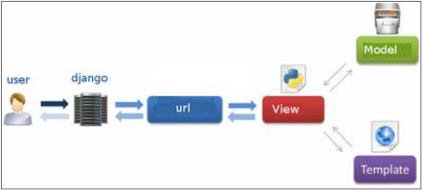

The developer provides the Model, the view and the template then just maps it to a URL and Django does the magic to serve it to the user.

**FRONTEND**

**HTML5 –HTML** stands for Hyper Text Markup Language. **HTML** is the standard markup language for creating Web pages. **HTML** describes the structure of a Web page. **HTML** consists of a series of elements. **HTML** elements tell the browser how to display the content.HTML5 is the next major revision of the HTML standard superseding HTML 4.01, XHTML 1.0, and XHTML 1.1. HTML5 is a standard for structuring and presenting content on the World Wide Web.

HTML5 is a cooperation between the World Wide Web Consortium (W3C) and the Web Hypertext Application Technology Working Group (WHATWG).

The new standard incorporates features like video playback and drag-and-drop that have been previously dependent on third-party browser plug-ins such as Adobe Flash, Microsoft Silverlight, and Google Gears.

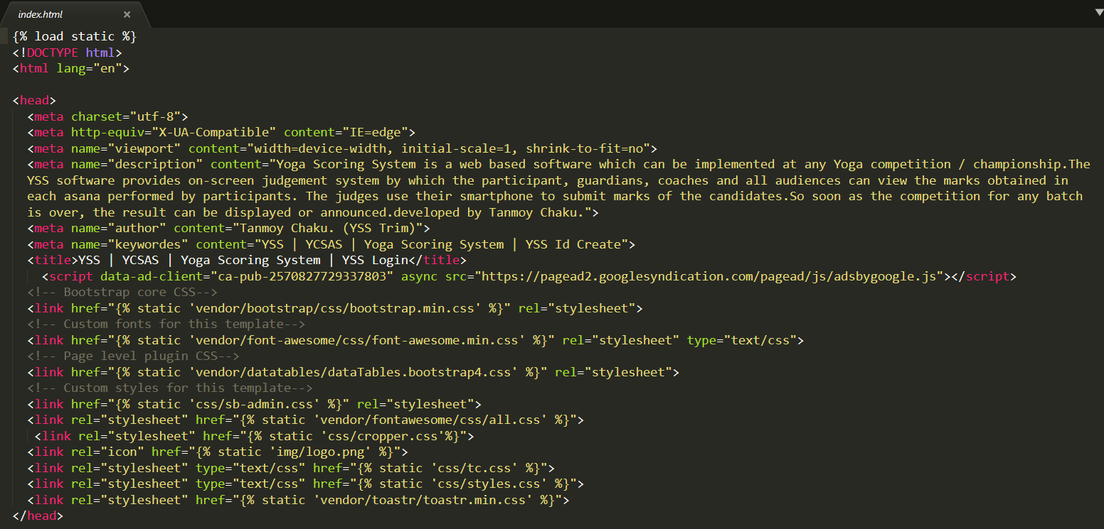

## A small part of html code used in the page

## Browser Support

The latest versions of Apple Safari, Google Chrome, Mozilla Firefox, and Opera all support many HTML5 features and Internet Explorer 9.0 will also have support for some HTML5 functionality.

The mobile web browsers that come pre-installed on iPhones, iPads, and Android phones all have excellent support for HTML5.

## Features

Here is a set of some of the most prominent features introduced in HTML5.

* **New Semantic Elements** − These are like <header>, <footer>, and <section>.
* **Forms 2.0** − Improvements to HTML web forms where new attributes have been introduced for <input> tag.
* **Persistent Local Storage** − To achieve without resorting to third-party plugins.
* **WebSocket** − A next-generation bidirectional communication technology for web applications.
* **Server-Sent Events** − HTML5 introduces events which flow from web server to the web browsers and they are called Server-Sent Events (SSE).
* **Canvas** − This supports a two-dimensional drawing surface that you can program with JavaScript.
* **Audio & Video** − You can embed audio or video on your webpages without resorting to third-party plugins.
* **Geolocation** − Now visitors can choose to share their physical location with your web application.
* **Microdata** − This lets you create your own vocabularies beyond HTML5 and extend your web pages with custom semantics.
* **Drag and drop** − Drag and drop the items from one location to another location on the same webpage.

**CSS-- this** is the acronym of “Cascading Style Sheets”. **CSS** is a computer language for laying out and structuring web pages (HTML or XML). This language contains coding elements and is composed of these “cascading style sheets” which are equally called **CSS** files.

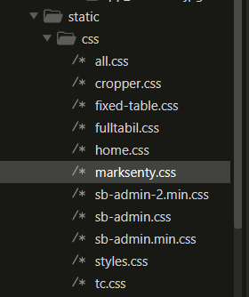

**All CSS used in project**

## Applications of CSS

* **CSS saves time** - You can write CSS once and then reuse same sheet in multiple HTML pages. You can define a style for each HTML element and apply it to as many Web pages as you want.
* **Pages load faster** - If you are using CSS, you do not need to write HTML tag attributes every time. Just write one CSS rule of a tag and apply it to all the occurrences of that tag. So less code means faster download times.
* **Easy maintenance** - To make a global change, simply change the style, and all elements in all the web pages will be updated automatically.
* **Superior styles to HTML** - CSS has a much wider array of attributes than HTML, so you can give a far better look to your HTML page in comparison to HTML attributes.
* **Multiple Device Compatibility** - Style sheets allow content to be optimized for more than one type of device. By using the same HTML document, different versions of a website can be presented for handheld devices such as PDAs and cell phones or for printing.
* **Global web standards**- Now HTML attributes are being deprecated and it is being recommended to use CSS. So its a good idea to start using CSS in all the HTML pages to make them compatible to future browsers.

A CSS comprises of style rules that are interpreted by the browser and then applied to the corresponding elements in your document. A style rule is made of three parts −

* **Selector** − A selector is an HTML tag at which a style will be applied. This could be any tag like <h1> or <table> etc.
* **Property** − A property is a type of attribute of HTML tag. Put simply, all the HTML attributes are converted into CSS properties. They could be *color*, *border* etc.
* **Value** − Values are assigned to properties. For example, *color* property can have value either *red* or *#F1F1F1* etc.

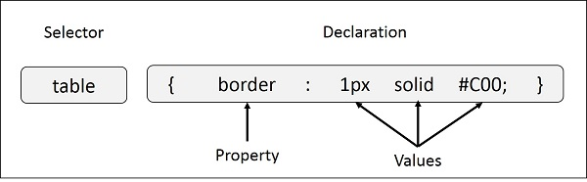

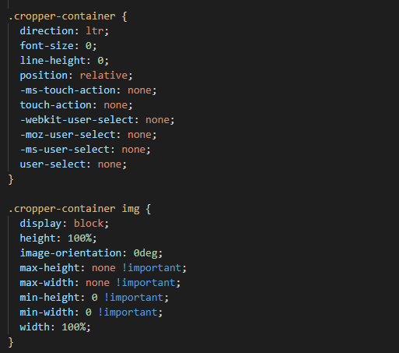

**BOOTSTRAP –**

Bootstrap is a free and open-source CSS framework directed at responsive, mobile-first front-end web development. It contains CSS- and JavaScript-based design templates for typography, forms, buttons, navigation, and other interface components.

## Applications of Bootstrap

* **Scaffolding** − Bootstrap provides a basic structure with Grid System, link styles, and background. This is is covered in detail in the section **Bootstrap Basic Structure**
* **CSS** − Bootstrap comes with the feature of global CSS settings, fundamental HTML elements styled and enhanced with extensible classes, and an advanced grid system. This is covered in detail in the section **Bootstrap with CSS**.
* **Components** − Bootstrap contains over a dozen reusable components built to provide iconography, dropdowns, navigation, alerts, pop-overs, and much more. This is covered in detail in the section **Layout Components**.
* **JavaScript Plugins** − Bootstrap contains over a dozen custom jQuery plugins. You can easily include them all, or one by one. This is covered in details in the section **Bootstrap Plugins**.
* **Customize** − You can customize Bootstrap's components, LESS variables, and jQuery plugins to get your very own version.

Use Bootstrap-

* **Mobile first approach** − Bootstrap 3, framework consists of Mobile first styles throughout the entire library instead them of in separate files.
* **Browser Support** − It is supported by all popular browsers.



* **Easy to get started** − With just the knowledge of HTML and CSS anyone can get started with Bootstrap. Also the Bootstrap official site has a good documentation.
* **Responsive design** − Bootstrap's responsive CSS adjusts to Desktops, Tablets and Mobiles. More about the responsive design is in the chapter [Bootstrap Responsive Design.](https://www.tutorialspoint.com/bootstrap/bootstrap_responsive_utilities.htm)



* Provides a clean and uniform solution for building an interface for developers.
* It contains beautiful and functional built-in components which are easy to customize.
* It also provides web based customization.
* And best of all it is an open source.

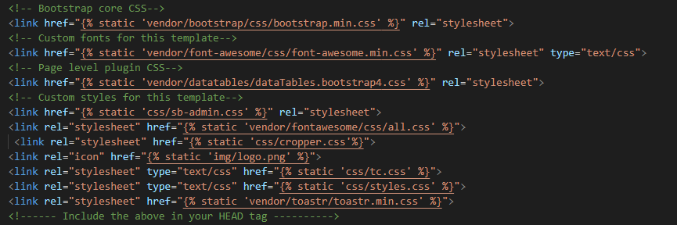

**Code Used in Our Project**

**JQUERY-** jQuery is a JavaScript library designed to simplify HTML DOM tree traversal and manipulation, as well as event handling, CSS animation, and Ajax. It is free, open-source software using the permissive MIT License. As of May 2019, jQuery is used by 73% of the 10 million most popular websites.

jQuery is a fast and concise JavaScript Library created by John Resig in 2006 with a nice motto: **Write less, do more**. jQuery simplifies HTML document traversing, event handling, animating, and Ajax interactions for rapid web development. jQuery is a JavaScript toolkit designed to simplify various tasks by writing less code. Here is the list of important core features supported by jQuery −

* **DOM manipulation** − The jQuery made it easy to select DOM elements, negotiate them and modifying their content by using cross-browser open source selector engine called **Sizzle**.
* **Event handling** − The jQuery offers an elegant way to capture a wide variety of events, such as a user clicking on a link, without the need to clutter the HTML code itself with event handlers.
* **AJAX Support** − The jQuery helps you a lot to develop a responsive and featurerich site using AJAX technology.
* **Animations** − The jQuery comes with plenty of built-in animation effects which you can use in your websites.
* **Lightweight** − The jQuery is very lightweight library - about 19KB in size (Minified and gzipped).
* **Cross Browser Support** − The jQuery has cross-browser support, and works well in IE 6.0+, FF 2.0+, Safari 3.0+, Chrome and Opera 9.0+
* **Latest Technology** − The jQuery supports CSS3 selectors and basic XPath syntax.

**JavaScript-- JavaScript** is a lightweight, interpreted **programming** language. It is designed for creating network-centric applications. It is complimentary to and integrated with Java. **JavaScript** is very easy to implement because it is integrated with HTML. It is open and cross-platform.

## Applications of JavaScript Programming

* **Client side validation** - This is really important to verify any user input before submitting it to the server and JavaScript plays an important role in validating those inputs at front-end itself.
* **Manipulating HTML Pages** - JavaScript helps in manipulating HTML page on the fly. This helps in adding and deleting any HTML tag very easily using JavaScript and modify your HTML to change its look and feel based on different devices and requirements.
* **User Notifications** - You can use JavaScript to raise dynamic pop-ups on the webpages to give different types of notifications to your website visitors.
* **Back-end Data Loading** - JavaScript provides Ajax library which helps in loading back-end data while you are doing some other processing. This really gives an amazing experience to your website visitors.
* **Presentations** - JavaScript also provides the facility of creating presentations which gives website look and feel. JavaScript provides RevealJS and BespokeJS libraries to build a web-based slide presentations.
* **Server Applications** - Node JS is built on Chrome's JavaScript runtime for building fast and scalable network applications. This is an event based library which helps in developing very sophisticated server applications including Web Servers.

## Advantages of JavaScript

The merits of using JavaScript are −

* **Less server interaction** − You can validate user input before sending the page off to the server. This saves server traffic, which means less load on your server.
* **Immediate feedback to the visitors** − They don't have to wait for a page reload to see if they have forgotten to enter something.
* **Increased interactivity** − You can create interfaces that react when the user hovers over them with a mouse or activates them via the keyboard.
* **Richer interfaces** − You can use JavaScript to include such items as drag-and-drop components and sliders to give a Rich Interface to your site visitors.

## Client-Side JavaScript

Client-side JavaScript is the most common form of the language. The script should be included in or referenced by an HTML document for the code to be interpreted by the browser.

It means that a web page need not be a static HTML, but can include programs that interact with the user, control the browser, and dynamically create HTML content.

The JavaScript client-side mechanism provides many advantages over traditional CGI server-side scripts. For example, you might use JavaScript to check if the user has entered a valid e-mail address in a form field.

The JavaScript code is executed when the user submits the form, and only if all the entries are valid, they would be submitted to the Web Server.

JavaScript can be used to trap user-initiated events such as button clicks, link navigation, and other actions that the user initiates explicitly or implicitly.

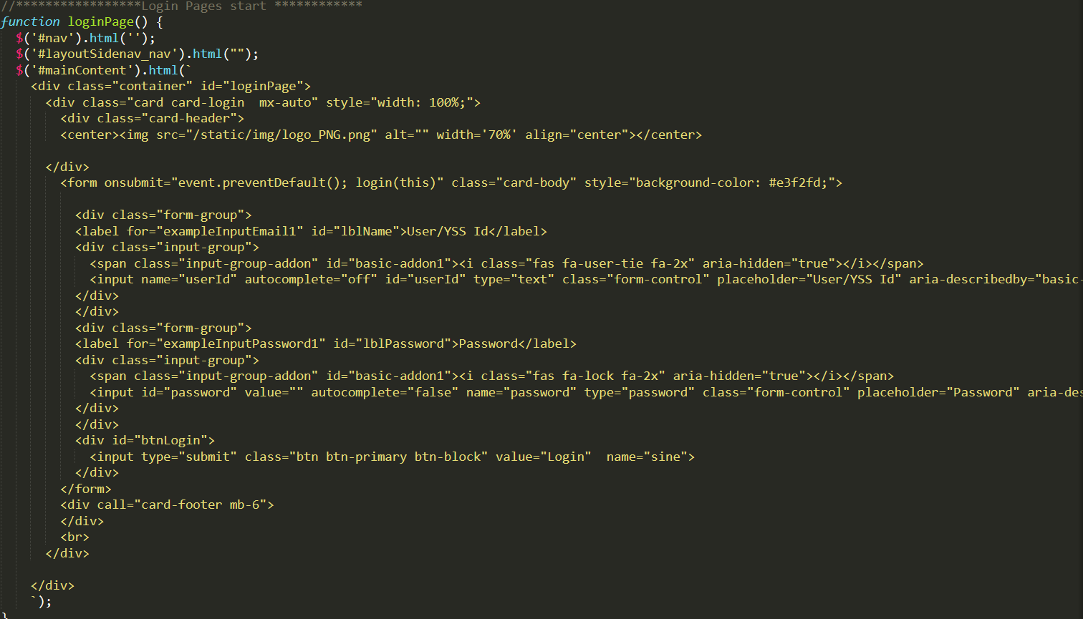

**AJAX--** is a web development technique for creating interactive web applications. If you know JavaScript, HTML, CSS, and XML, then you need to spend just one hour to start with AJAX.

* Ajax uses XHTML for content, CSS for presentation, along with Document Object Model and JavaScript for dynamic content display.
* Conventional web applications transmit information to and from the sever using synchronous requests. It means you fill out a form, hit submit, and get directed to a new page with new information from the server.
* With AJAX, when you hit submit, JavaScript will make a request to the server, interpret the results, and update the current screen. In the purest sense, the user would never know that anything was even transmitted to the server.
* XML is commonly used as the format for receiving server data, although any format, including plain text, can be used.
* AJAX is a web browser technology independent of web server software.
* A user can continue to use the application while the client program requests information from the server in the background.
* Intuitive and natural user interaction. Clicking is not required, mouse movement is a sufficient event trigger.
* Data-driven as opposed to page-driven.

## Rich Internet Application Technology

AJAX is the most viable Rich Internet Application (RIA) technology so far. It is getting tremendous industry momentum and several tool kit and frameworks are emerging.

AJAX is Based on Open Standard

* Browser-based presentation using HTML and Cascading Style Sheets (CSS).
* Data is stored in XML format and fetched from the server.
* Behind-the-scenes data fetches using XMLHttpRequest objects in the browser.
* JavaScript to make everything happen.

**Font Awesome--**

Font Awesome icons library provides 519 free scalable vector icons. This library is completely free for both personal and commercial use. Originally designed for Bootstrap, these icons can be customized easily.

Font Awesome provides several icons. Choose one of them and add the name of the icon class to any HTML element within the <body> tag.

List of Categories

Font Awesome provides 519 icons in the following categories −

* Web Application Icons
* Hand Icons
* Transportation Icons
* Gender Icons
* File Type Icons
* Spinner Icons
* Form Control Icons
* Payment Icons
* Chart Icons
* Currency Icons
* Text editor Icons
* Directional Icons
* Video Player Icons
* Brand Icons

To use any of these icons, you have to replace the class name in the programs given in this chapter with the class name of the desired icon. In the coming chapters of this Unit (Font Awesome), we have explained category-wise the usage and the respective outputs of various Font Awesome icons.

**Cropper--**

**Cropper** v4.1.0. A simple jQuery image cropping plugin. As of v4.0.0, the core code of **Cropper** is replaced with **Cropper**.js.

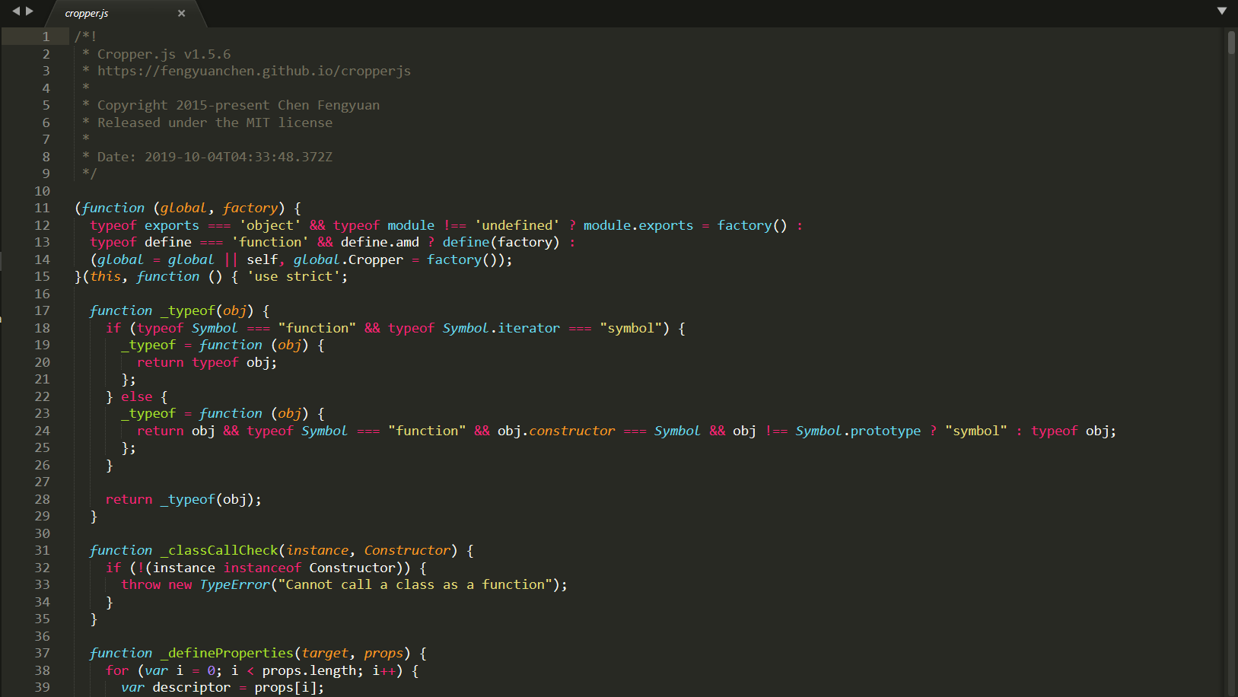

**A small part of cropper.js from our project**

Toastr –

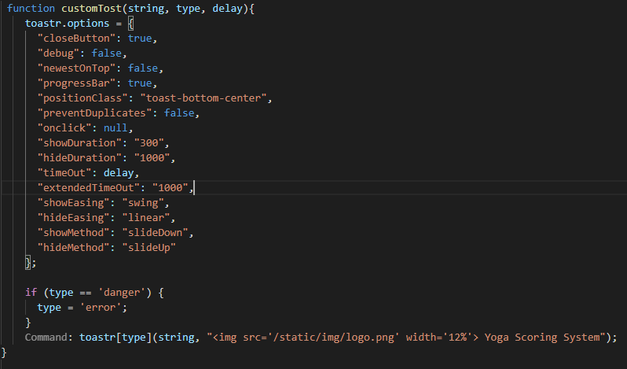

**Database**

**MYSQL**

In our software we need to store information about the user into something. So we will be using a database. There are many types of databases like object oriented, network, relational & hierarchical. We are using a relational database. And it's one of the named frameworks, MY SQL. There are many database software in the market but we use this because of its most likely feature that is being light weighted database software. The capacity to construct meaningful information by linking tables is the major advantage of the relational database strategy. Understanding the relationships between the data, or how the tables relate, can be accomplished via joining tables. SQL supports counting, adding, grouping, and combining queries.

**Triggers**

Triggers are a component of Procedural SQL(PL SQL) . Triggers are stored programmes that are executed or fired automatically when certain events occur. Triggers are written to be run in reaction to any of the events, such as DML, DDL, and DCL instructions.

Triggers' Advantages

Triggers can be written for a variety of reasons:

* Automatically generating some derived column values
* Referential integrity must be maintained.
* Information on table access is logged and stored in an event log.
* Examining
* Table replication in real time
* Putting in place security authorizations
* Preventing transactions that are invalid
* Developing Triggers

Table

A table in a database is a collection of related data. It's made up of columns and rows. A table is a collection of data components in relational and flat file databases that uses a model of vertical columns and horizontal rows, with the cell being the unit where a row and column intersect. In our database we have 18 tables out of them 2 are used to hold session values. And the rest stores up the information of the user in a very normalised way. So the Back End and Front End both can be easily handled and the data duplicacy problem can be overcomed.

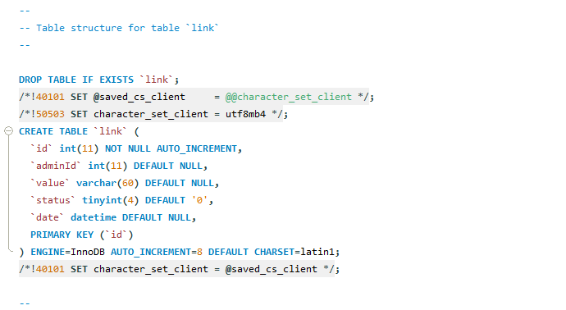

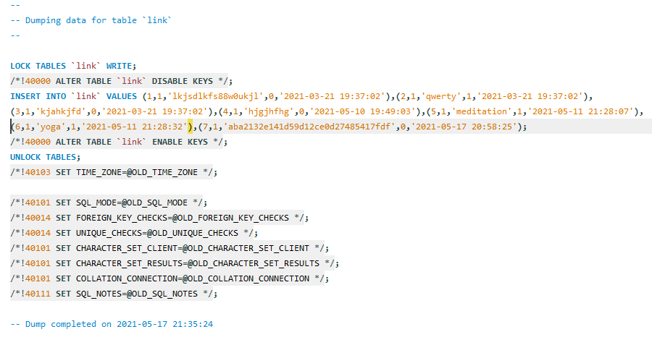

**SINGLE PAGE APPLICATION—**

A **single-page application (SPA)** is an application that interrelates with users by vigorously rewriting the existing web pages with novel data from the web server, instead of the default technique of the browser running a completely new page.  The objective is to have quicker transitions that can make the site feel more like an inherent application.

In a SPA, all the required HTML, JavaScript, and CSS code is either recovered by the browser or suitable resources that are robustly loaded and added to the pages as required.  This generally happens in reply to the user’s actions.

The page does not reload at any given point in the procedure and does not transfer the control to an alternative page, though **HTML5 history API** or the location hash can be utilized to offer the navigability and perception of distinct logical pages in the web application.

### single Page Application Work

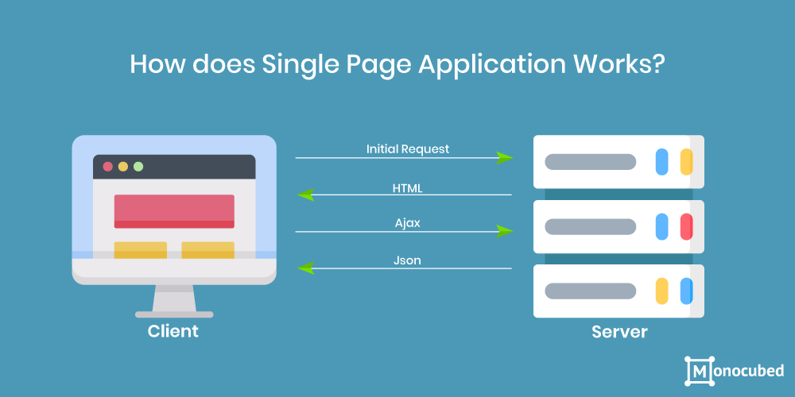

Single page application architecture is pretty straightforward.  It contains the server-side and client-side technologies and there are three choices to select from as depicted in the diagram below:

1. **Server-side Rendering (SSR)**
   * The browser directs a request for the HTML file from the server.
   * The server procures all the desired data, extracts the application, and produces the application’s HTML file on the fly.
   * The users see accessible content.
   * The single page application framework is what adjoins the events, creates virtual DOM, and executes further actions.
   * The application is ready to use.

Server-side rendering can opt as it associates both the promptness of the single page web application and does not overload the browser of the users, making the app rapid.

1. **Client-Side Rendering (CSR)**
   * The browser leads a request for an HTML file from the server.
   * The server replies rapidly with a simple HTML file, along with scripts and styles linked.
   * The users see a blank page or certain loader image while JavaScript is performing.
   * The application procures the data, generates the views, and inserts it into DOM.
   * The application is ready to use.

This can be an alternative for simple-looking websites, but you must keep in mind that interpreting the data on the client-side involves many resources from the device and this might overload the user’s browser.  As a consequence, this choice can prove to be sluggish as compared to all the three alternatives.

Also, if you have a website that has high-traffic, CSR would be preferable, as it would deliver the information to users without talking much to the server.  Moreover, if you require social sharing alternatives, remember that all the pages in CSR typically have a similar open graph and values, hence you must employ server-side rendering or static site generators.

1. **Static Site Generators (SSG)**
   * The browser directs a request for the HTML file from the server.
   * The server then replies speedily with a previously organized HTML file.
   * The users see the page.
   * The application draws the data, produces views, and inserts it into DOM.
   * The application is ready to use.

It is considered to be fast and a good option, but bear in mind that if you have active content on your site, static site generators (SSG) would not be your best support because they are focused more on static pages.

## Advantages of Single-Page Application

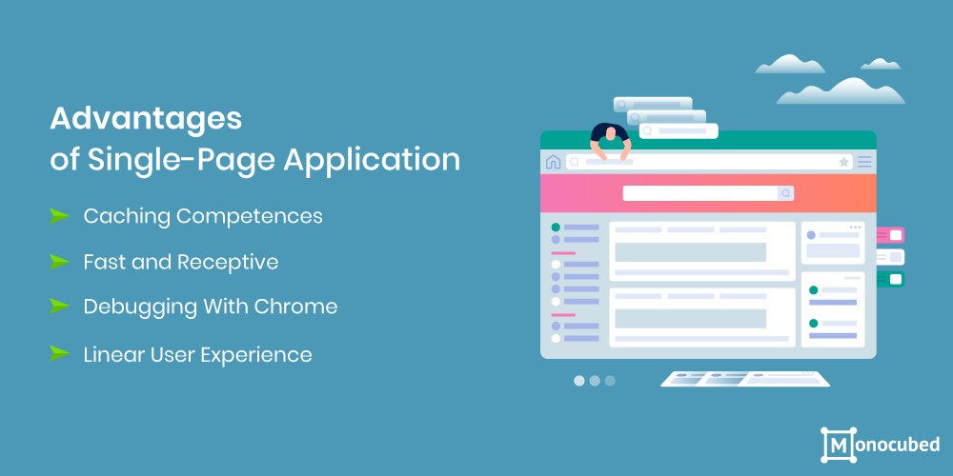

### Caching Competences

A single-page application can cache local data effectively.  SPA directs only one request to the server and then stocks all the data it obtains.  Then it can utilize this data and function even while being offline.  If any user has reduced connectivity, the local data can be synchronized with the server whenever the connection permits.

### Fast and Receptive

As single-page applications do not update the complete page but only essential content, they meaningfully enhance the speed of the website.  Most of the resources (CSS/HTML/Scripts) are only loaded once through the duration of an application.  Only the data is conveyed back and forth.

This is a huge benefit, and according to a Google study, if a page requires more than 200 milliseconds to load it can have a possibly high impression on the sales and business.

### Debugging With Chrome

It is easy to debug SPA with Chrome as these [apps are built on the frameworks like Angular and React](https://www.monocubed.com/websites-built-with-angular/) developer tools. Such frameworks have their Chrome developer tools that can make debugging much easier as compared with **multi-page** application (MPA) Moreover, SPAs permit you to observe network procedures and examine page elements and data connected with them.

### Linear User Experience

SPAs present its users with an easy linear experience.  These web applications like Saucony, for instance, comprise a perfect beginning, middle, and finish.  The Saucony web application development offers an outstanding interactive user experience utilizing parallax scrolling and astonishing transitions and effects to display the whole customer journey.

With SPA, scrolling is suitable and incessant; there is no requirement to click on infinite links.  Certainly, the scrolling trait of SPA makes them impeccably suited for the mobile users who have become habituated to scrolling.

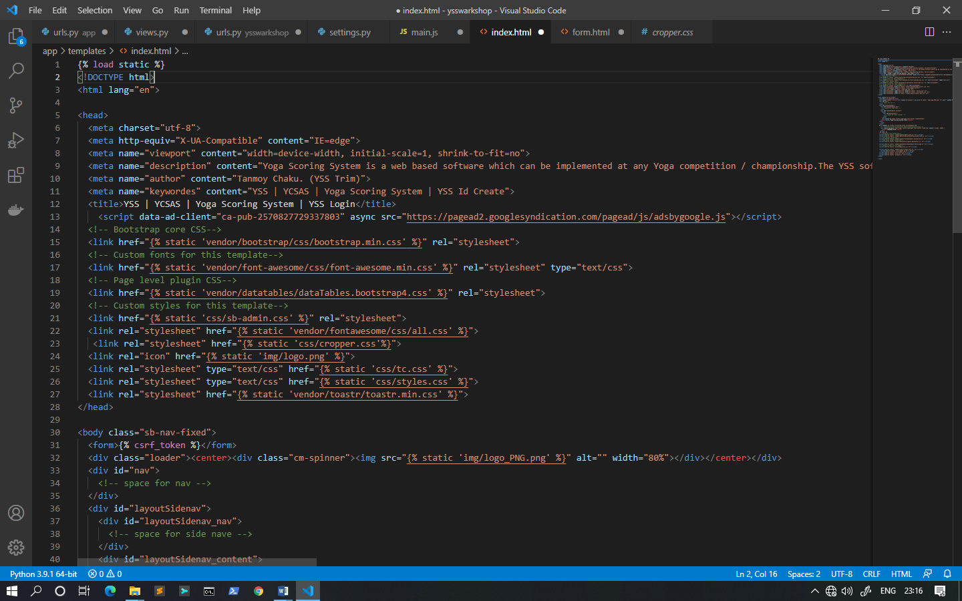

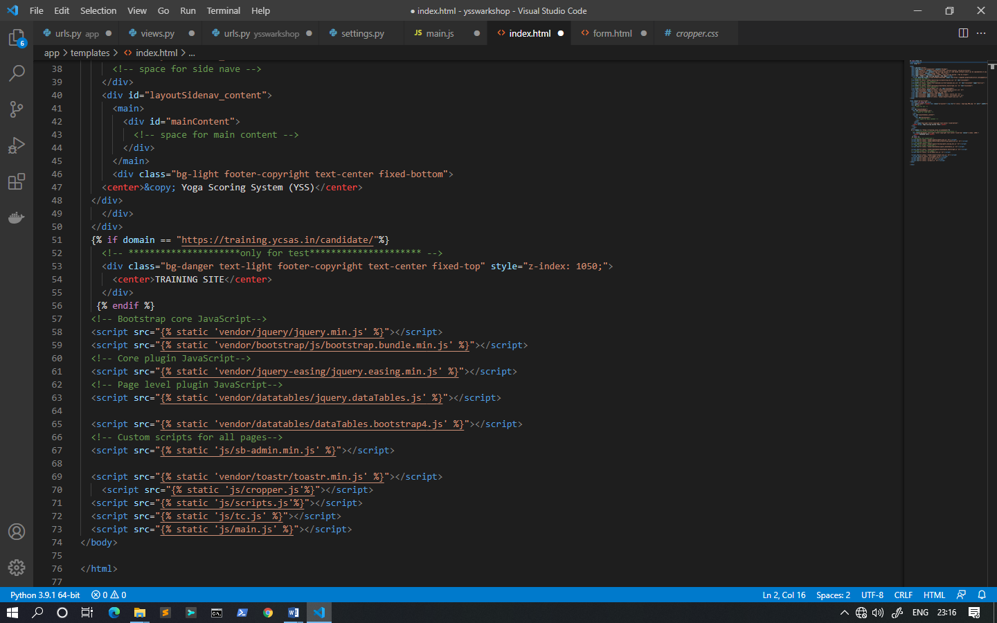

**Tools & Technology**

Visual Studio is an **Integrated Development Environment (IDE)** developed by Microsoft to develop GUI (Graphical User Interface), console, Web applications, web apps, mobile apps, cloud, and web services etc. With the help of this IDE, you can create managed code as well as native code. It uses the various platforms of Microsoft software development software like Windows store, Microsoft Silverlight, and Windows API etc. It is not a language specific IDE as you can use this to write code in C#, C++, VB (Visual Basic), Python, JavaScript, and many more languages. It provides support for 36 different programming languages. It is available for Windows as well as for macOS.

**Evolution of Visual Studio:** The first version of VS (Visual Studio) was released in 1997, named as Visual Studio 97 having version number 5.0. The latest version of Visual Studio is 15.0 which was released on March 7, 2017. It is also termed as Visual Studio 2017. The supported .Net Framework Versions in latest Visual Studio is 3.5 to 4.7. Java was supported in old versions of Visual Studio but in latest version doesn’t provide any support for Java language.

##### **Visual Studio Editions**

There are 3 editions of Microsoft Visual Studio as follows:

**1. Community:** It is a **free** version which is announced in 2014. All other editions are paid. This contains the features similar to Professional edition. Using this edition, any individual developer can develop their own free or paid apps like .Net applications, Web applications and many more. In an enterprise organization, this edition has some limitations. For example, if your organization have more than 250 PCs and having annual revenue greater than $1 Million (US Dollars) then you are not permitted to use this edition. In a non-enterprise organization, up to five users can use this edition. Its main purpose is to provide the Ecosystem (Access to thousands of extensions) and Languages (You can code in C#, VB, F#, C++, HTML, JavaScript, Python etc.) support.

**2. Professional:** It is the commercial edition of Visual Studio. It comes in Visual Studio 2010 and later versions. It provides the support for XML and XSLT editing and includes the tool like Server Explorer and integration with Microsoft SQL Server. Microsoft provides a free trial of this edition and after trial period user has to pay to continue using it. Its main purpose is to provide Flexibility (Professional developer tools for building any application type), Productivity (Powerful features such as CodeLens improve your team’s productivity), Collaboration (Agile project planning tools, charts etc.) and Subscriber benefits like Microsoft software, plus Azure, Pluralsight etc.

1. **Enterprise:** It is an integrated, end to end solution for teams of any size with the demanding quality and scale needs. Microsoft provides a 90-days free trial of this edition and after trial period user has to pay to continue using it. The main benefit of this edition is that it is highly scalable and deliver the high-quality software.

[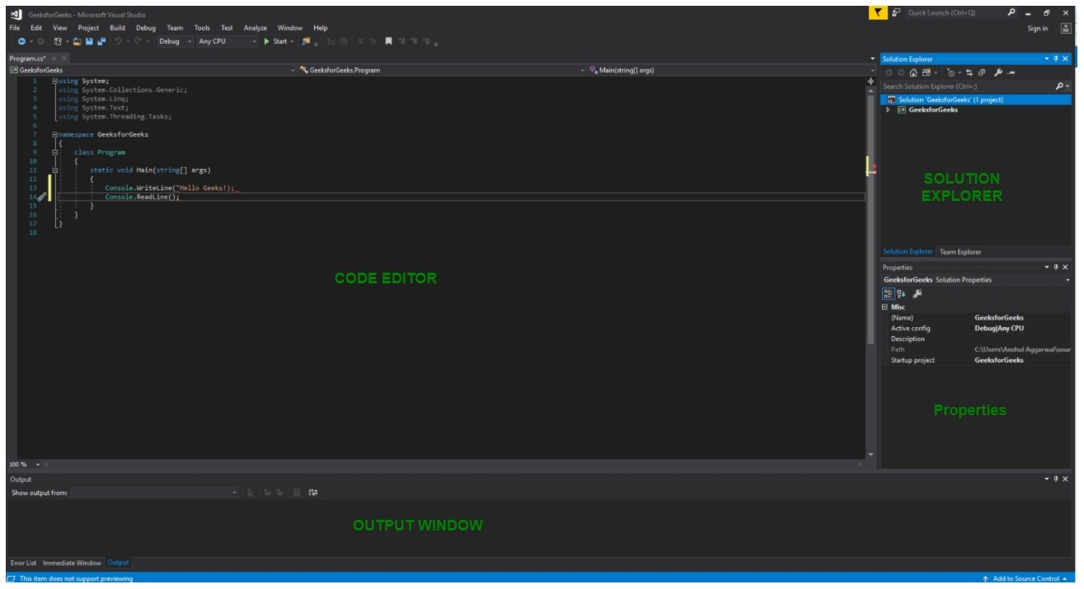](https://tutorialspoint.dev/image/VS2017.jpg)

* 1. **Code Editor:** Where the user will write code.
  2. **Output Window:** Here the Visual Studio shows the outputs, compiler warnings, error messages and debugging information.
  3. **Solution Explorer:** It shows the files on which the user is currently working.
  4. **Properties:** It will give the additional information and context about the selected parts of the current project.
* A user can also add windows as per requirement by choosing them from **View**menu. In Visual Studio the tool windows are customizable as a user can add more windows, remove the existing open one or can move windows around to best suit.
* **Various Menus in Visual Studio:**A user can find a lot of menus on the top screen of Visual Studio as shown below
* [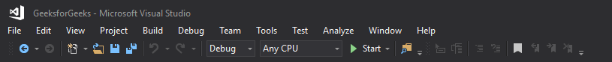](https://tutorialspoint.dev/image/VS2017-2.png)
  1. Create, Open and save projects commands are contained by **File**menu.
  2. Searching, Modifying, Refactoring code commands are contained by the **Edit**menu.
  3. **View**Menu is used to open the additional tool windows in Visual Studio.
  4. **Project**menu is used to add some files and dependencies in the project.
  5. To change the settings, add functionality to Visual Studio via extensions, and access various Visual Studio tools can be used by using **Tools**menu.
* The below menu is known as the **toolbar**which provide the quick access to the most frequently used commands. You can add and remove the commands by going to**View → Customize**
* [](https://tutorialspoint.dev/image/VS2017-3.png)

**Note:**

* Support for different programming languages in Visual Studio is added by using a special **VSPackage**which is known as Language Service.
* When you will install the Visual Studio then the functionality which is coded as VSPackage will be available as Service.
* Visual Studio IDE provides the three different types of services known as **SVsSolution**, **SVsUIShell**, and **SVsShell**.
* SVsSolution service is used to provide the functionality to enumerate solutions and projects in Visual Studio.
* SVsUIShell service is used to provide User Interface functionality like toolbars, tabs etc.
* SvsShell service is used to deal with the registration of VSPackages.

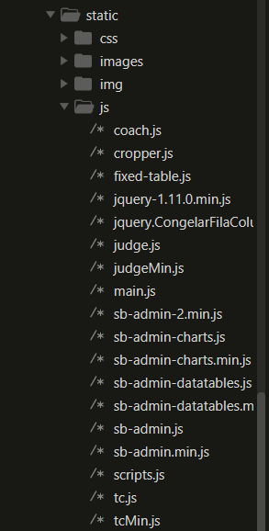

**All java scripts we have user in our project**

# Sublime Text

Sublime Text editor is a sophisticated text editor which is widely used among developers. It includes wide features such as Syntax Highlight, Auto Indentation, File Type Recognition, Sidebar, Macros, Plug-in and Packages that make it easy for working with code base. This tutorial gives you a comprehensive coverage of concepts of Sublime Text and makes you comfortable to use it in your software development projects.

Sublime Text Editor is a full featured Text editor for editing local files or a code base. It includes various features for editing code base which helps developers to keep track of changes. Various features that are supported by Sublime are as follows −

* Syntax Highlight
* Auto Indentation
* File Type Recognition
* Sidebar with files of mentioned directory
* Macros
* Plug-in and Packages

Sublime Text editor is used as an Integrated Development Editor (IDE) like Visual Studio code and NetBeans. The current version of Sublime Text editor is 3.0 and is compatible with various operating systems like Windows, Linux and MacOS.

When you use a suitable Text editor, you can enjoy its rich beneficial features. Sublime Text offers its users the following benefits −

* Ability to solve linker errors.
* Keeping track of all files and folders to work with.
* Connectivity with version control systems like Git, Mercurial.
* Problem solving capabilities.
* Keeping color combination for syntax combination.

Sublime Text editor is supported by the following major operating systems −

* Windows
* Linux and its distributions
* OS X

## 

## This is an example how the settings.py of the project look like when we use Sublime Text editor.

## 

## This is how we can detect the errors easily through Sublime Text editor. Here we can see that the colors of the text automatically changed if there were any errors.

## Command Prompt

Command Prompt is a [command line interpreter](https://www.lifewire.com/what-is-a-command-line-interpreter-2625827) application available in most Windows [operating systems](https://www.lifewire.com/operating-systems-2625912). It's used to execute entered [commands](https://www.lifewire.com/what-is-a-command-2625828). Most of those commands automate tasks via scripts and [batch files](https://www.lifewire.com/bat-file-2619796), perform advanced administrative functions, and troubleshoot or solve certain kinds of Windows issues.

Command Prompt is officially called Windows Command Processor, but it's also sometimes referred to as ​the command shell or cmd prompt, or even by its filename, cmd.exe.

Command Prompt is sometimes incorrectly referred to as "the DOS prompt" or as MS-DOS itself. Command Prompt is a Windows program that emulates many of the command line abilities available in MS-DOS, but it's not MS-DOS.

## ﻿Command Prompt Availability

Command Prompt is available on every Windows NT-based operating system which includes [Windows 10](https://www.lifewire.com/windows-10-2626217), [Windows 8](https://www.lifewire.com/windows-8-2626235), [Windows 7](https://www.lifewire.com/windows-7-2626265), [Windows Vista](https://www.lifewire.com/windows-vista-2626311), [Windows XP](https://www.lifewire.com/windows-xp-2626354), and Windows 2000, as well as Windows Server 2012, 2008, and 2003.

Windows PowerShell, an advanced command line interpreter available in recent Windows versions, supplements the command executing abilities available in Command Prompt. Windows PowerShell may eventually replace the Command Prompt in a future version of Windows.

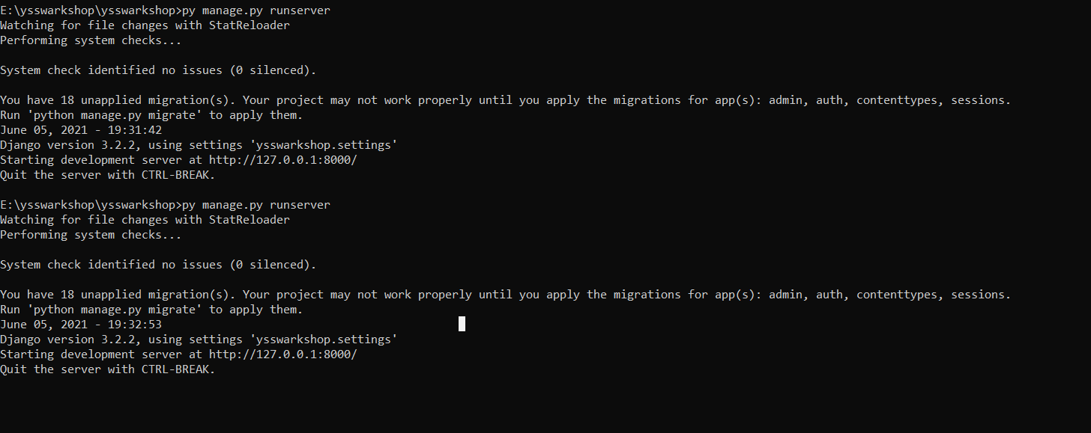

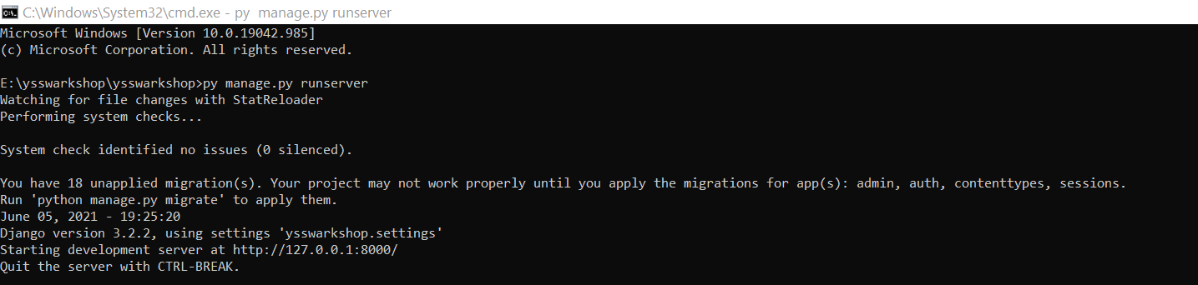

**We use commands to run the server using command prompt. We can also detect the error through the Command Prompt.**

# PowerShell

PowerShell is a cross-platform task automation solution made up of a command-line shell, a scripting language, and a configuration management framework. PowerShell runs on Windows, Linux, and macOS.

## Shell

PowerShell is a modern command shell that includes the best features of other popular shells. Unlike most shells that only accept and return text, PowerShell accepts and returns .NET objects. The shell includes the following features:

* Robust command-line [history](https://docs.microsoft.com/en-us/powershell/module/microsoft.powershell.core/about/about_history)
* Tab completion and command prediction (See [about_PSReadLine](https://docs.microsoft.com/en-us/powershell/module/psreadline/about/about_psreadline))
* Supports command and parameter [aliases](https://docs.microsoft.com/en-us/powershell/module/microsoft.powershell.core/about/about_aliases)
* [Pipeline](https://docs.microsoft.com/en-us/powershell/module/microsoft.powershell.core/about/about_pipelines) for chaining commands
* In-console [help](https://docs.microsoft.com/en-us/powershell/module/microsoft.powershell.core/get-help) system, similar to Unix man pages

## Scripting language

As a scripting language, PowerShell is commonly used for automating the management of systems. It is also used to build, test, and deploy solutions, often in CI/CD environments. PowerShell is built on the .NET Common Language Runtime (CLR). All inputs and outputs are .NET objects. No need to parse text output to extract information from output. The PowerShell scripting language includes the following features:

* Extensible through [functions](https://docs.microsoft.com/en-us/powershell/module/microsoft.powershell.core/about/about_functions_advanced), [classes](https://docs.microsoft.com/en-us/powershell/module/microsoft.powershell.core/about/about_classes), [scripts](https://docs.microsoft.com/en-us/powershell/module/microsoft.powershell.core/about/about_scripts), and [modules](https://docs.microsoft.com/en-us/powershell/module/microsoft.powershell.core/about/about_modules)
* Extensible [formatting system](https://docs.microsoft.com/en-us/powershell/module/microsoft.powershell.core/about/about_format.ps1xml) for easy output
* Extensible [type system](https://docs.microsoft.com/en-us/powershell/module/microsoft.powershell.core/about/about_types.ps1xml) for creating dynamic types
* Built-in support for common data formats like [CSV](https://docs.microsoft.com/en-us/powershell/module/microsoft.powershell.utility/convertfrom-csv), [JSON](https://docs.microsoft.com/en-us/powershell/module/microsoft.powershell.utility/convertfrom-json), and [XML](https://docs.microsoft.com/en-us/powershell/module/microsoft.powershell.utility/convertto-xml)

### PowerShell in action

Take a look at how PowerShell is being used in different scenarios and on different platforms.

* [PowerShell remoting over SSH](https://docs.microsoft.com/en-us/powershell/scripting/learn/remoting/ssh-remoting-in-powershell-core)
* [Getting started with Azure PowerShell](https://docs.microsoft.com/en-us/powershell/azure/get-started-azureps)
* [Building a CI/CD pipeline with DSC](https://docs.microsoft.com/en-us/azure/devops/pipelines/release/dsc-cicd)
* [Managing Microsoft Exchange](https://docs.microsoft.com/en-us/powershell/exchange/exchange-management-shell)

# Pycharm

PyCharm is the most popular IDE for Python, and includes great features such as excellent code completion and inspection with advanced debugger and support for web programming and various frameworks. PyCharm is created by Czech company, Jet brains which focusses on creating integrated development environment for various web development languages like JavaScript and PHP.

PyCharm is the most popular IDE used for Python scripting language. This chapter will give you an introduction to PyCharm and explains its features.

PyCharm offers some of the best features to its users and developers in the following aspects −

* Code completion and inspection
* Advanced debugging
* Support for web programming and frameworks such as Django and Flask

## Features of PyCharm

Besides, a developer will find PyCharm comfortable to work with because of the features mentioned below −

### Code Completion

PyCharm enables smoother code completion whether it is for built in or for an external package.

### SQLAlchemy as Debugger

You can set a breakpoint, pause in the debugger and can see the SQL representation of the user expression for SQL Language code.

### Git Visualization in Editor

When coding in Python, queries are normal for a developer. You can check the last commit easily in PyCharm as it has the blue sections that can define the difference between the last commit and the current one.

### Code Coverage in Editor

You can run **.py** files outside PyCharm Editor as well marking it as code coverage details elsewhere in the project tree, in the summary section etc.

### Package Management

All the installed packages are displayed with proper visual representation. This includes list of installed packages and the ability to search and add new packages.

### Local History

Local History is always keeping track of the changes in a way that complements like Git. Local history in PyCharm gives complete details of what is needed to rollback and what is to be added.

### Refactoring

Refactoring is the process of renaming one or more files at a time and PyCharm includes various shortcuts for a smooth refactoring process.

### User Interface of PyCharm Editor

The user interface of PyCharm editor is shown in the screenshot given below. Observe that the editor includes various features to create a new project or import from an existing project.

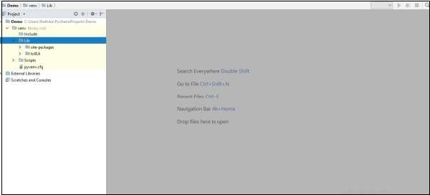

Work Bench

**MySQL Workbench** is a **Visual database designing and modeling** access tool for MySQL server relational database. It facilitates creation of new physical data models and modification of existing MySQL databases with reverse/forward engineering and change management functions. The purpose of MySQL workbench is to provide the interface to work with databases more easily and in a more structured way.

[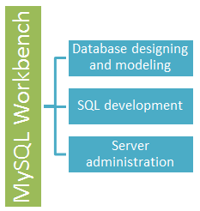](https://www.guru99.com/images/mysql_workbench.png)

* Models are at the core of most valid and high performance databases. MySQLworkbench has tools that allow developers and database administrators visually create physical database design models that can be easily translated into MySQL databases using forward engineering.
* MySQL workbench supports creation of multiple models in the same environment.
* It supports all objects such as tables, views, stored procedures, triggers,  etc. that make up a database.
* MySQL workbench has a built in model validating utility that reports any issues that might be found to the data modeler.
* It also allows for different modeling notations and can be extended by using LUA a scripting language.
* The figure shown below shows the modeling window for MySQLWorkbench.
* [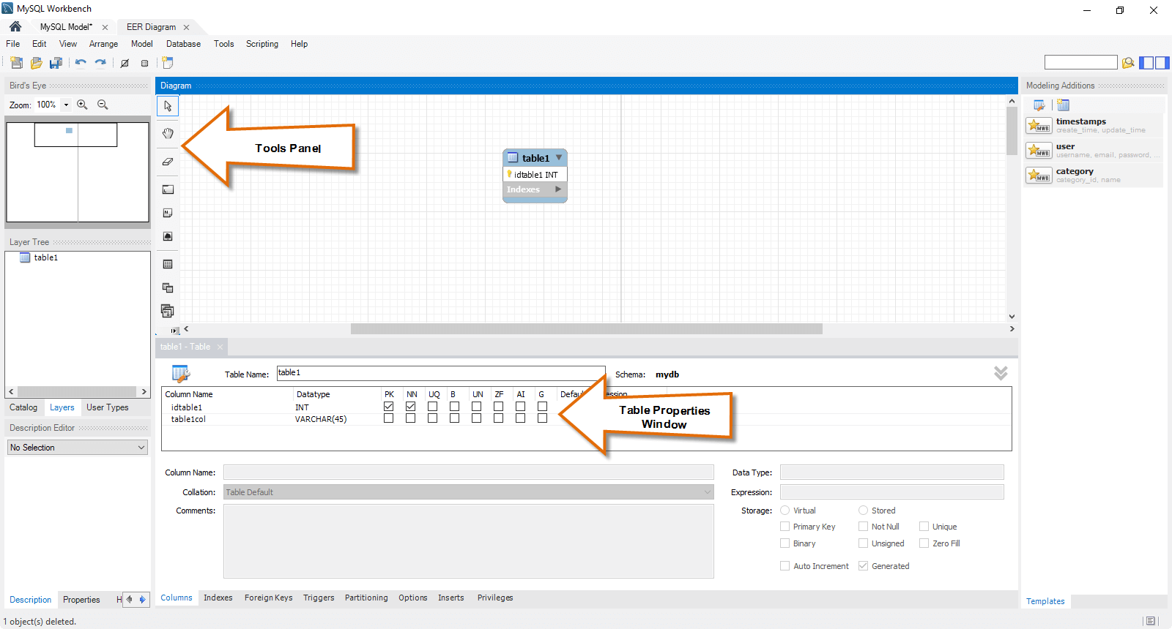](https://www.guru99.com/images/MSQLWorkBench.png)

## MySQL workbench - SQL development tool

[Structured Query Language (SQL)](https://www.guru99.com/what-is-sql.html) allows us to manipulate our relational databases. SQL is at the heart of all relational databases.

* MySQL workbench, has built in SQL visual editor.
* The Visual SQL editor allows developers to build, edit and run queries against MySQL server databases. It has utilities for viewing data and exporting it.
* Its syntax color highlighters help developers easily write and debug SQL statements.
* Multiple queries can be run and results automatically displayed in different tabs.
* The queries are also saved in the history panel for later retrieval and running.

The figure shown below shows the SQL development window for MySQL Workbench.

[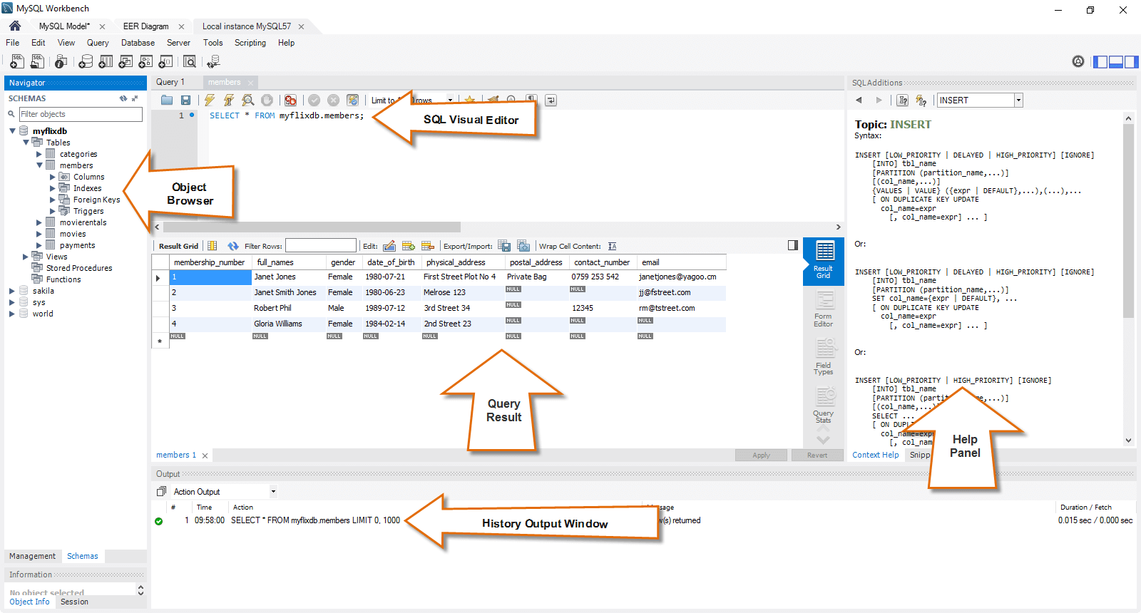](https://www.guru99.com/images/mysql_workbench_sql_development.png)

**MySQL workbench - Administration tool**

Server administration plays a critical role in securing the data of the company. The major issues concerning server administration are users' management, server configuration, server logs and many more. Workbench MySQL has the following features that simplify the process of MySQL server administration;

* **User administration** - visual utility for managing users that lets database administrators easily add new and remove existing users if need arises, grant and drop privileges and view user profiles.
* **Server configuration** - allows for advanced configuration of the server and fine tuning for optimal performance.
* **Database backup and restorations** - visual tool for exporting/importing MySQL dump files. MySQL dump files contain SQL scripts for creating databases, tables, views, stored procedures and insertion of data.
* **Server logs** - visual tool for viewing MySQL server logs. The logs include error logs, binary logs and InnodDB logs. These logs come in handy when performing diagnosis on the server. The figure shown below shows the modeling window for MySQL Workbench.

The figure shown below shows  the Admin panel for Workbench MySQL.

[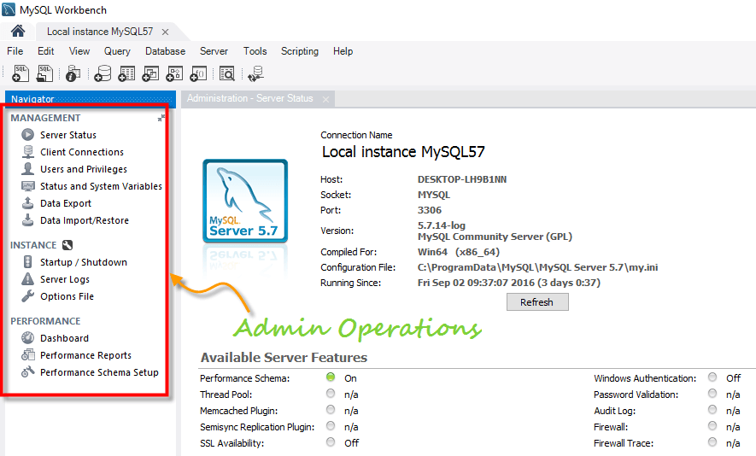](https://www.guru99.com/images/mysql_workbench_administration.png)

**SRC:**

* + 1. **ER Diagram:**

A Unique Link Senario

* Event Manager, also known as ‘admin’ will be generating a unique link to get reviews of different people.
* Admin are identified by id, name.
* Each ‘admin’ will get the opportunity to create as many links as he wants.
* Links will be identified by id,under a certain admin.
* The link shared with people will direct them to a page where they can give review or advice.
* The link once submitted cannot be operated twice.
* The submitted review with the user information who submitted the link will be stored.

The Entities

* Admin
* Link
* Datastore

The Entities with Attributes

* Admin
  + id
  + userId
  + password
  + name
* Link
  + id
  + adminid
  + value
  + status
  + date
* Datastore
  + id
  + linkId
  + fullname
  + address
  + state
  + phoneNo
  + date

Relationship Between Entities

* Admin generates Link
* Link sends received data to Datastore

Cardinality

* Admin generates Link(1:N)
* Link sends received data to Datastore(1:1)

Weak Entities

* Datastore

Participation

* Admin generates Link -> Admin: partial Link: total
* Link sends received data to Datastore -> Link: partial Datastore: total

Represented Diagrammatically

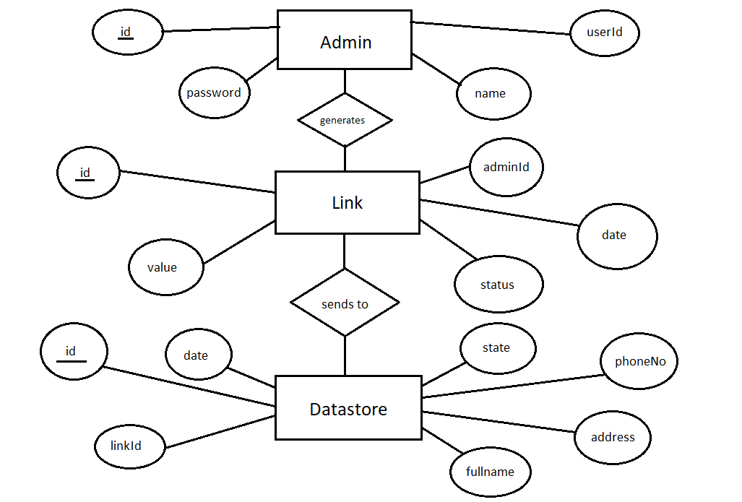

* + 1. Data Flow Diagram (DFD) :

**File Structure**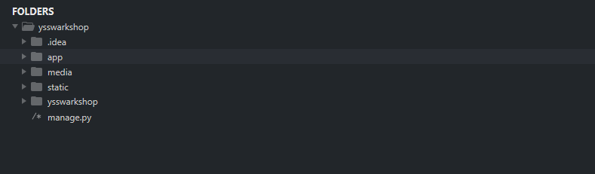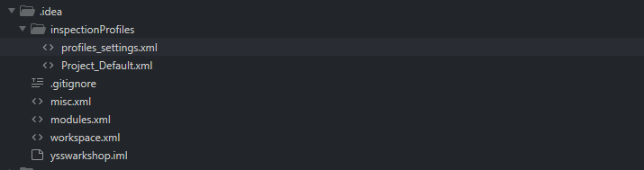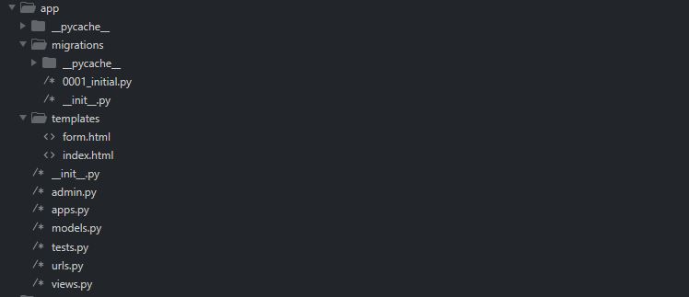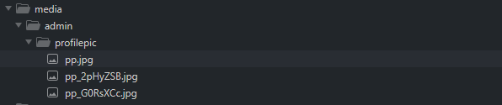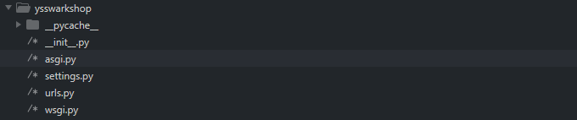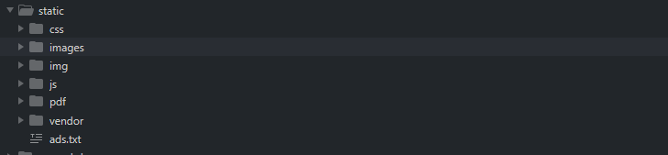

7) CODE:

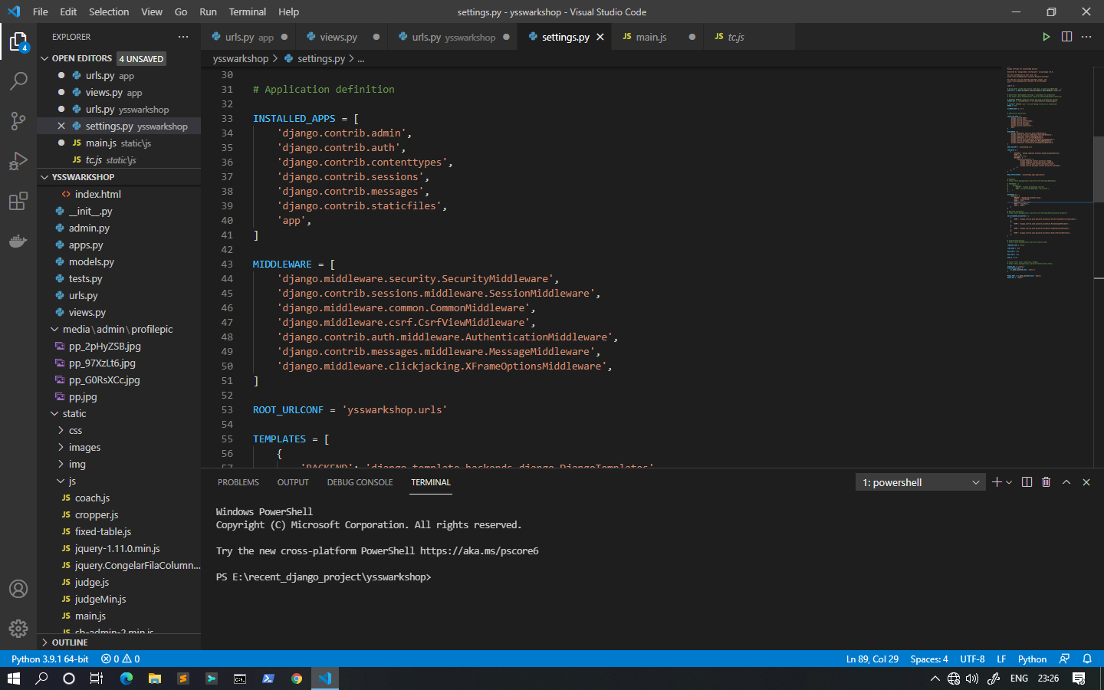

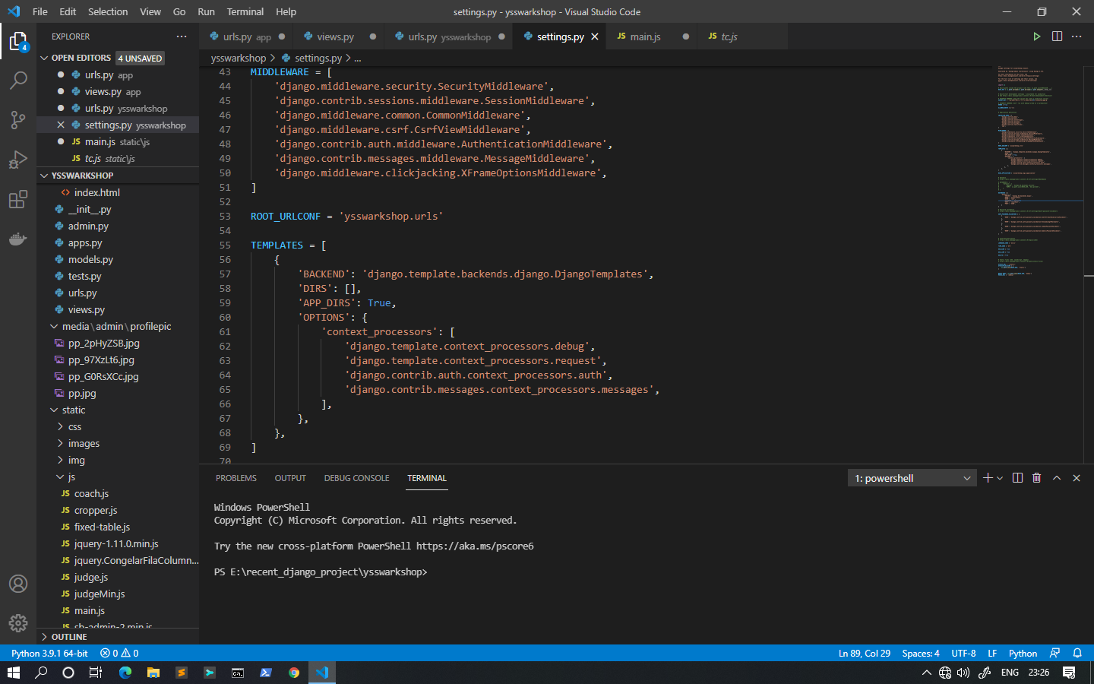

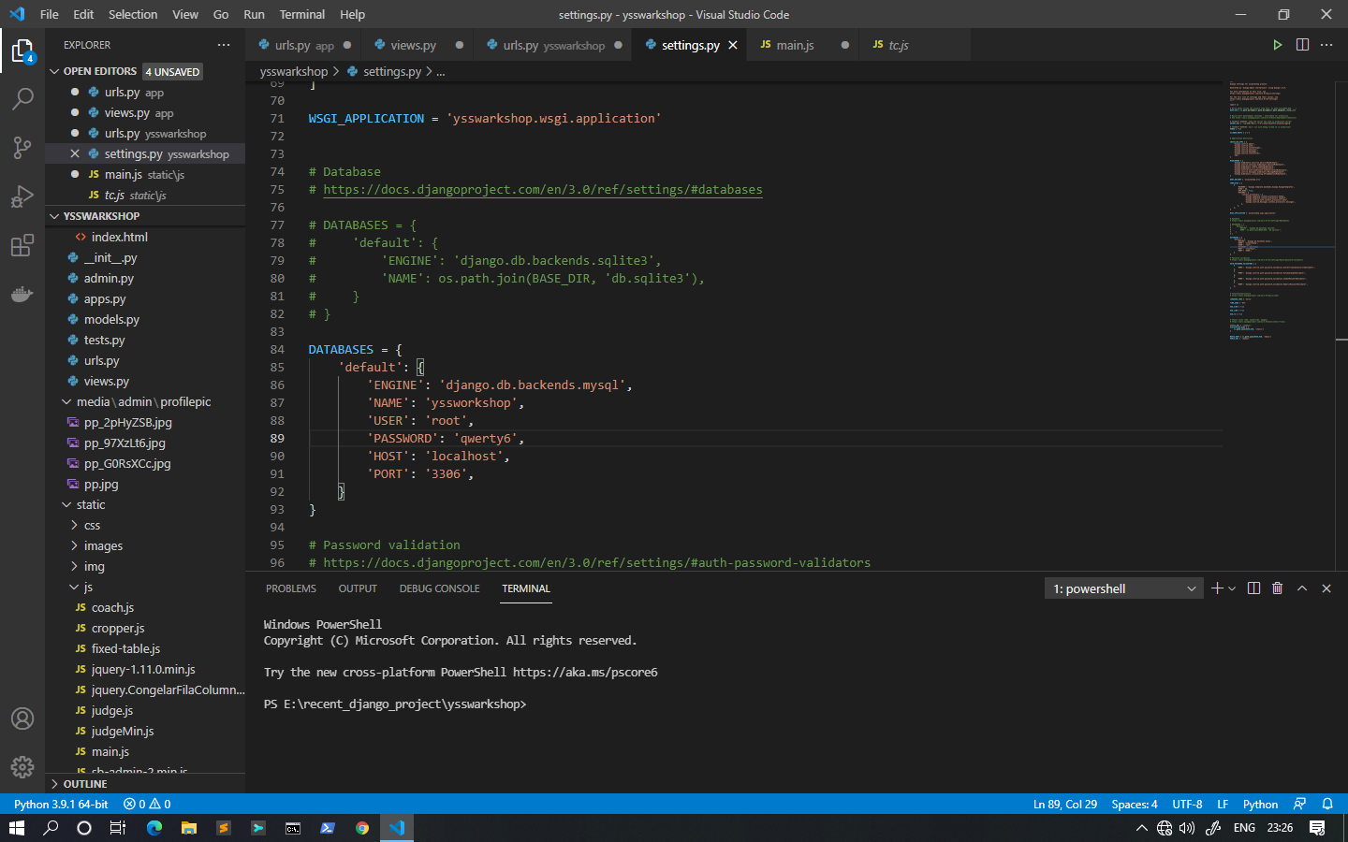

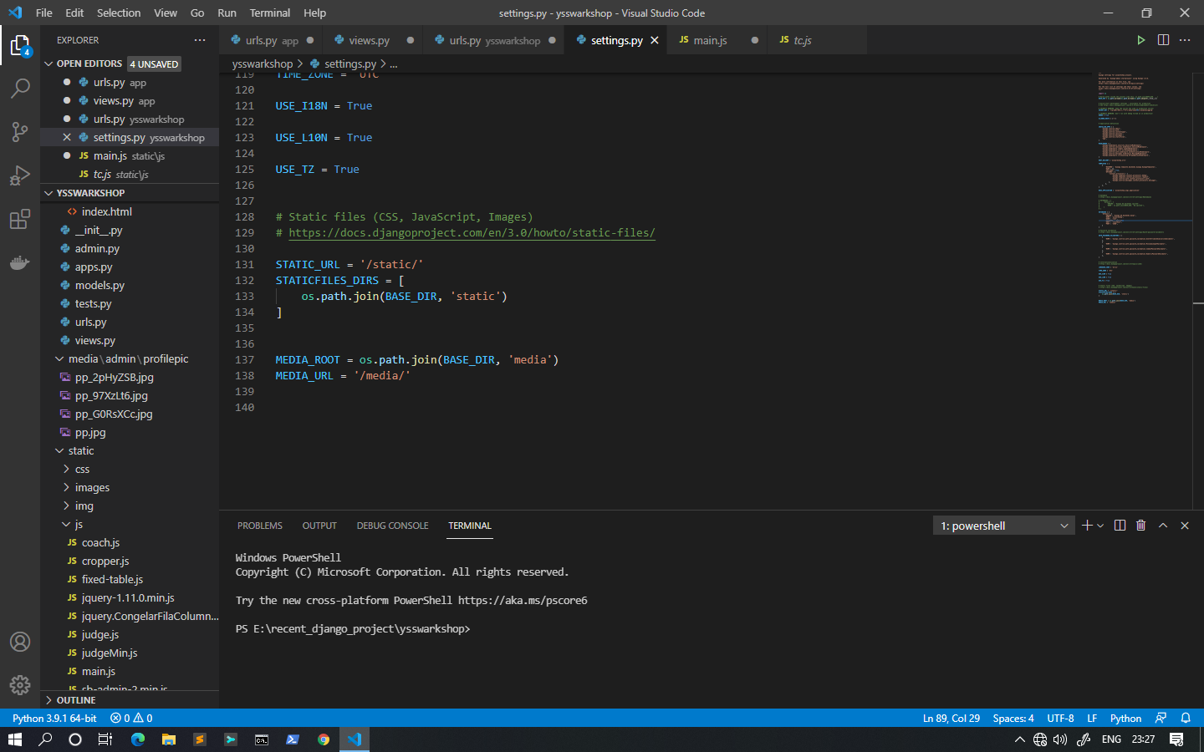

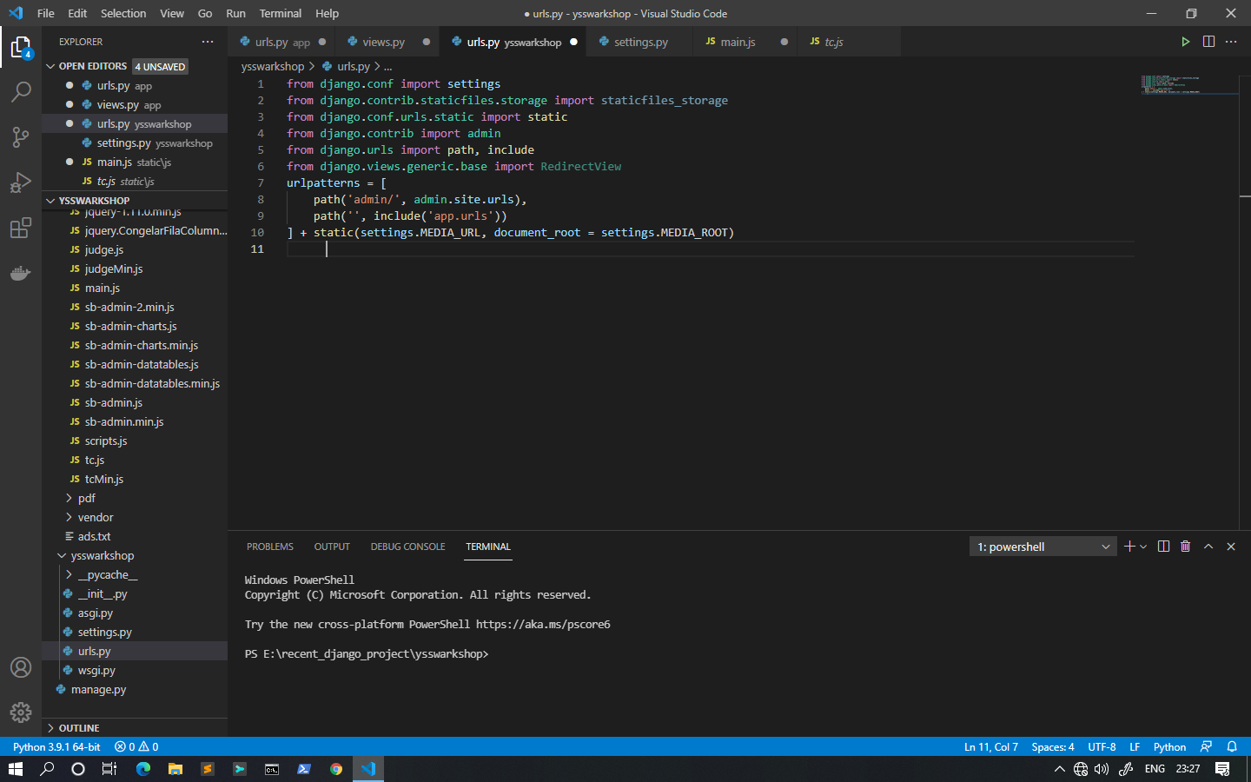

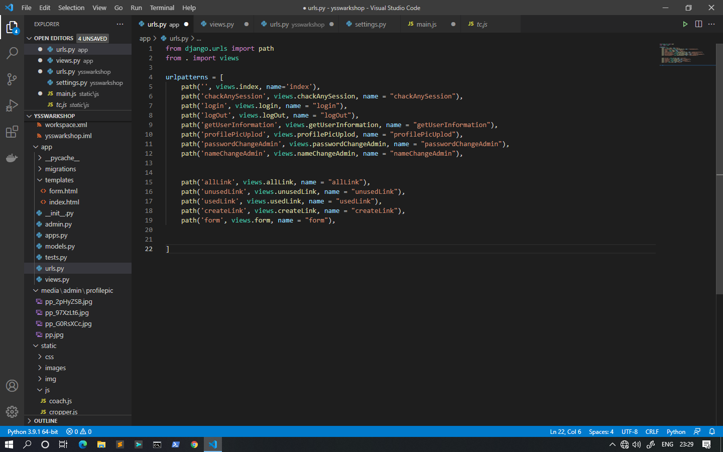

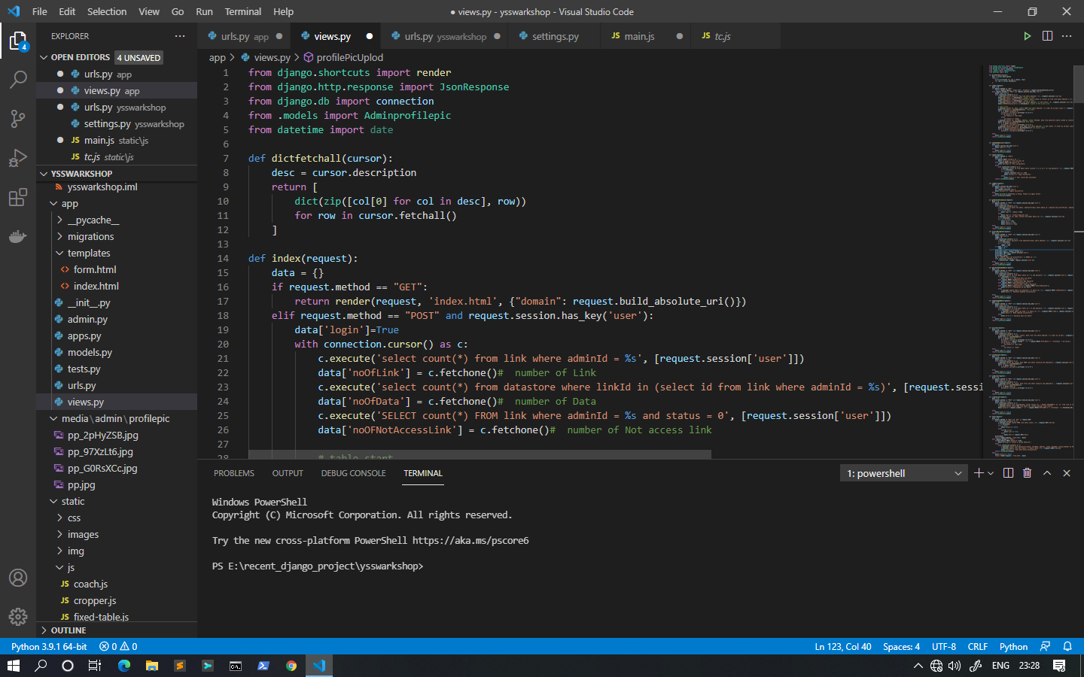

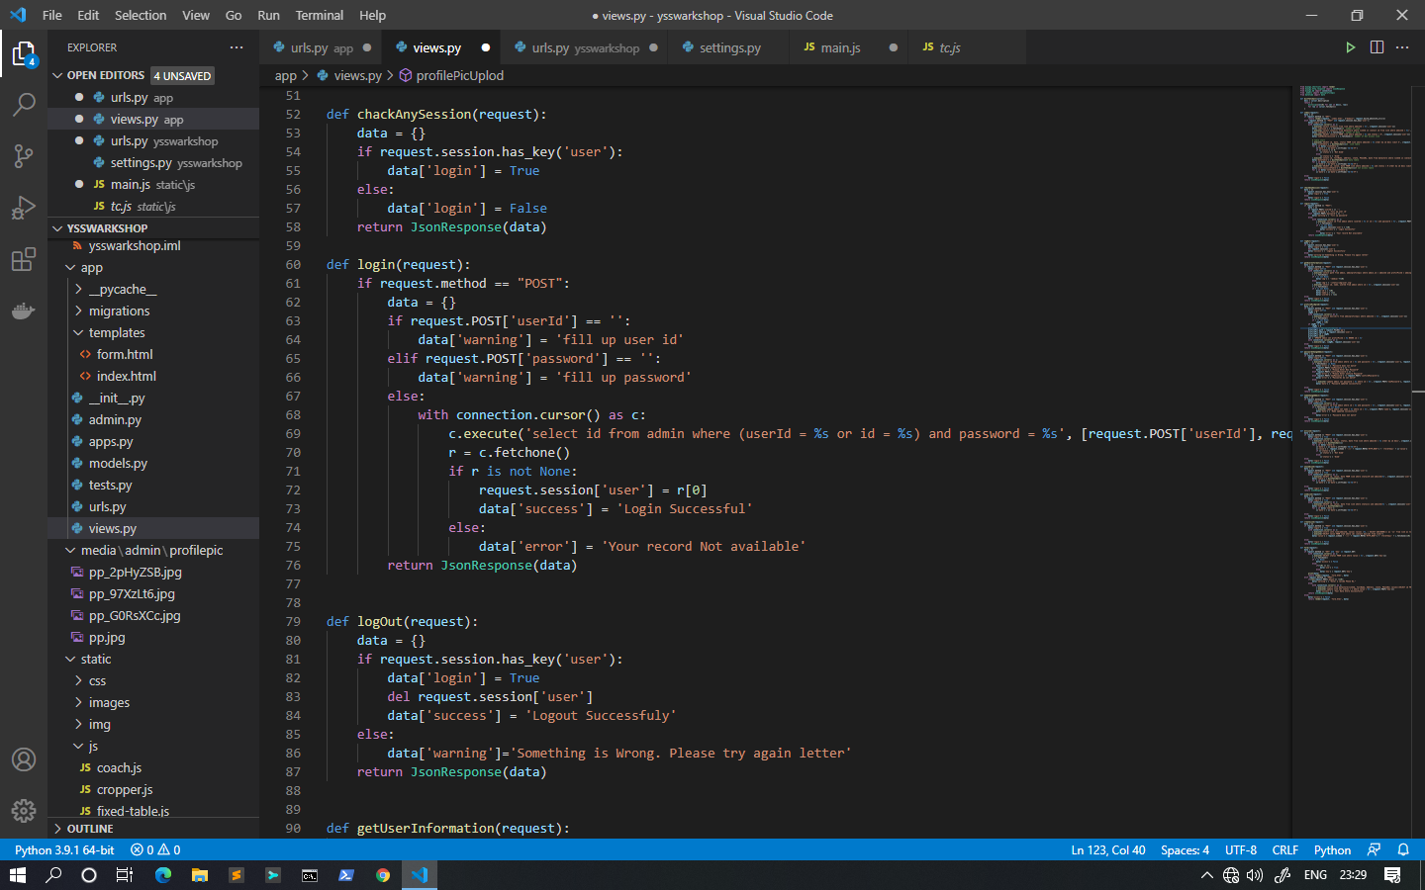

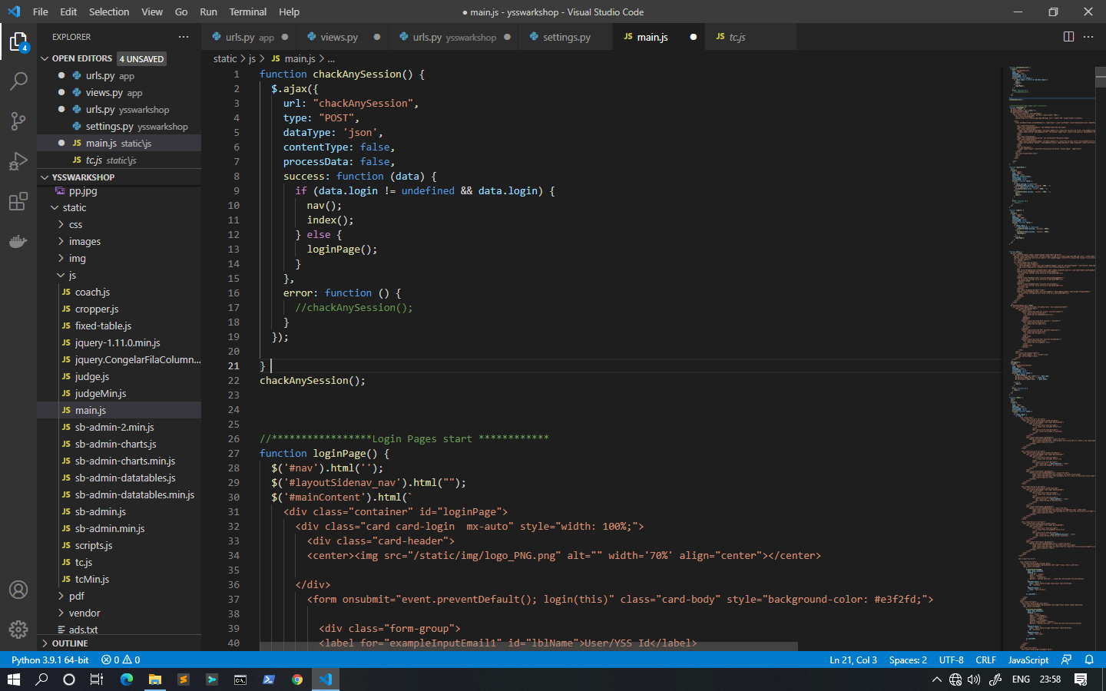

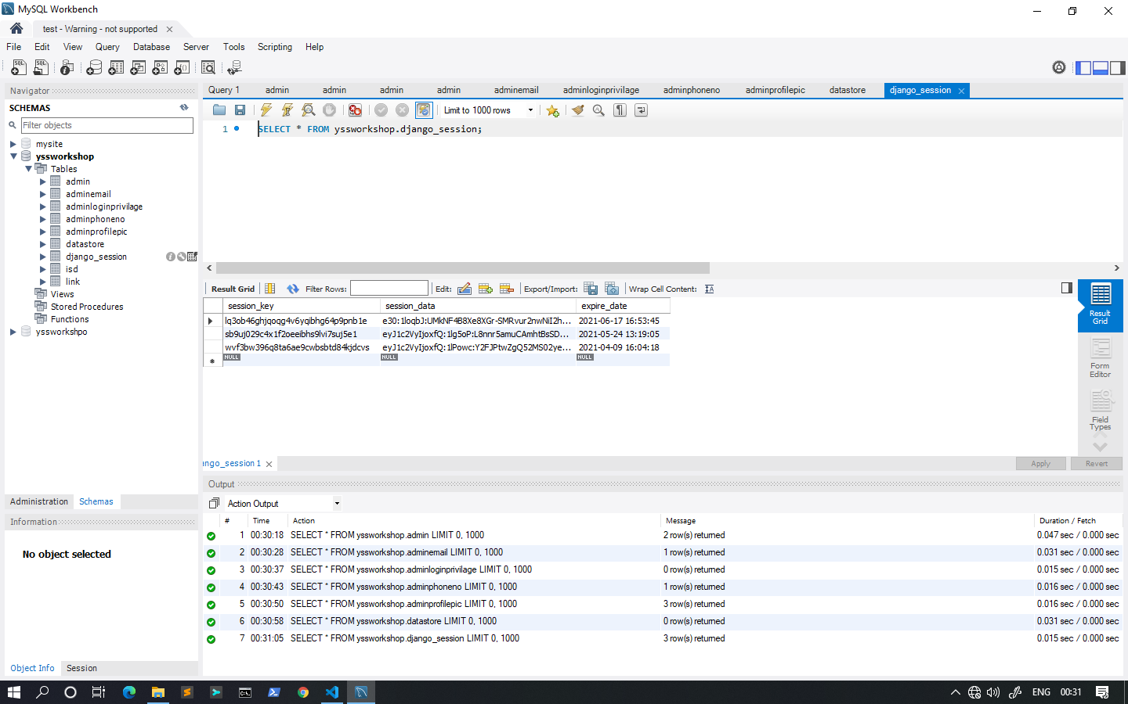

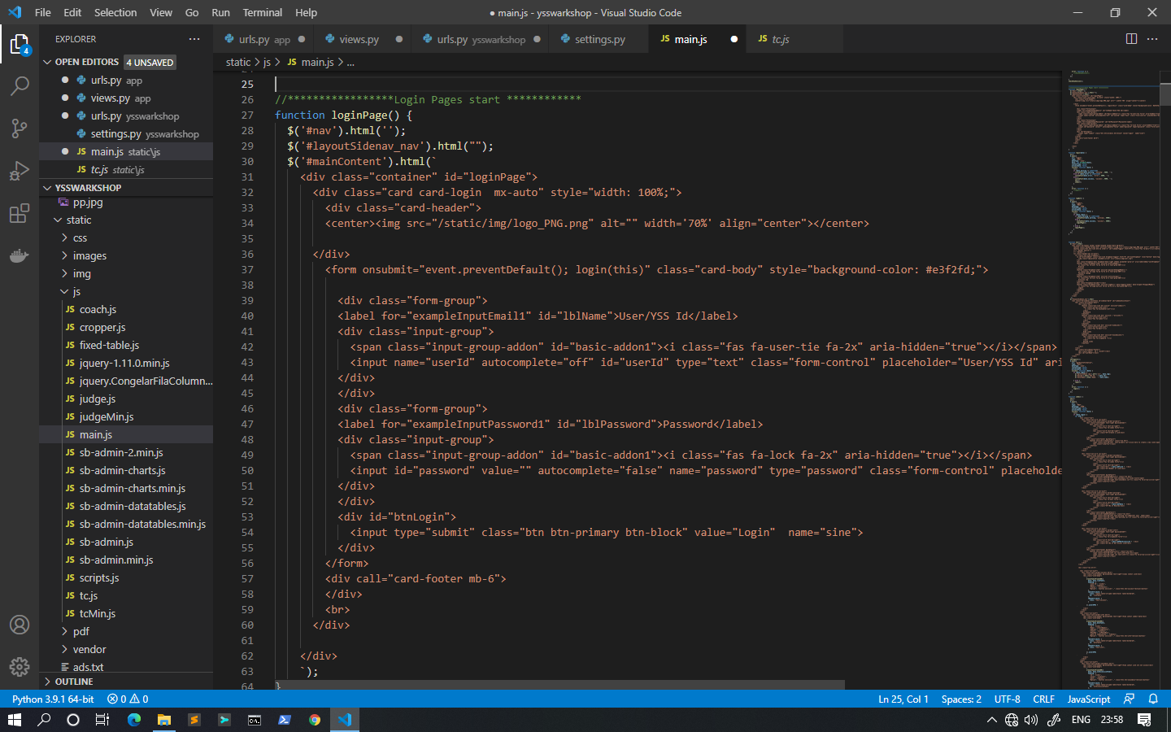

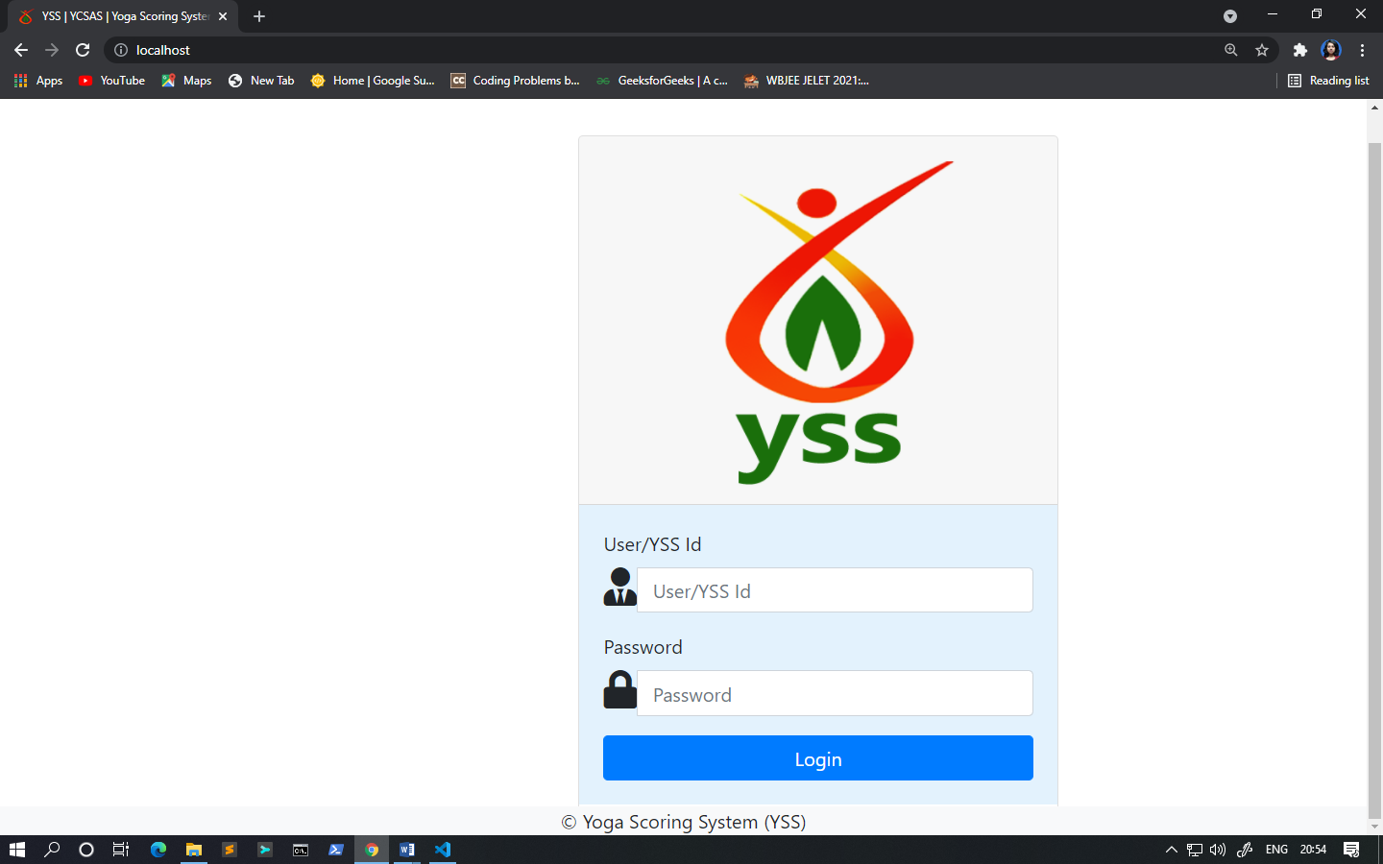

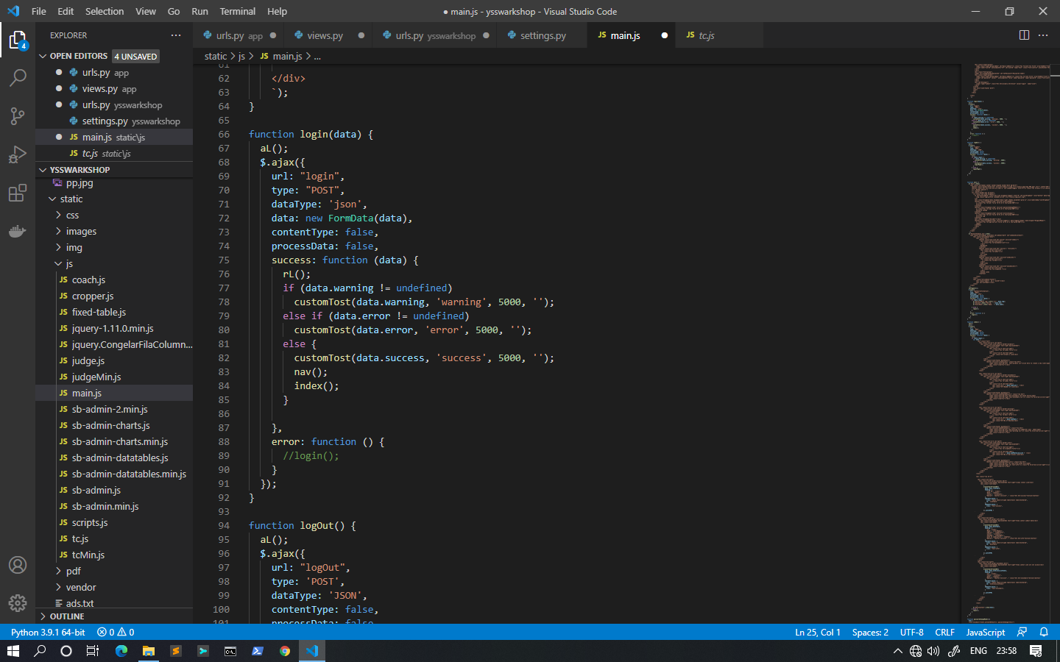

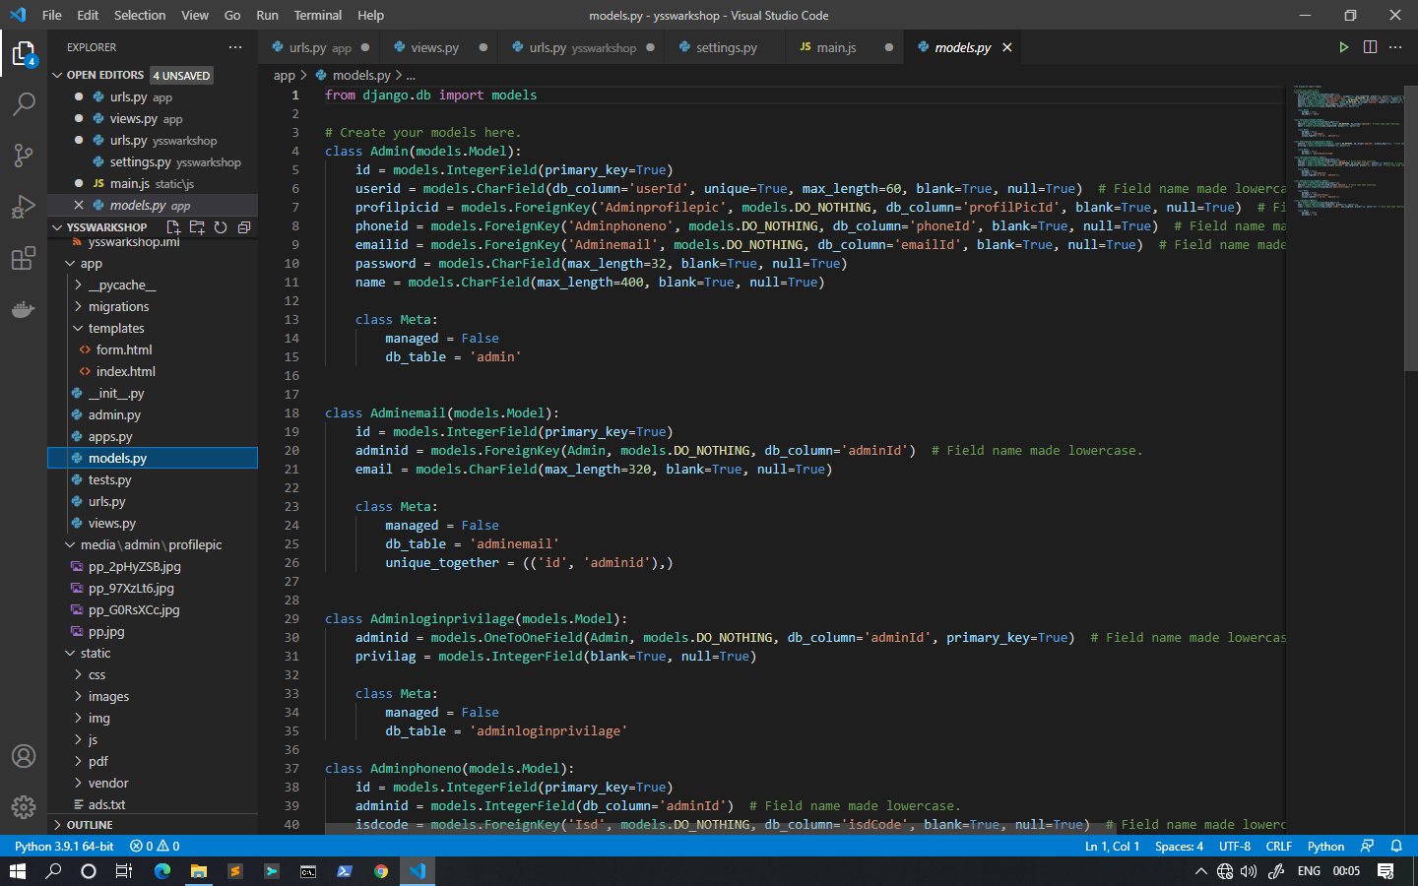

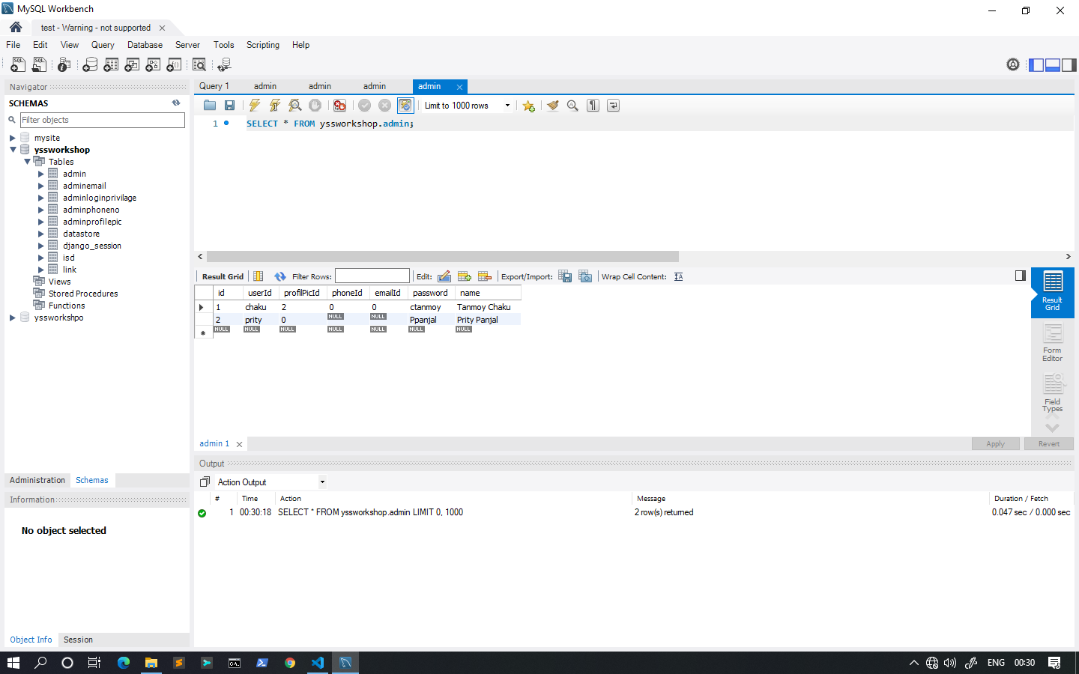

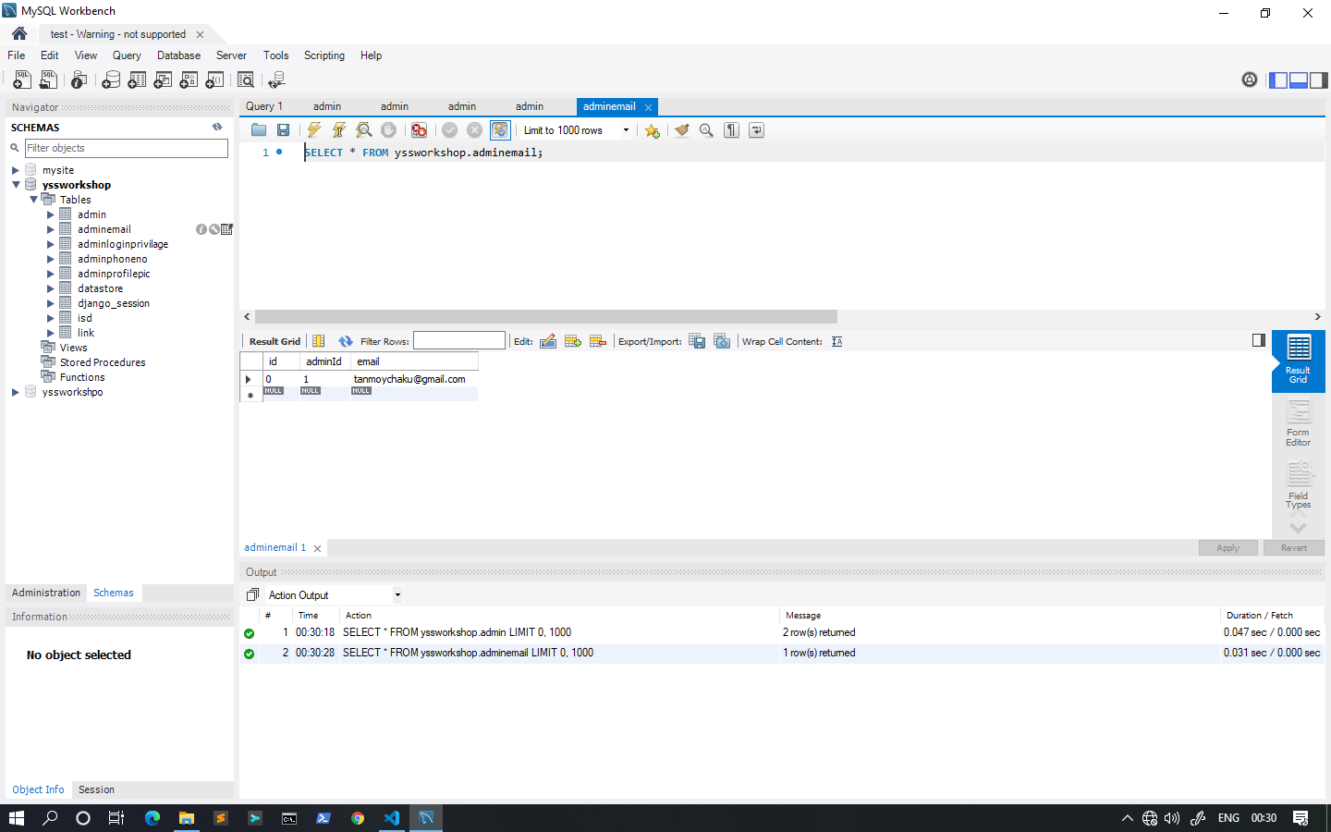

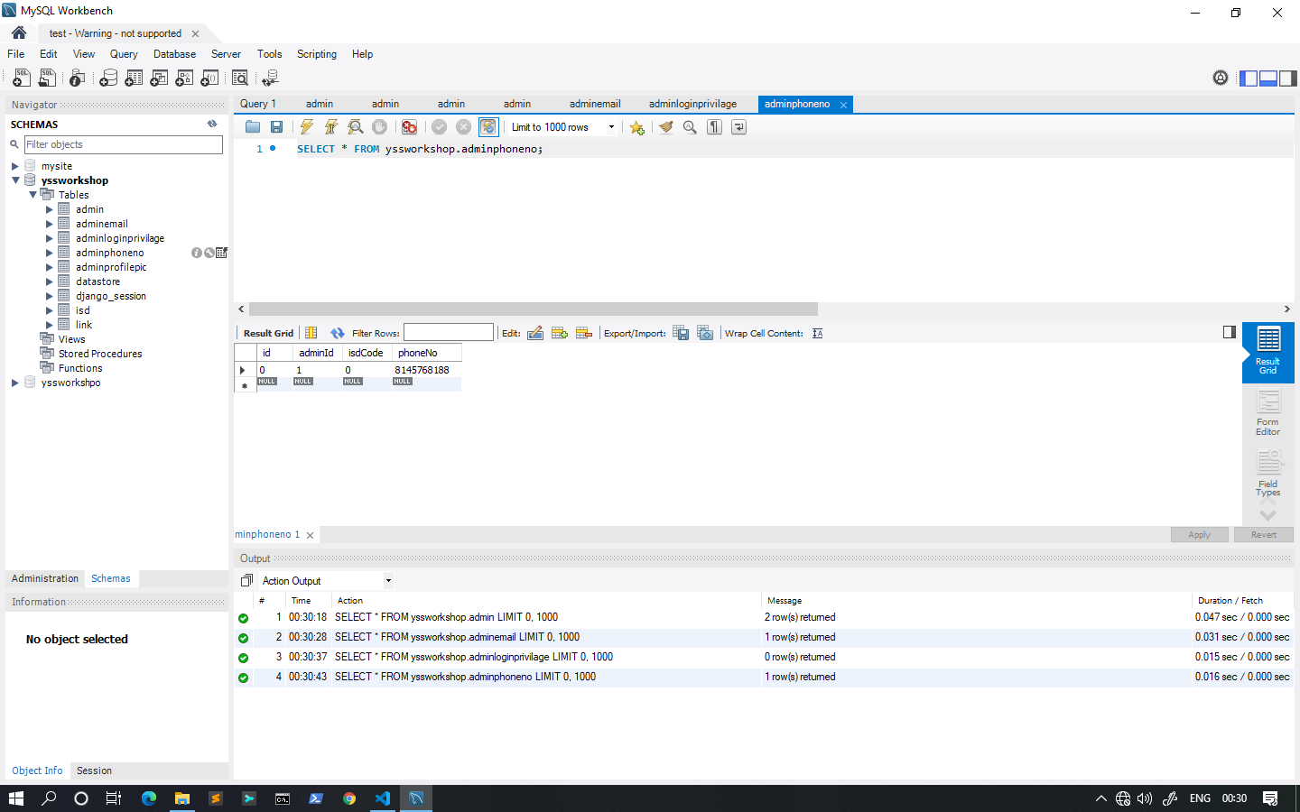

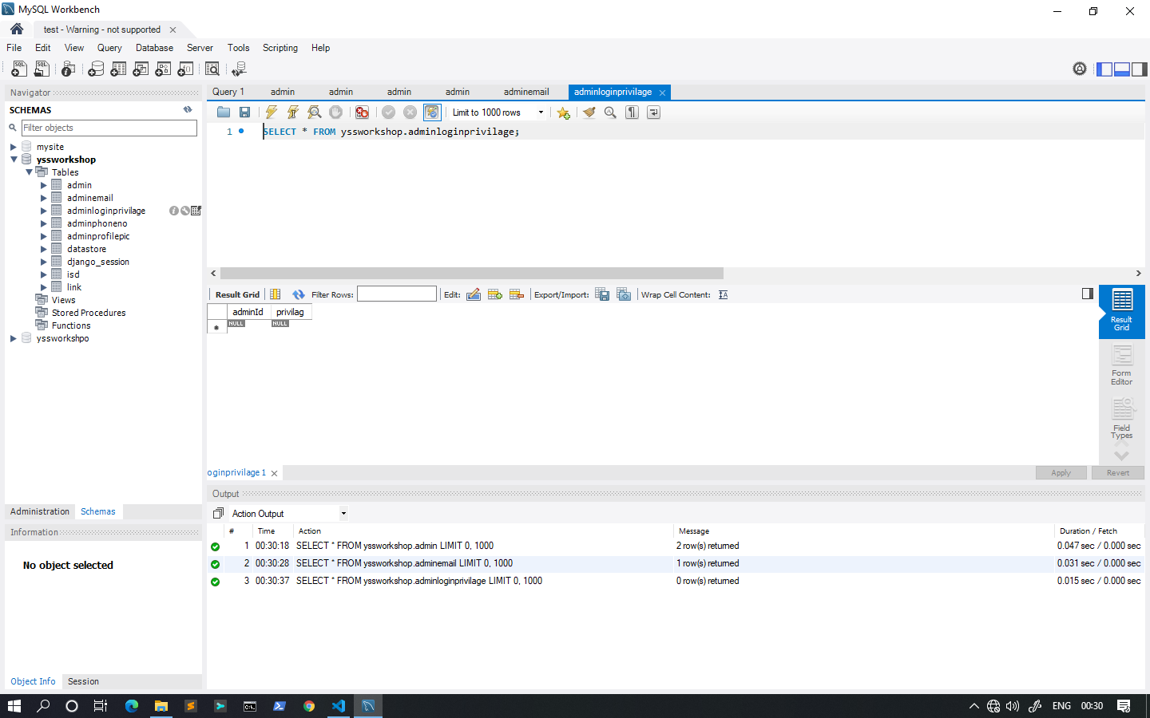

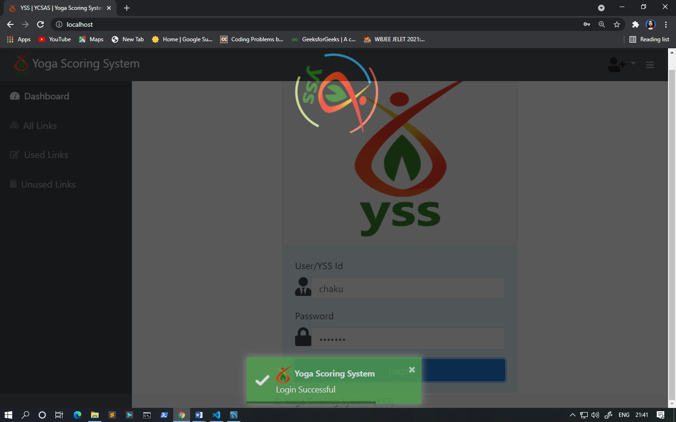



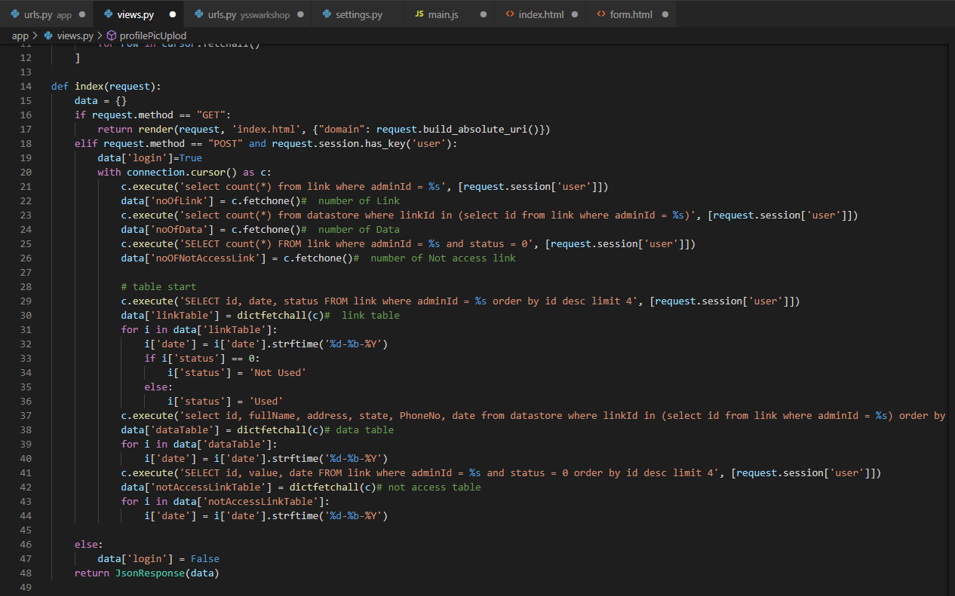

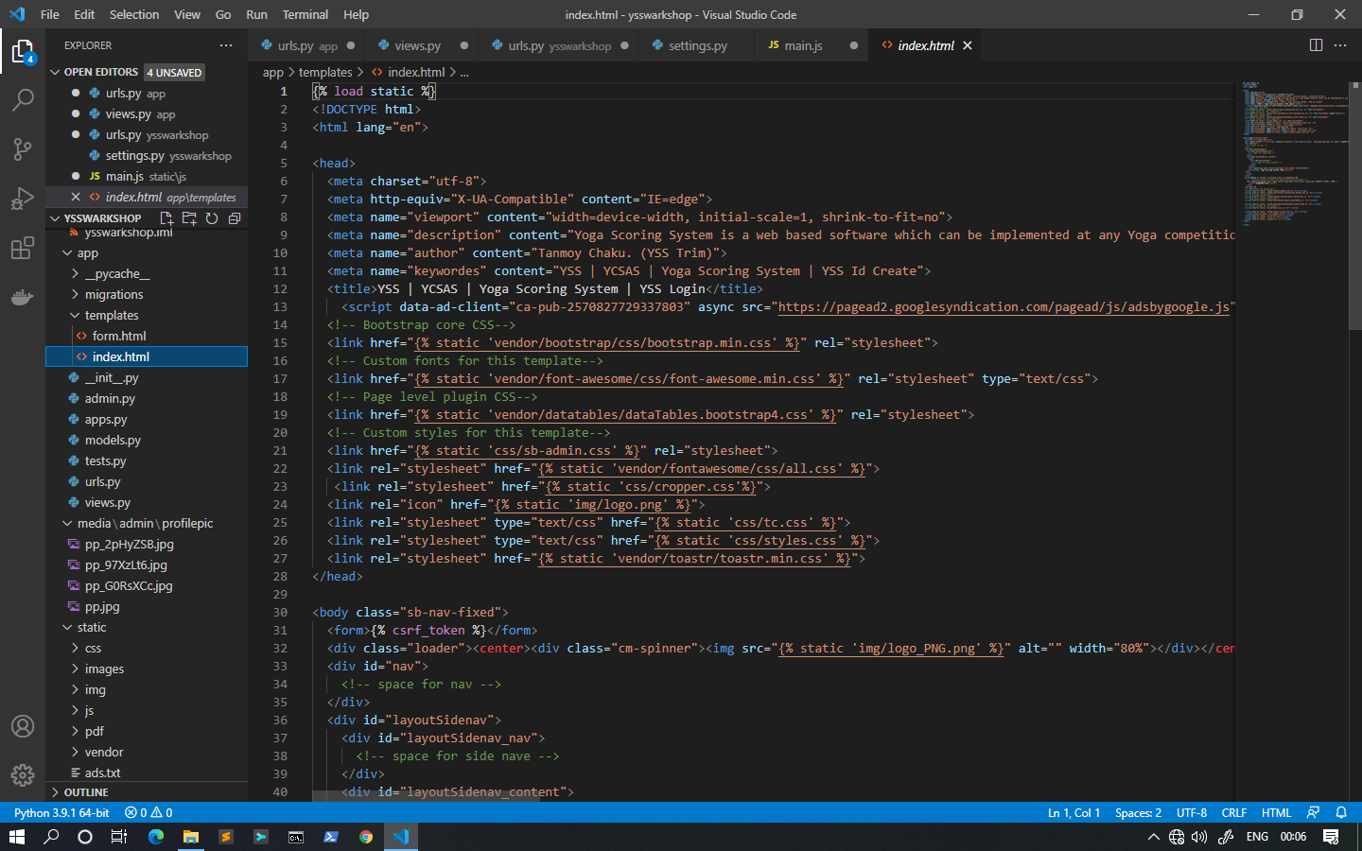

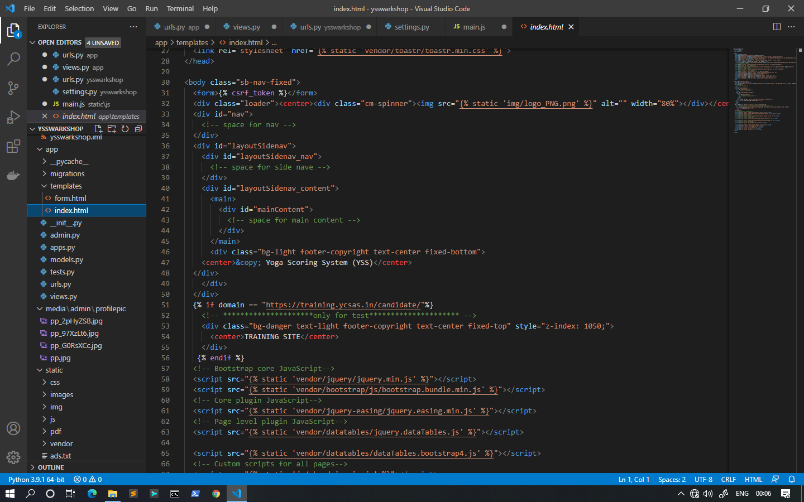

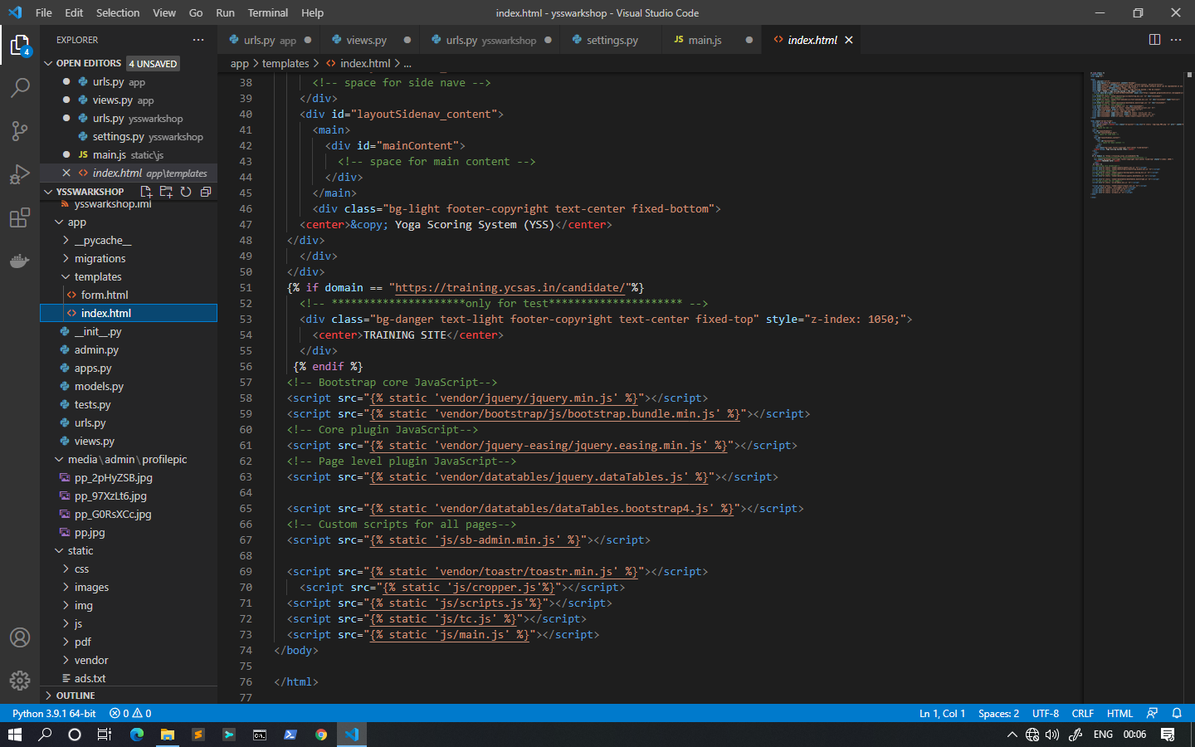

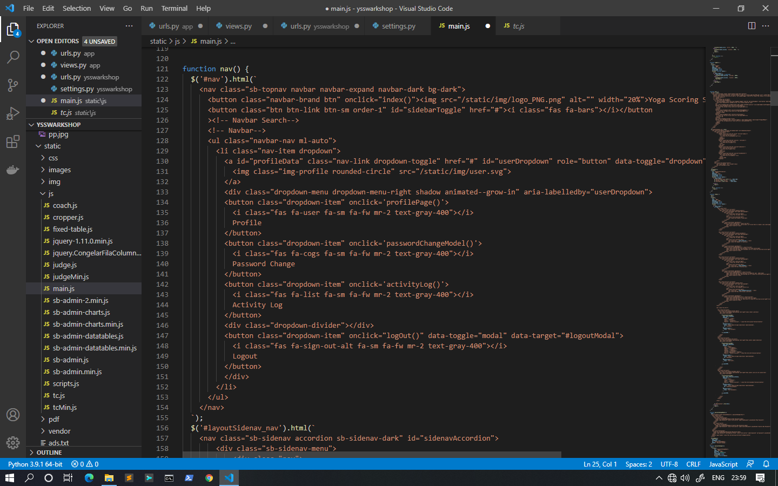

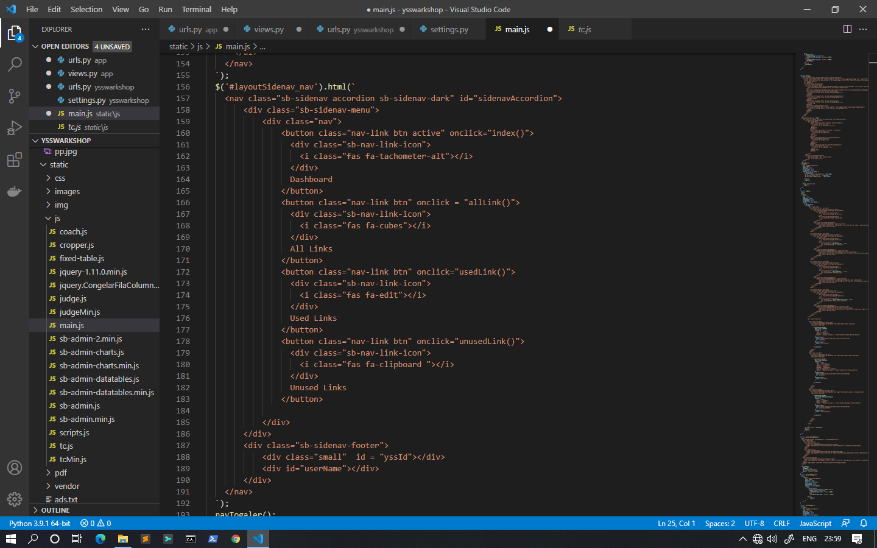

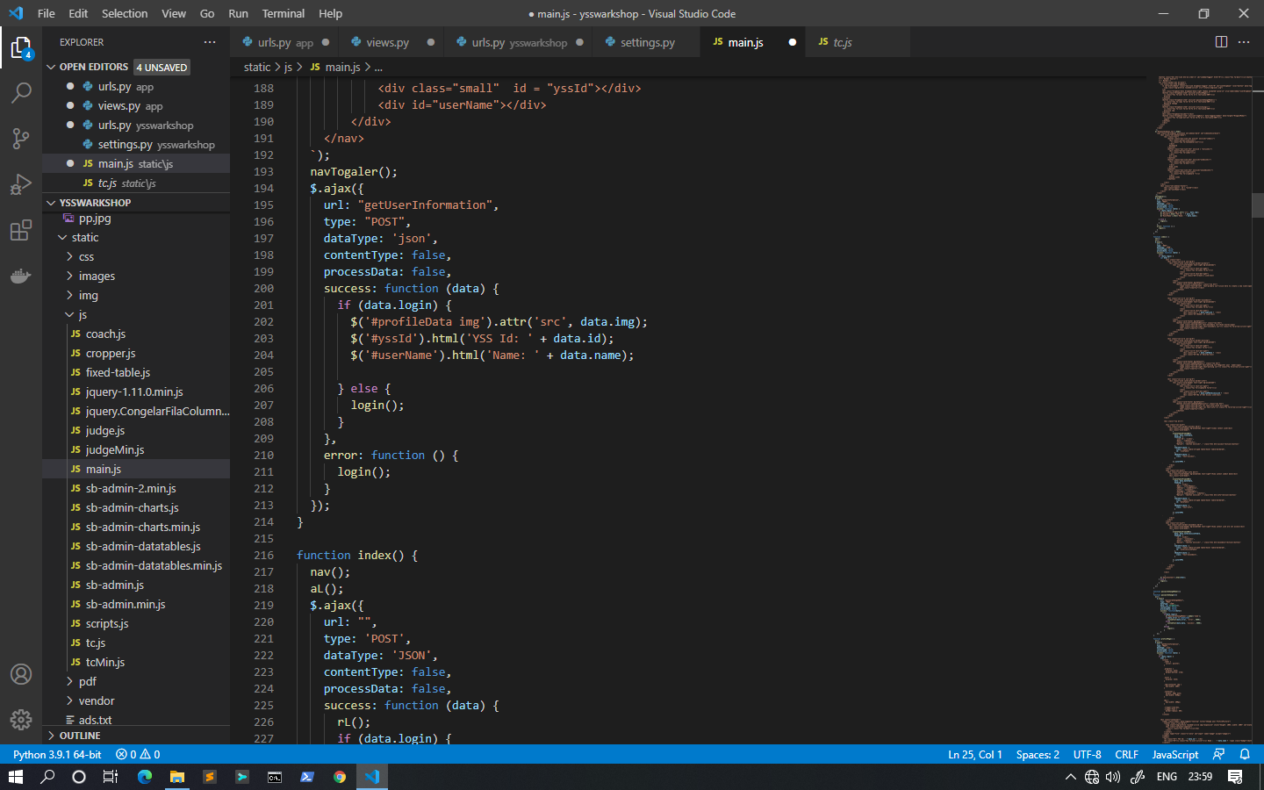

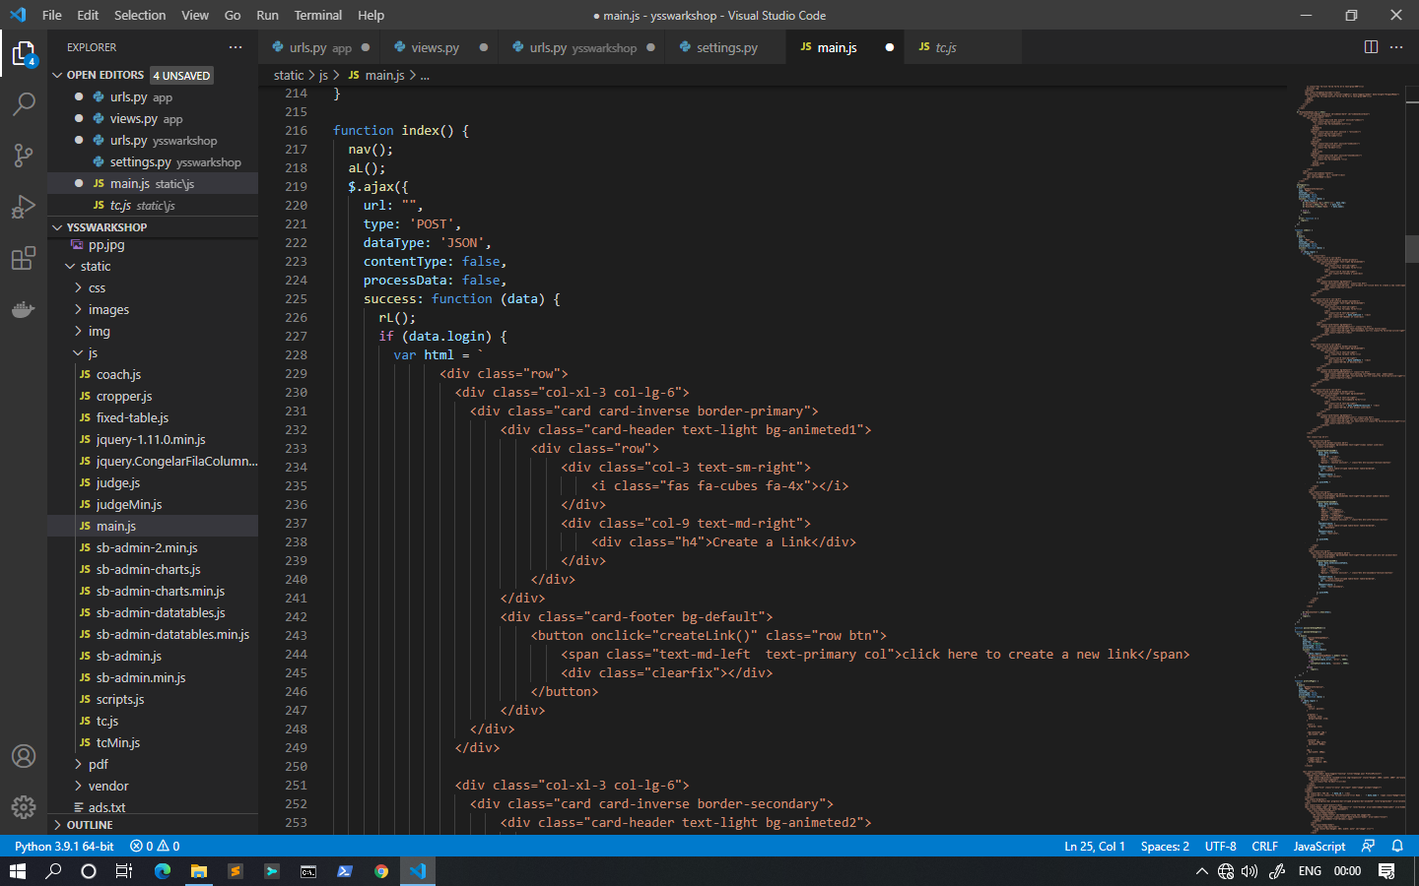

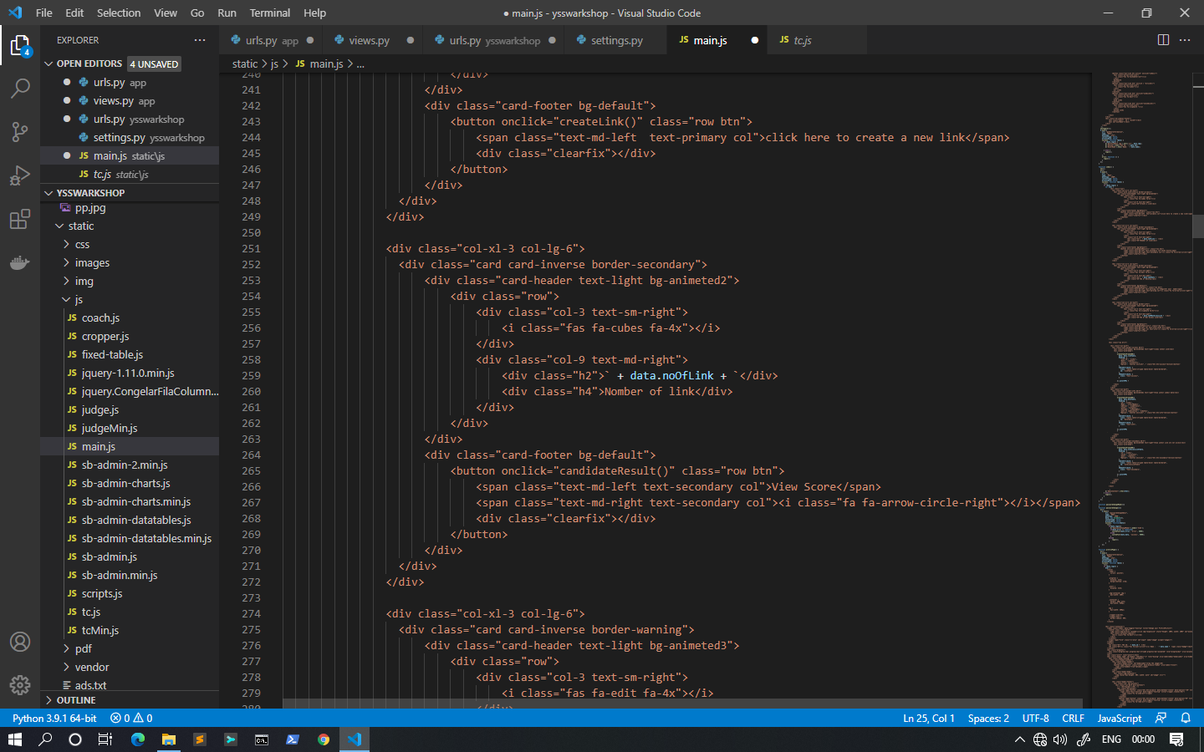

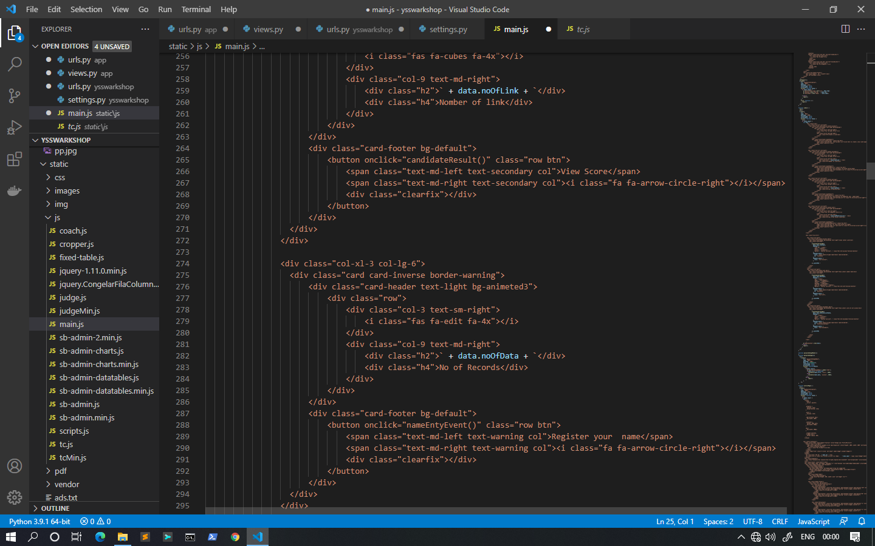

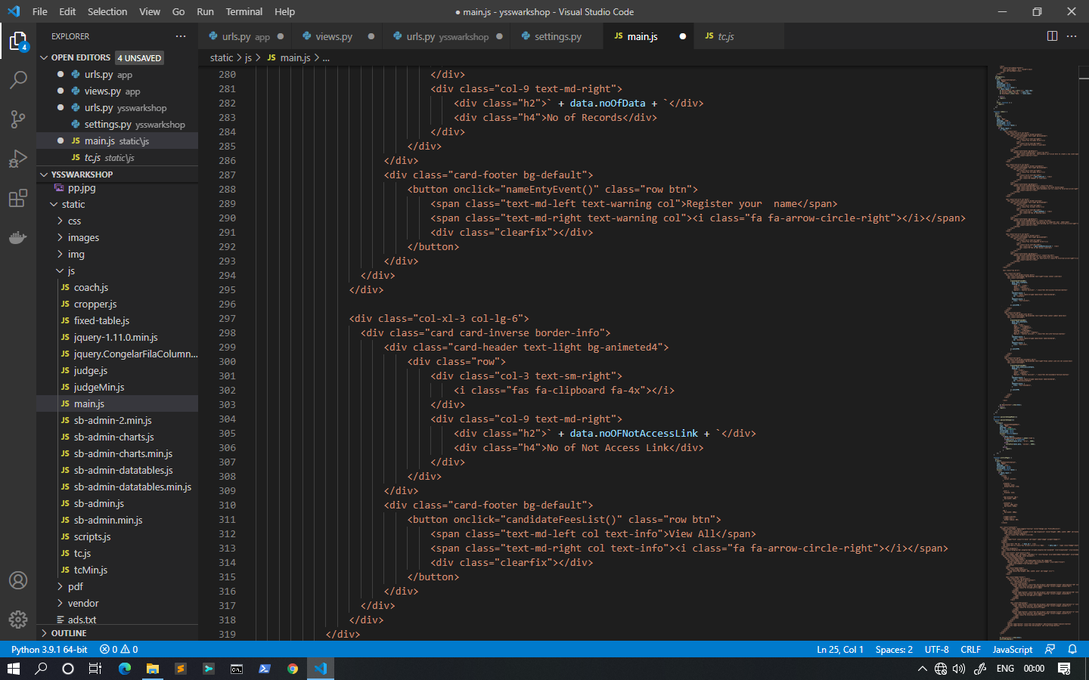

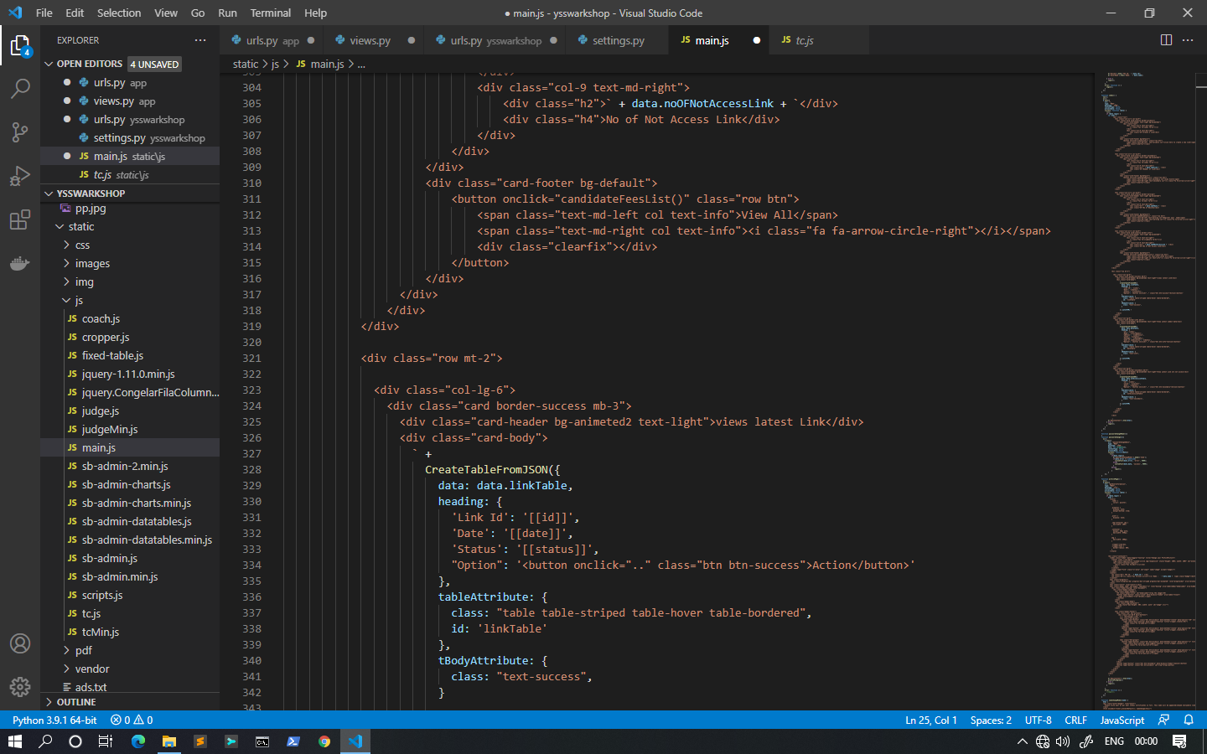

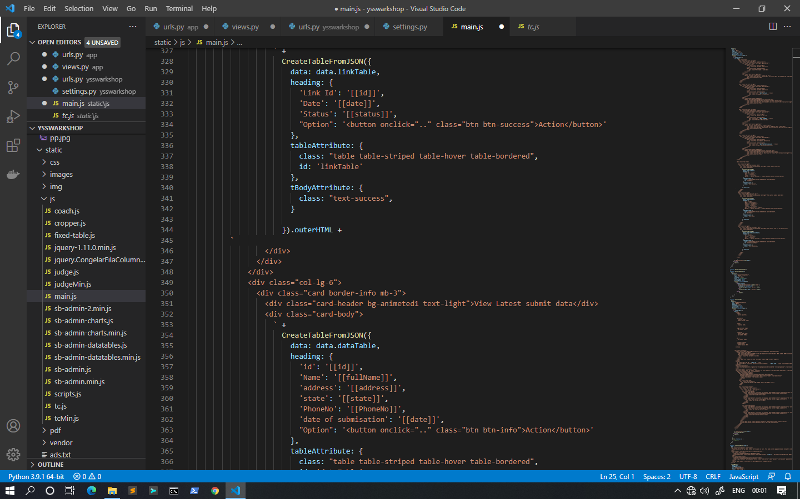

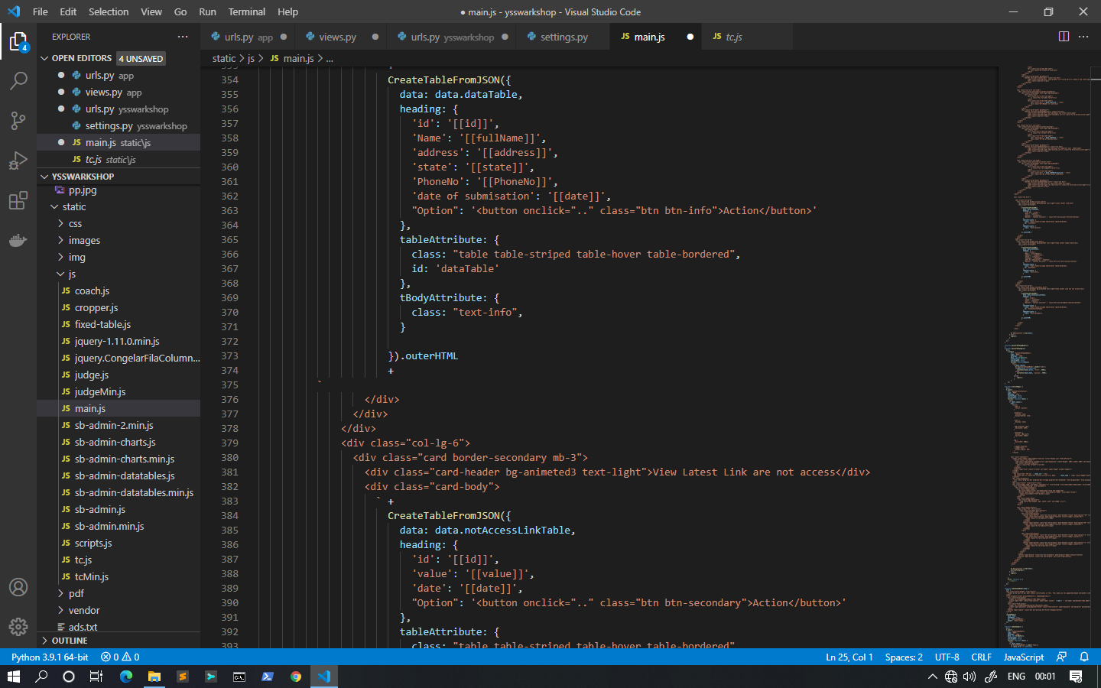

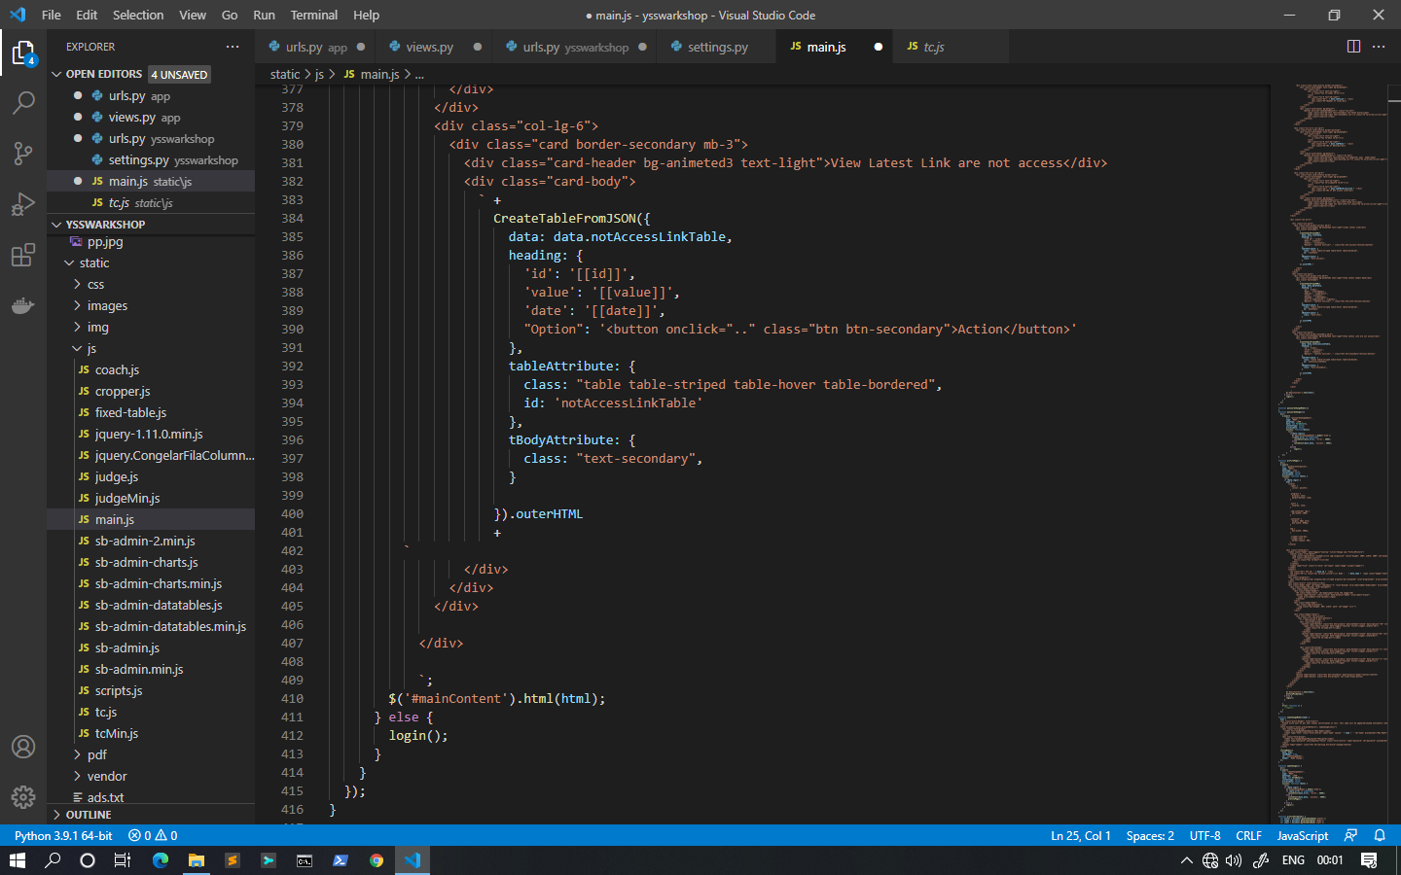

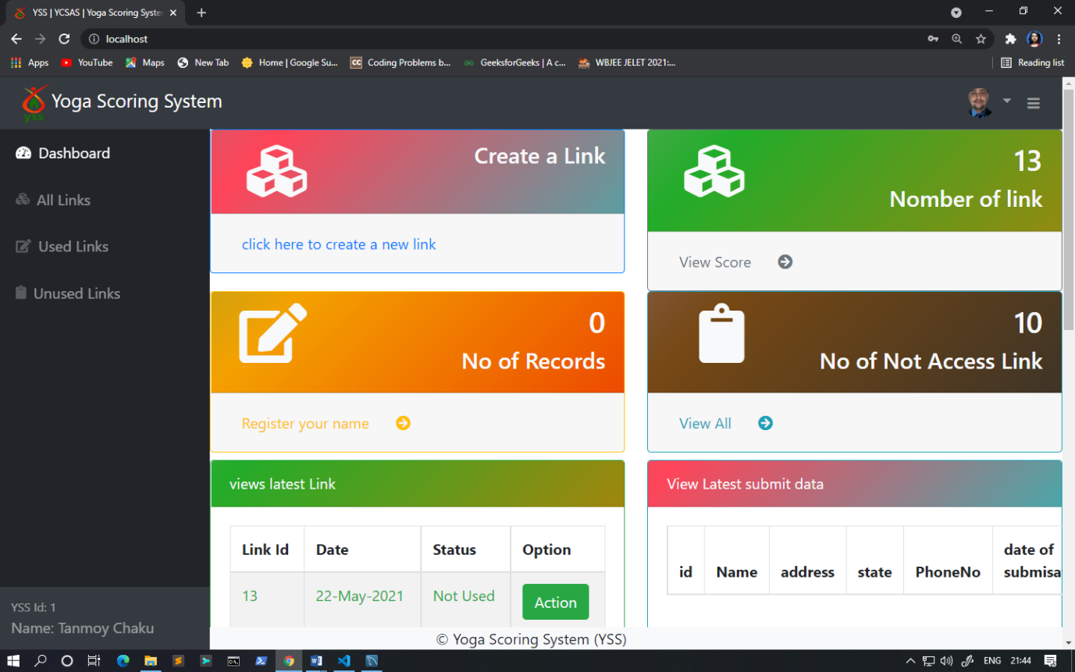



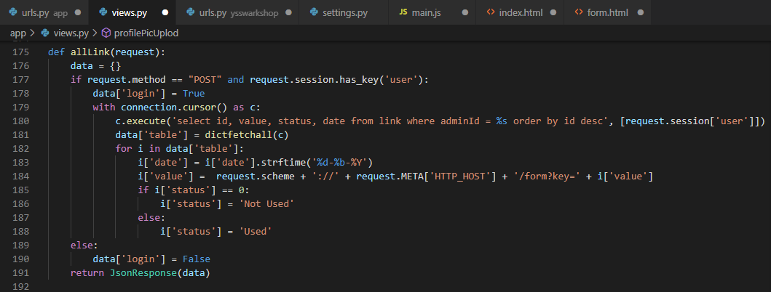

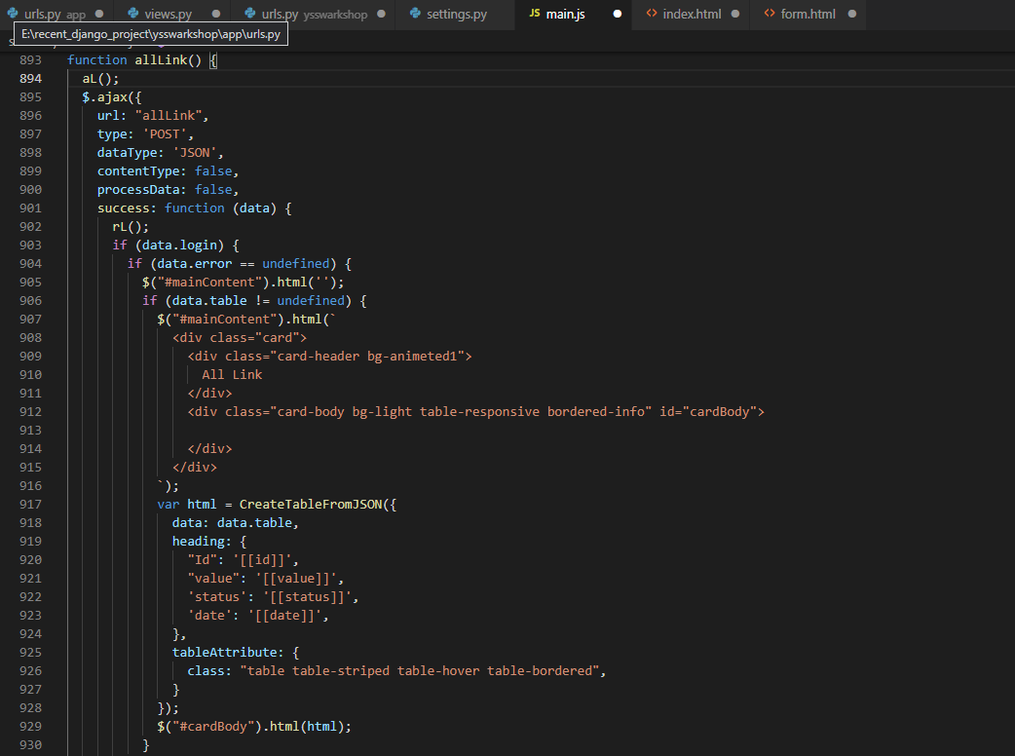

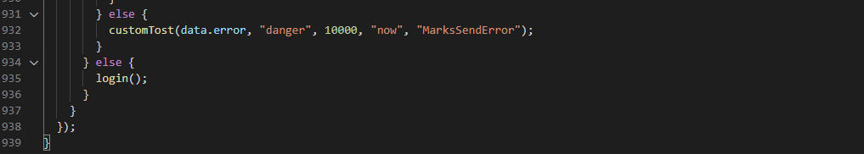

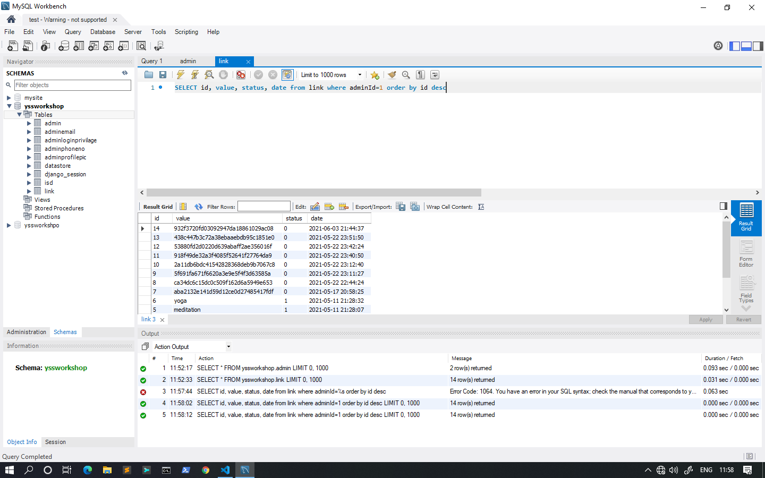

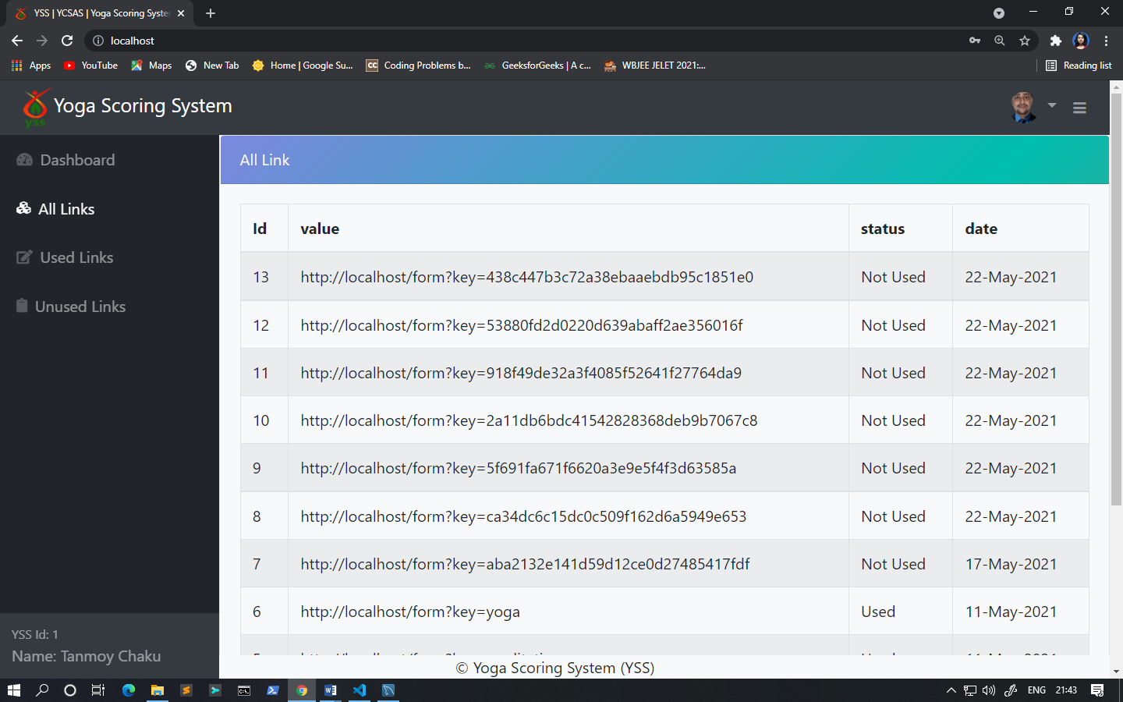

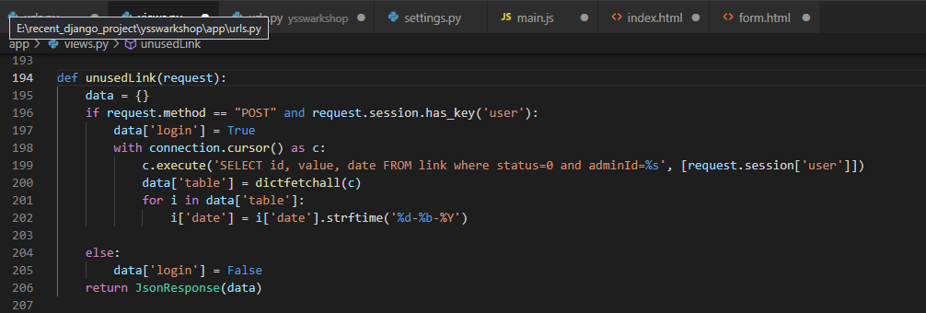

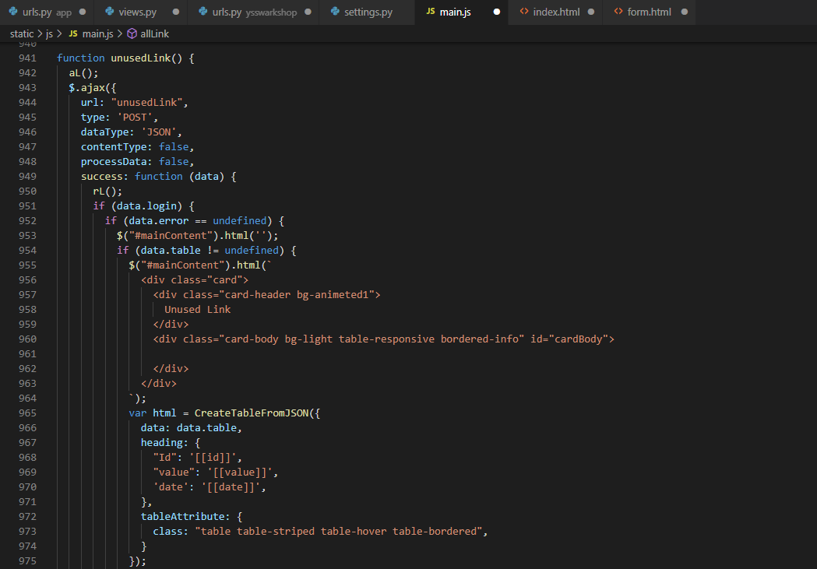

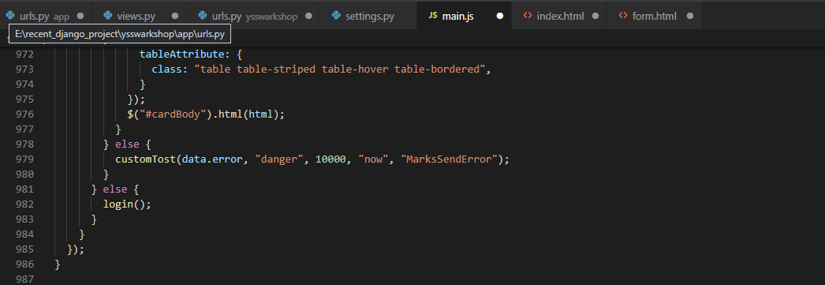

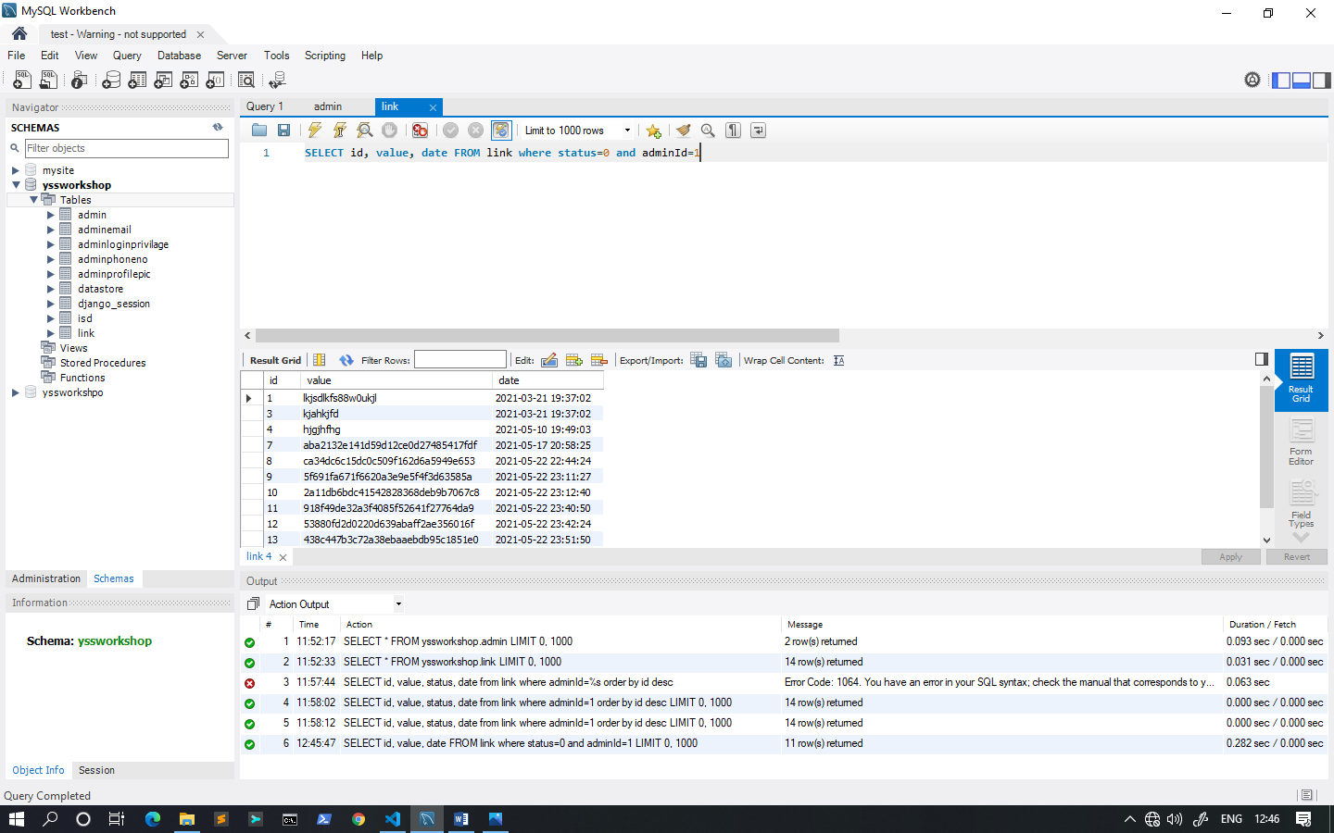

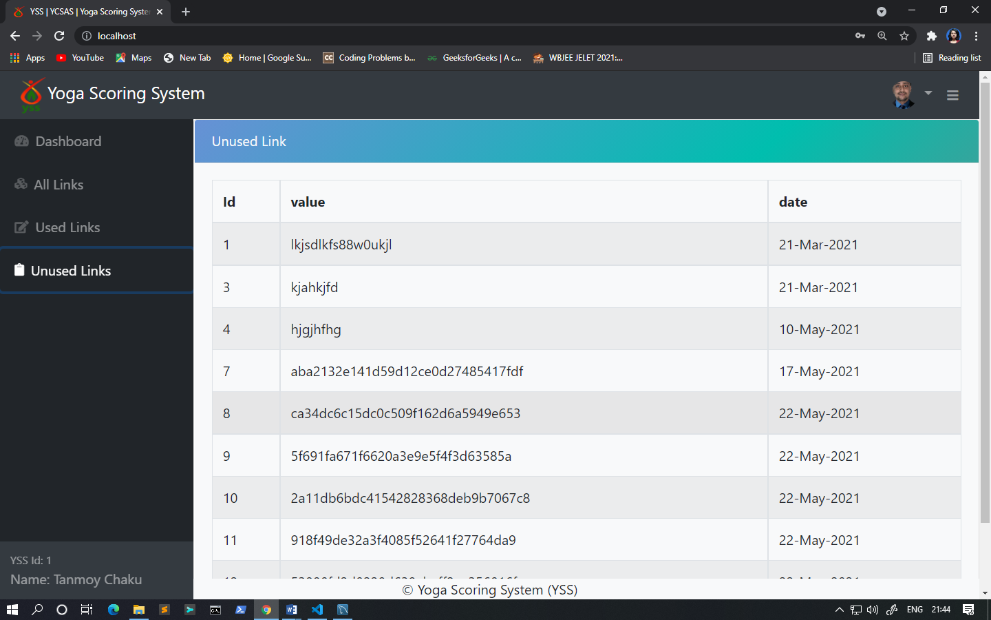

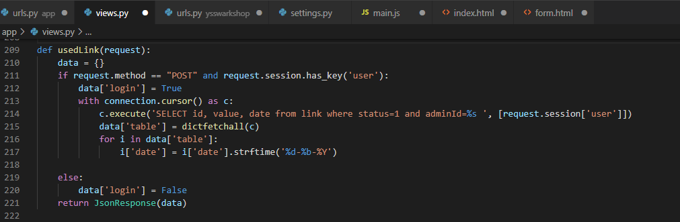

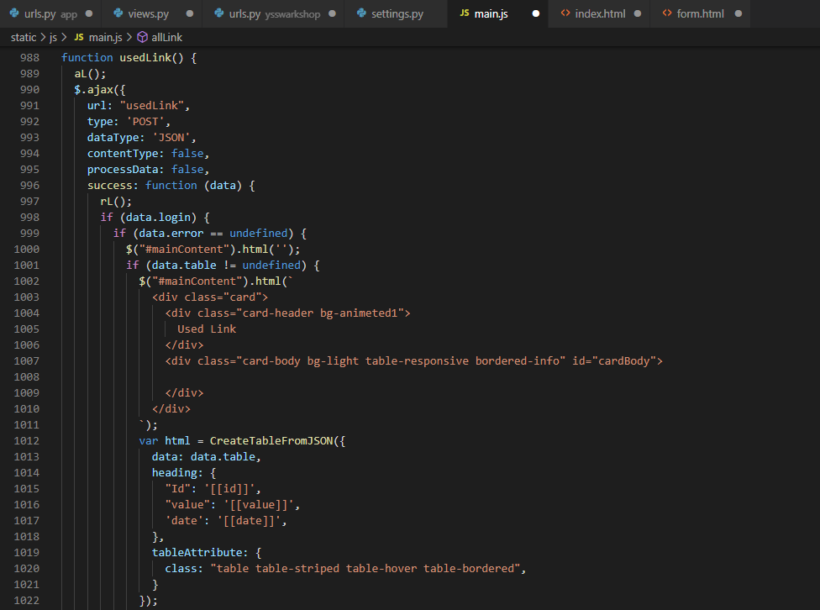

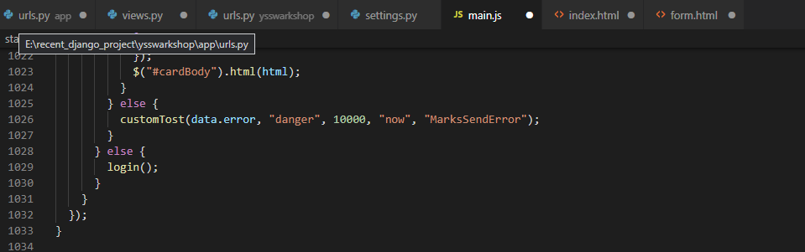

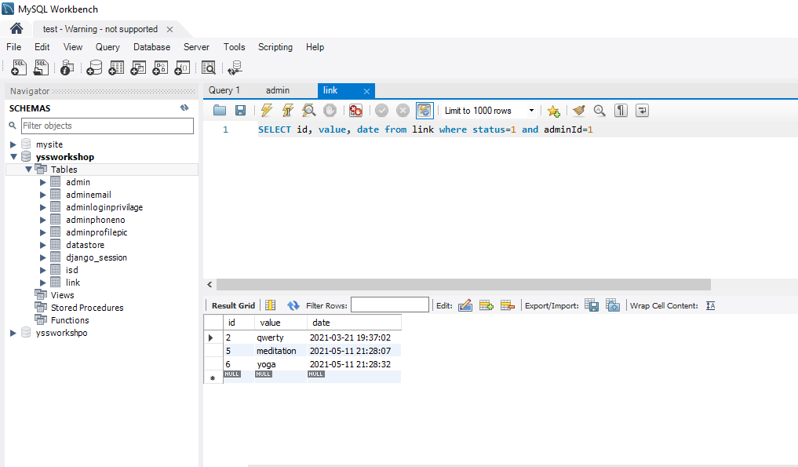

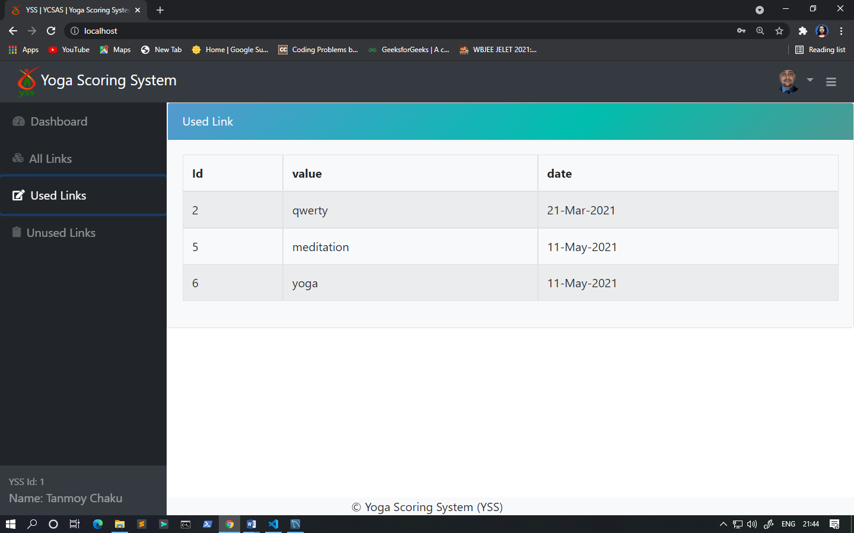

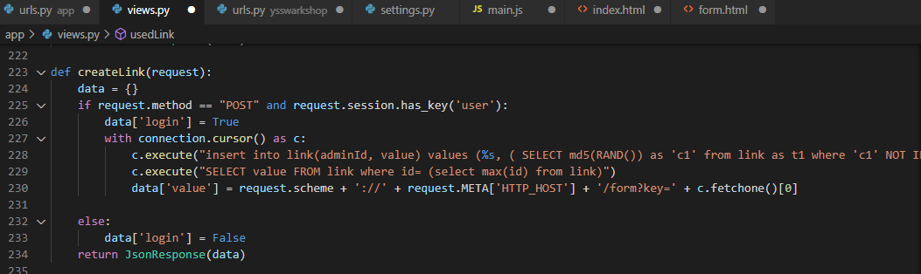

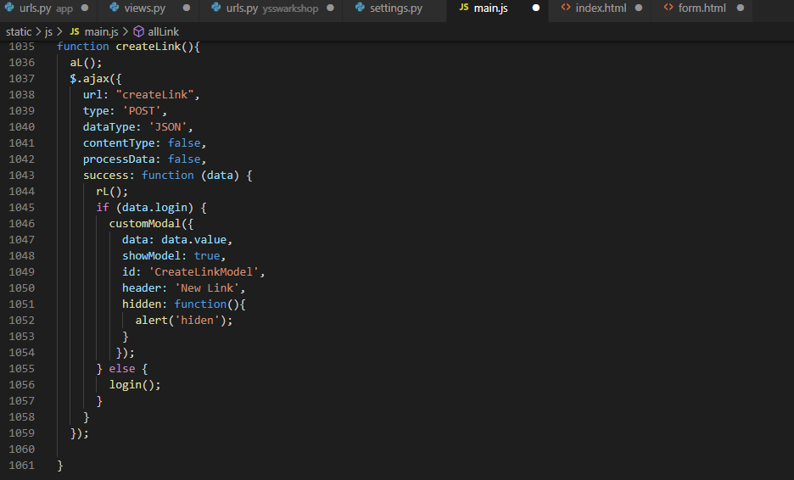

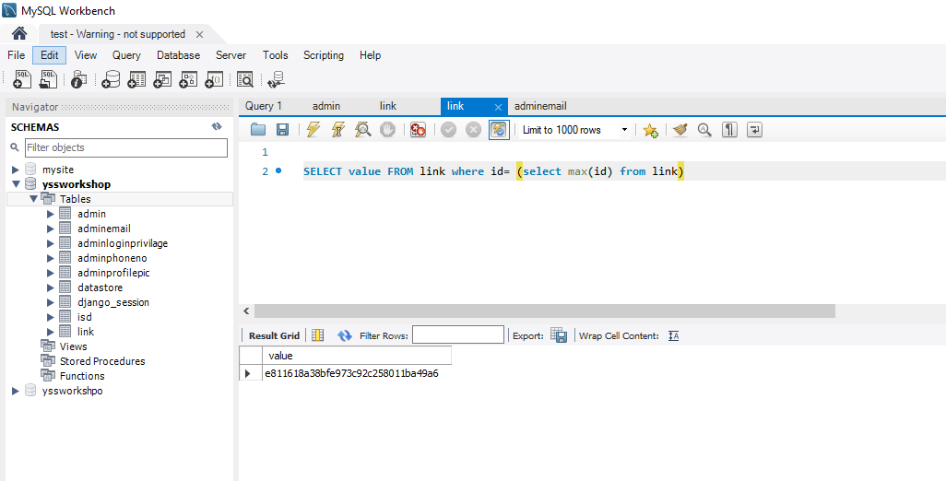

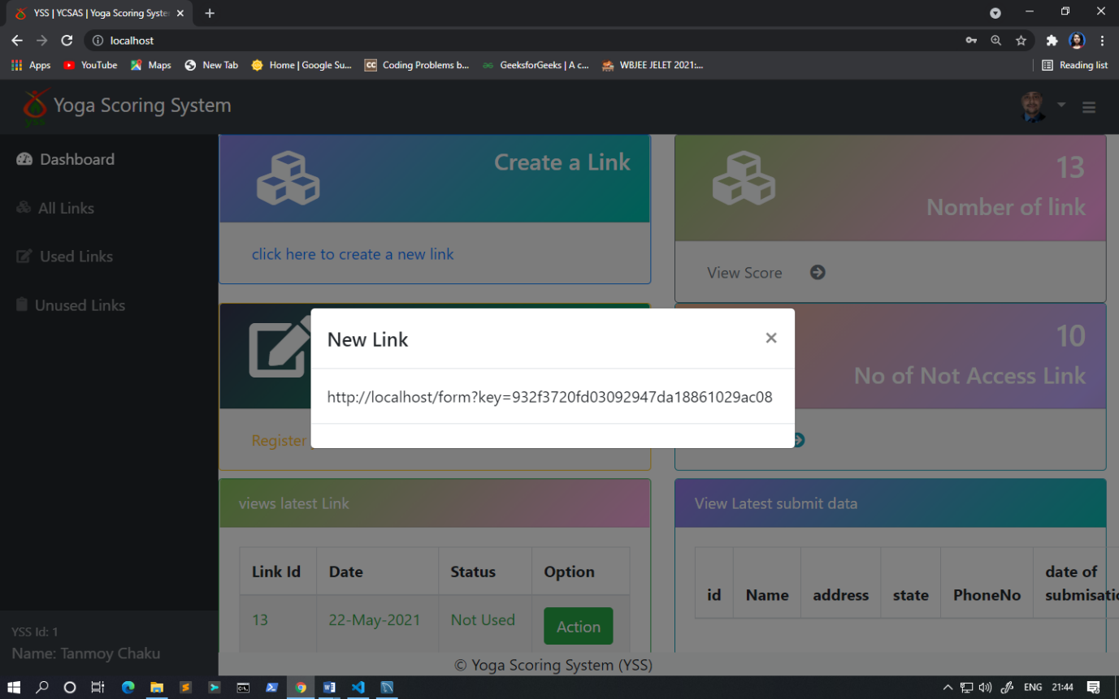

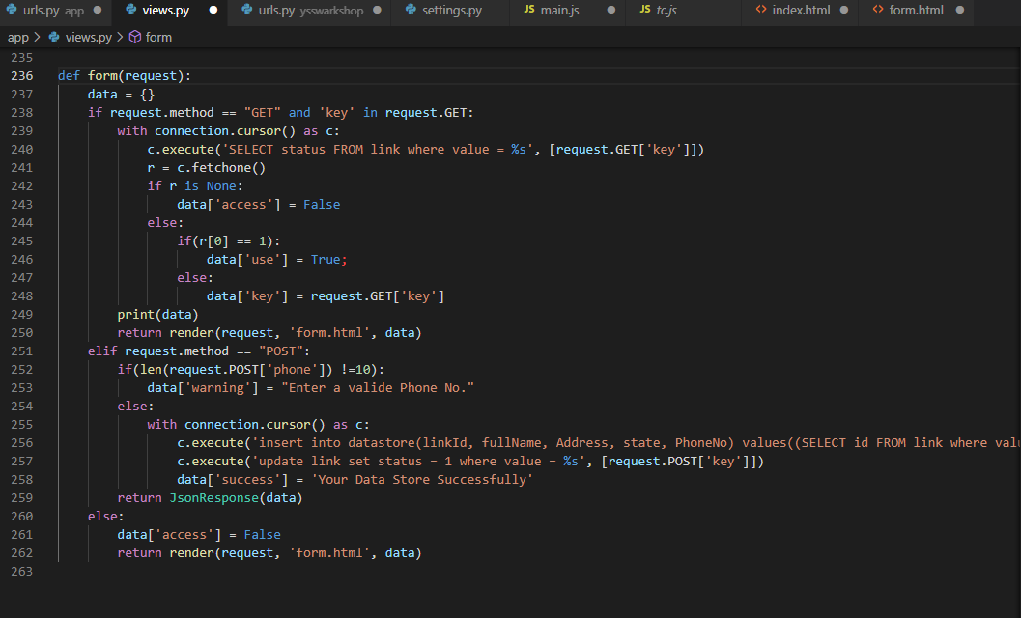

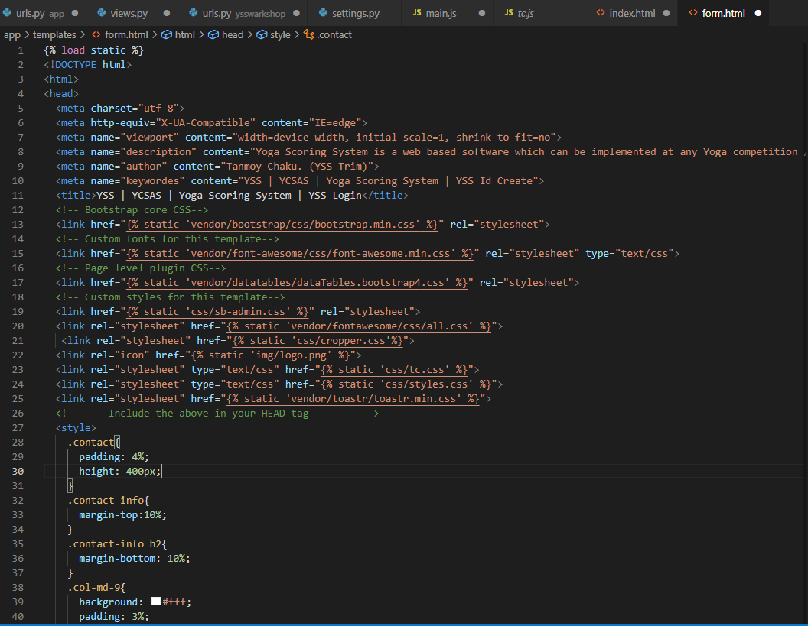

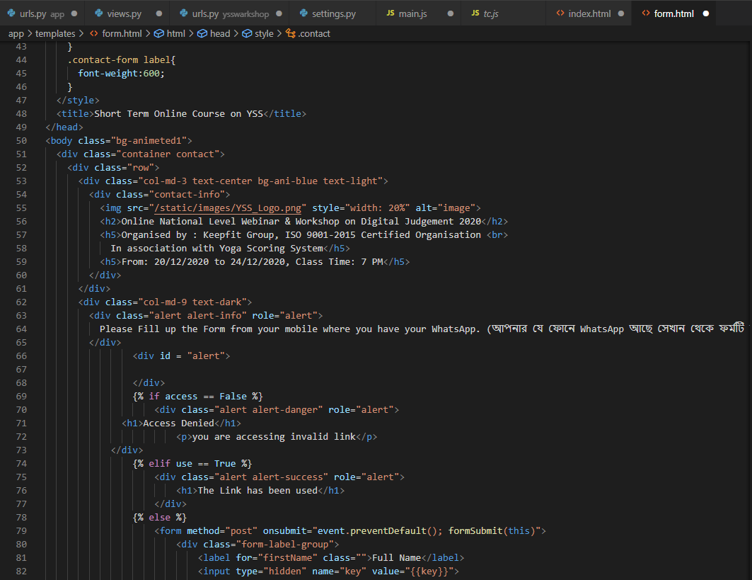

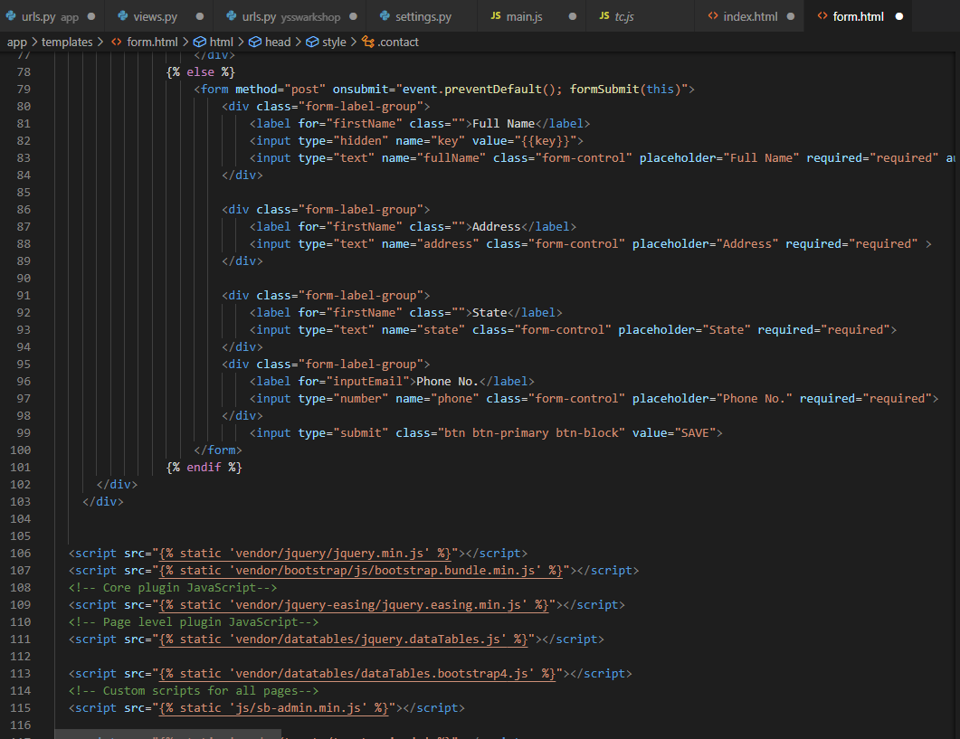

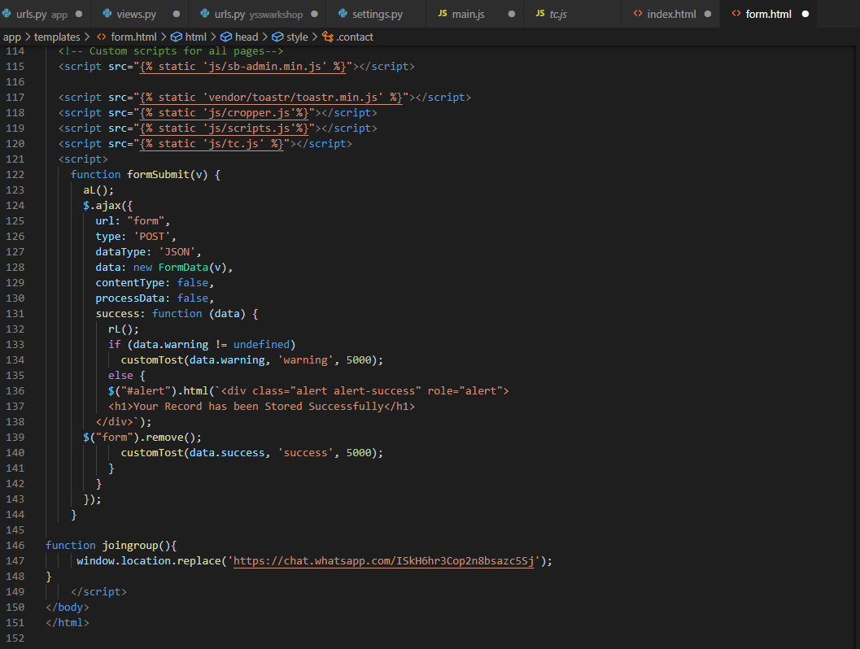

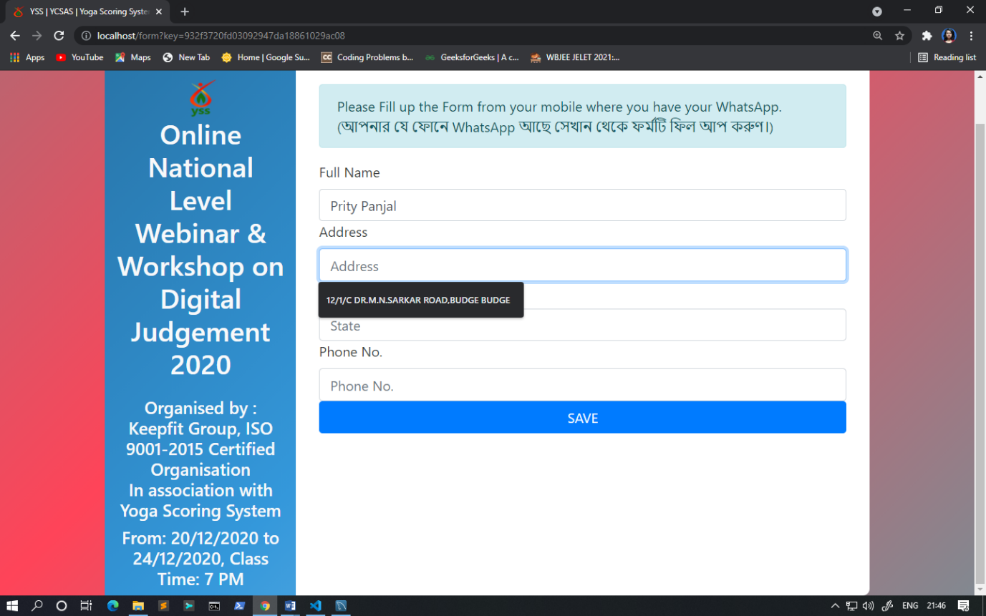

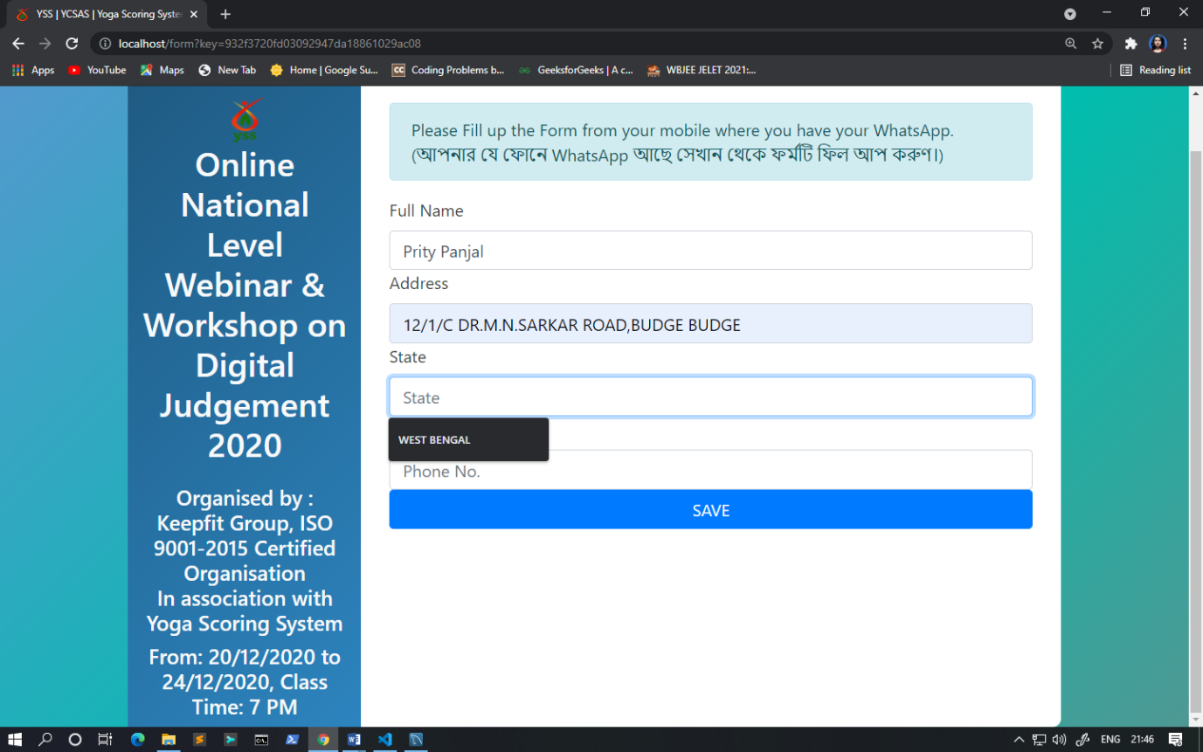

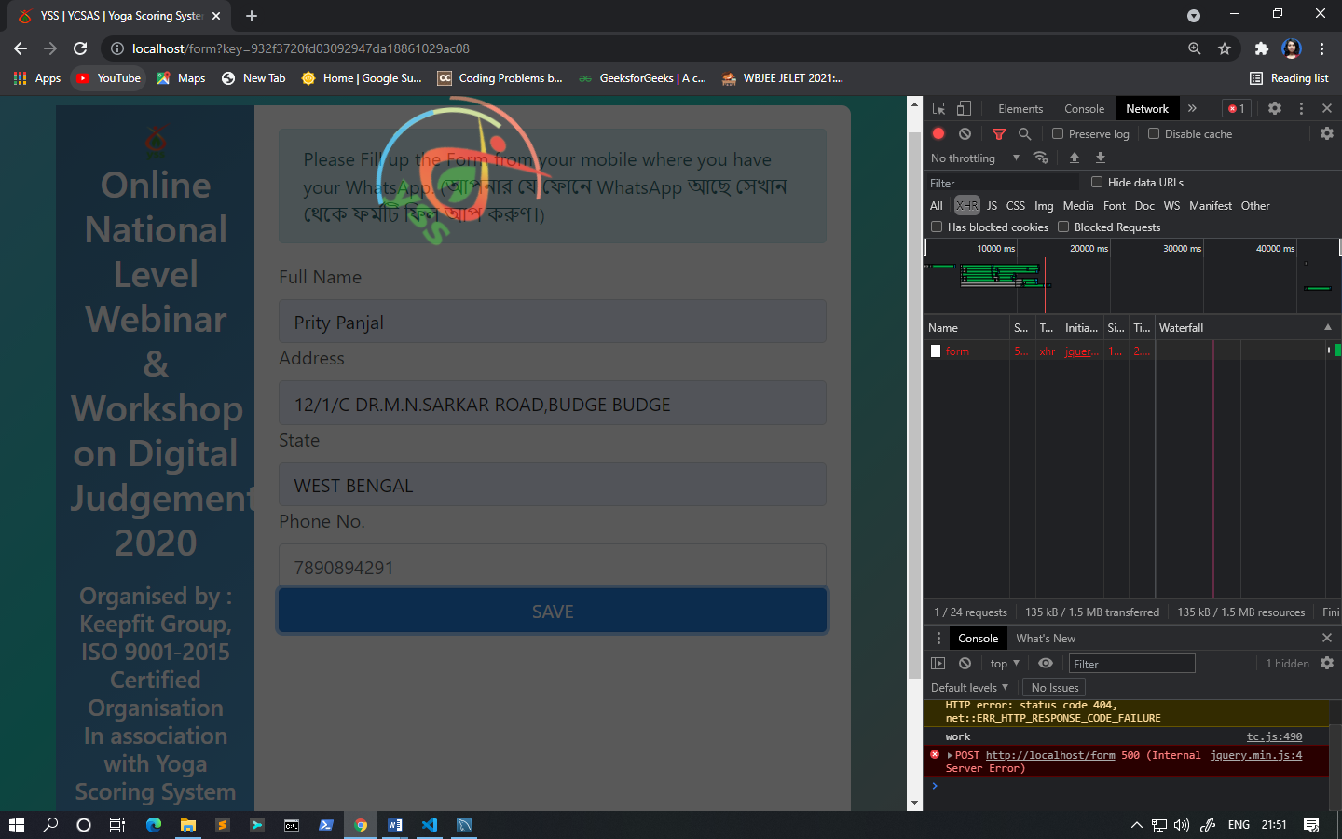

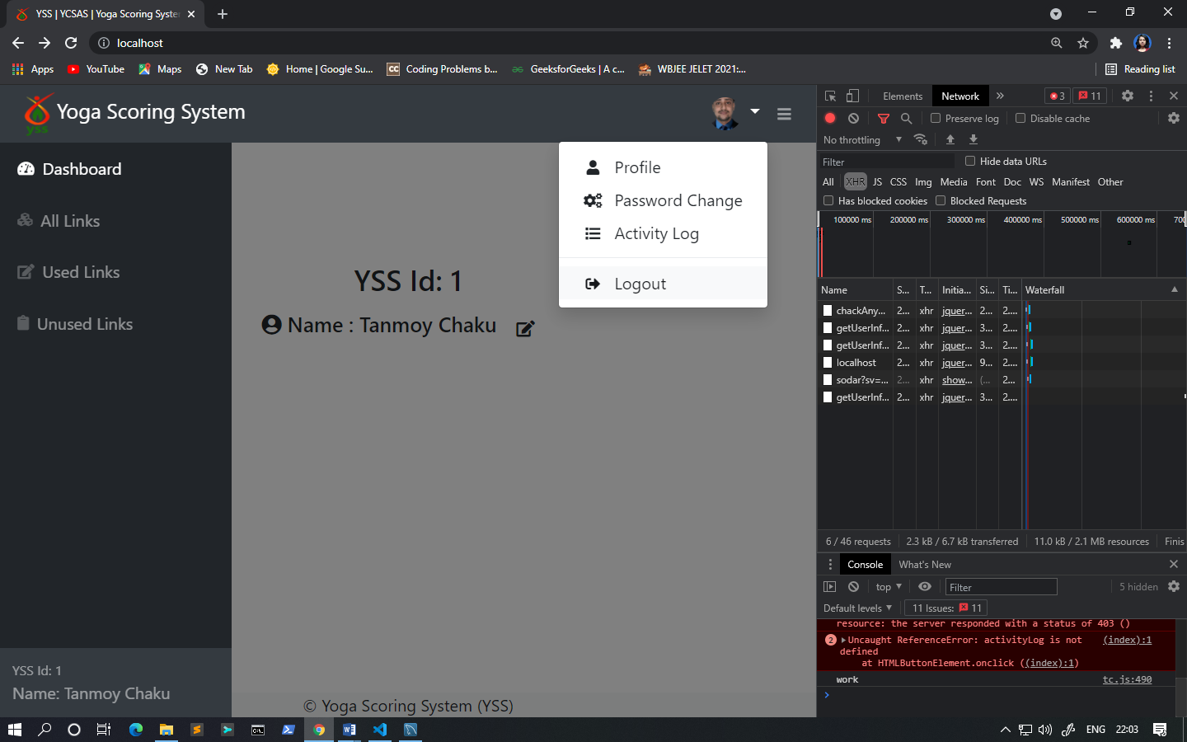

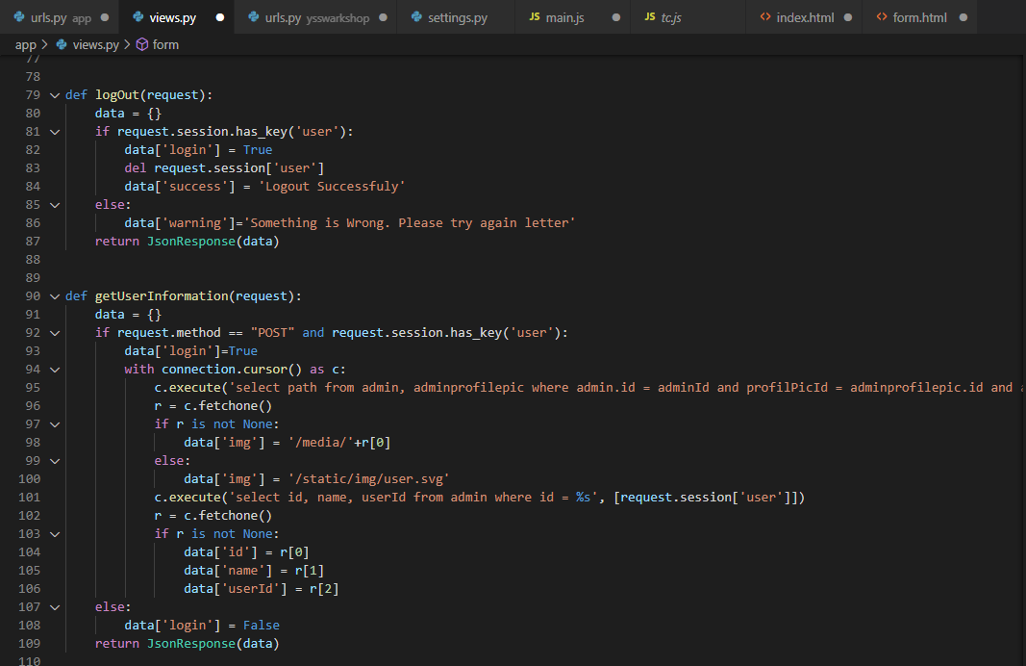

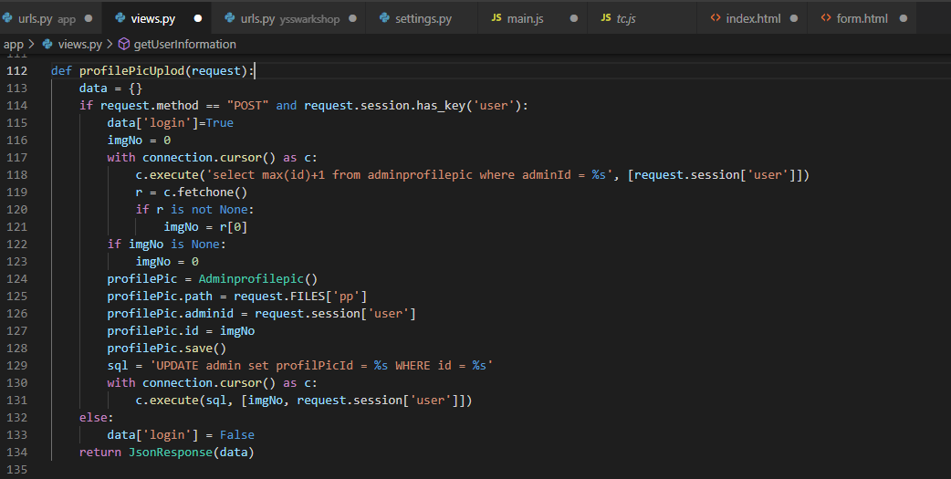

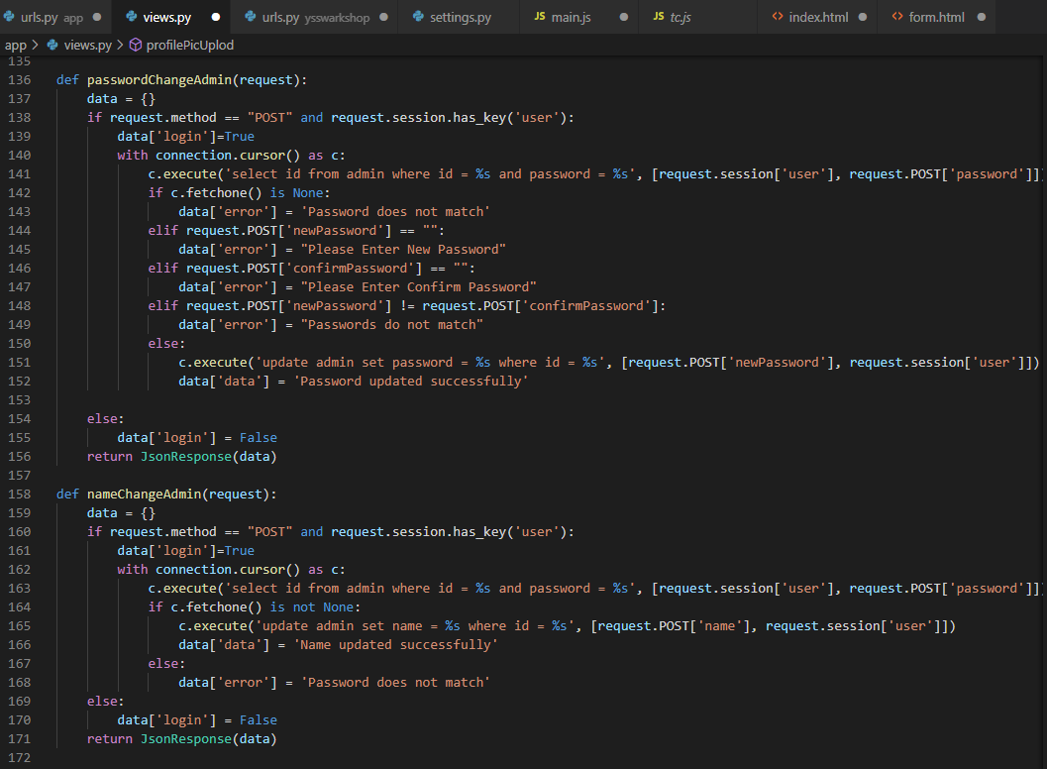

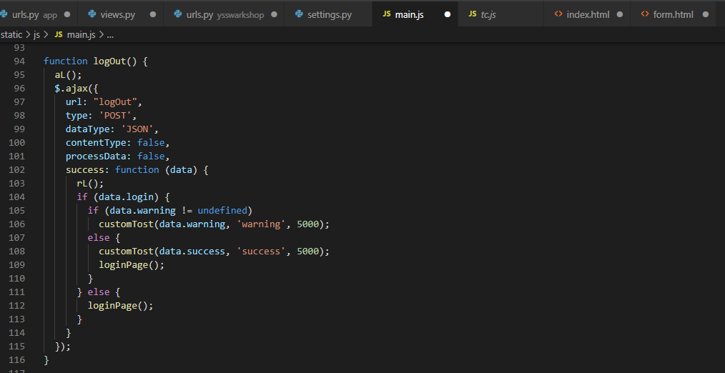

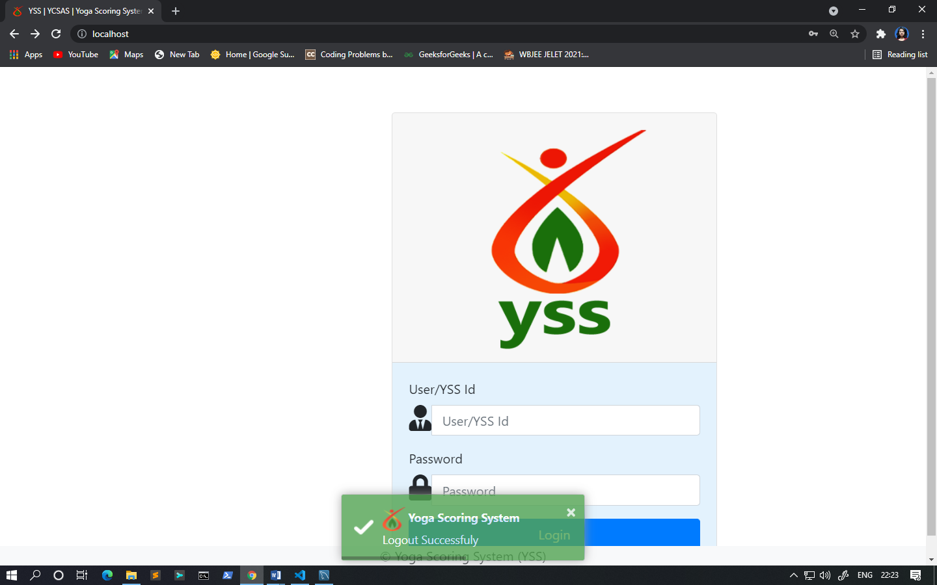

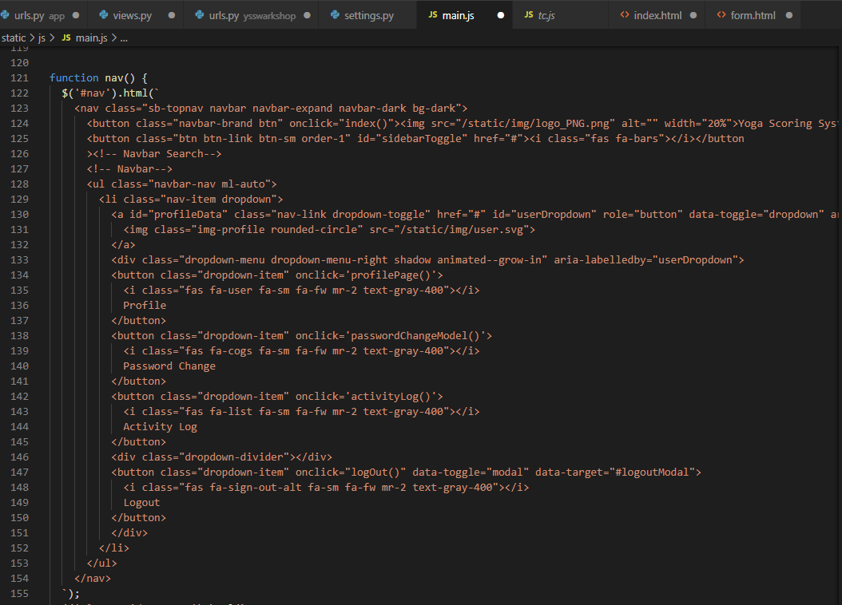

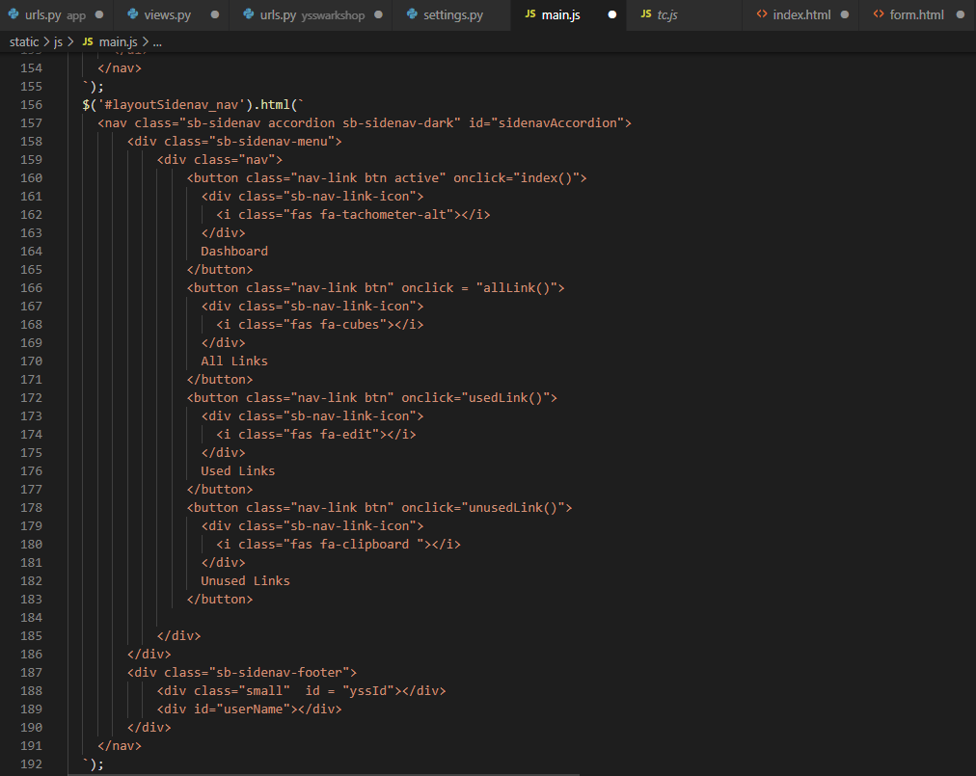

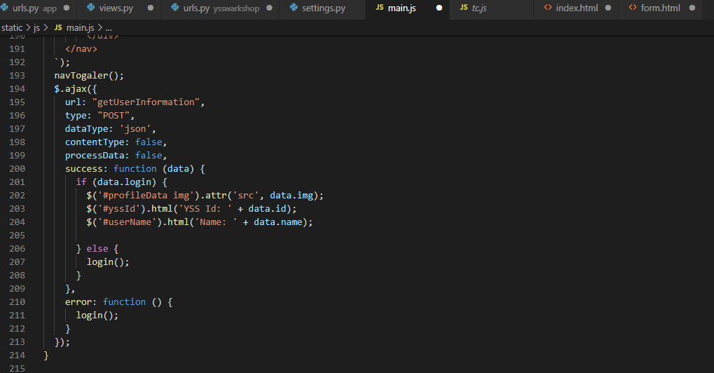

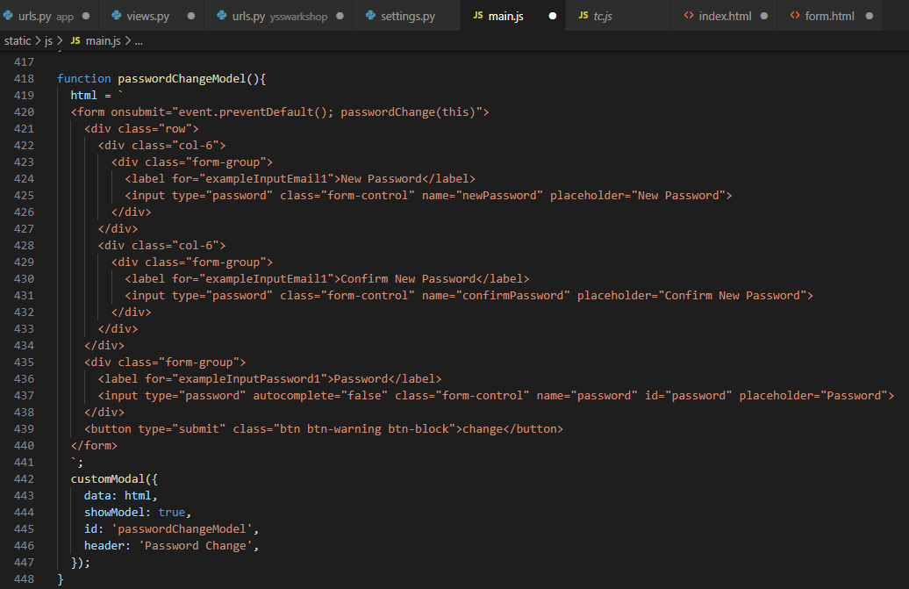



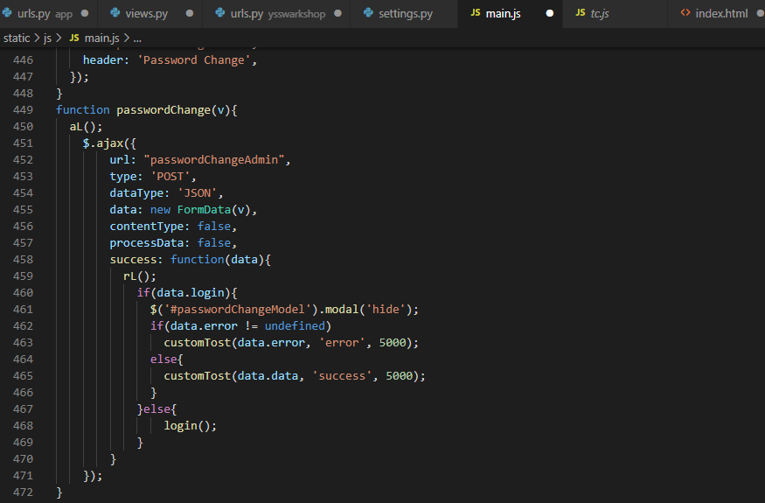

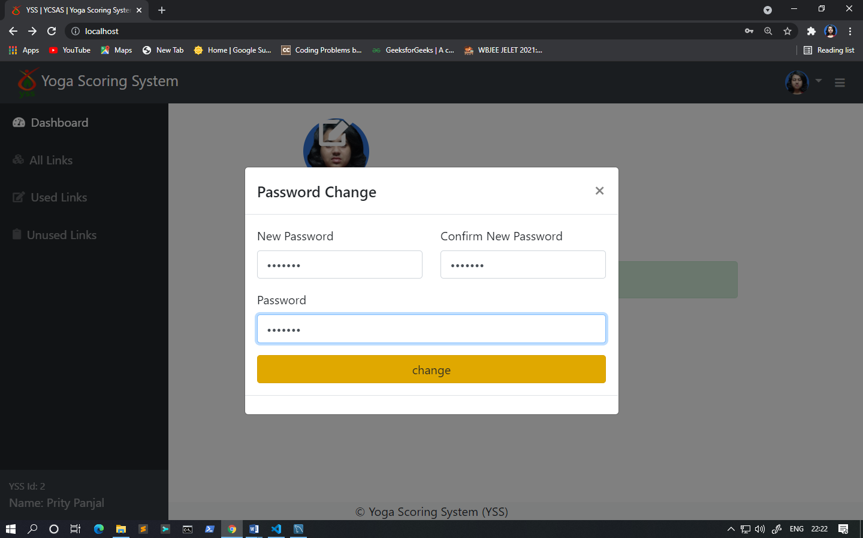

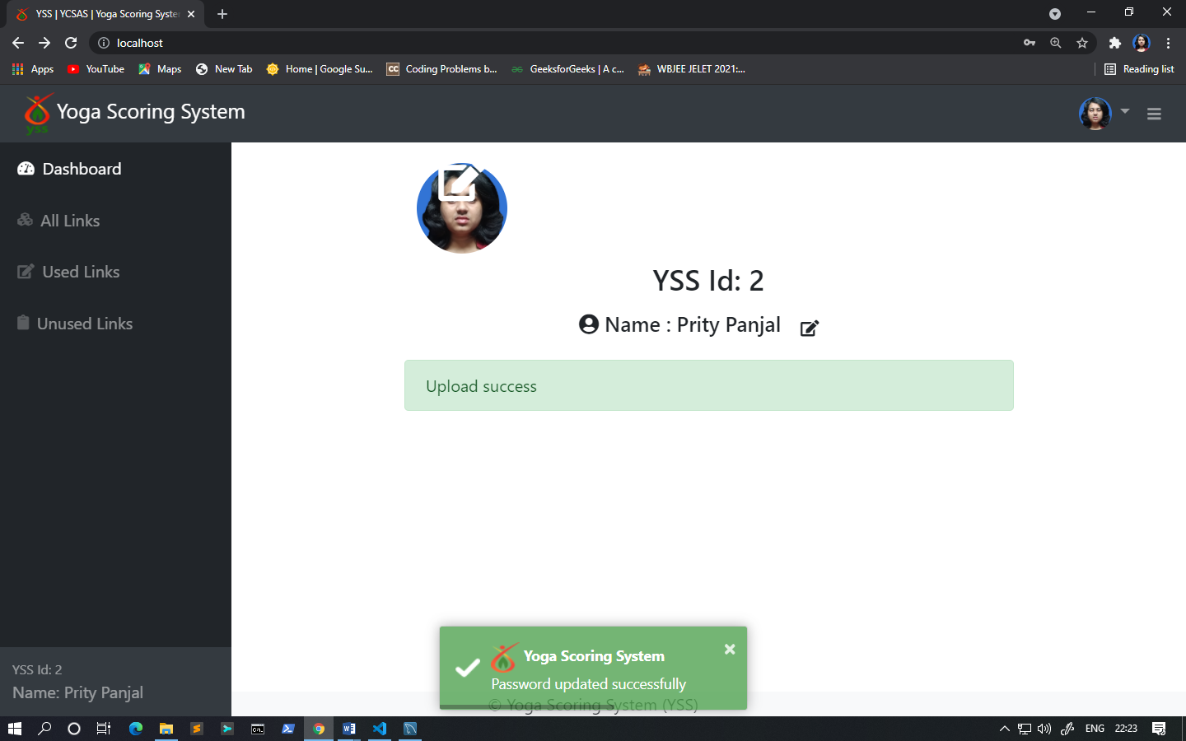

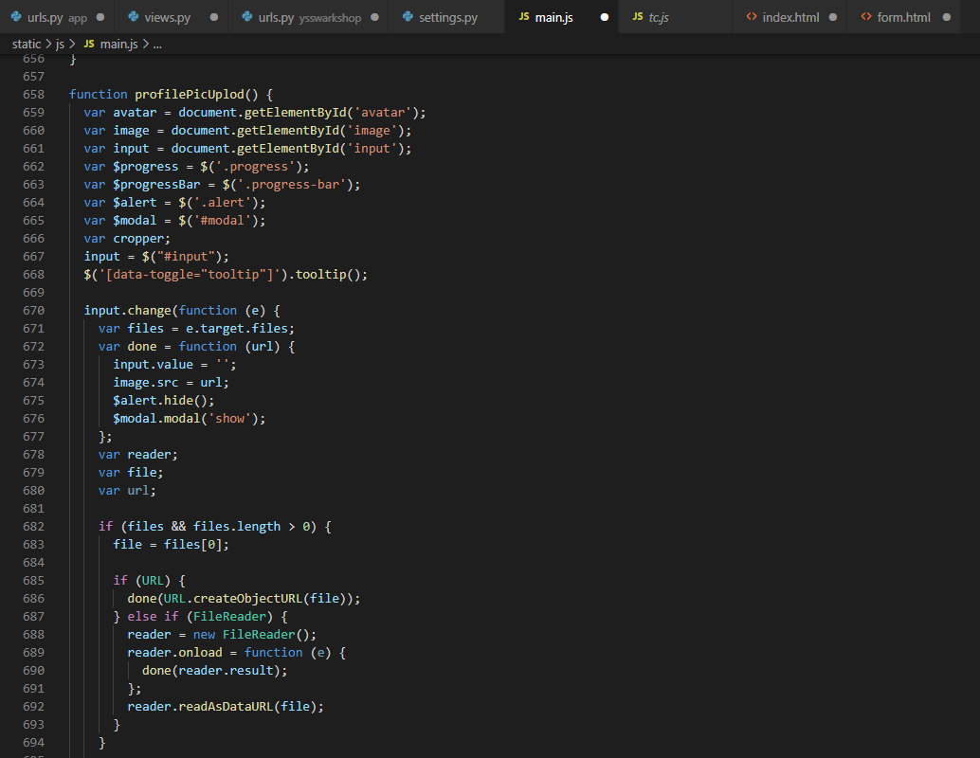

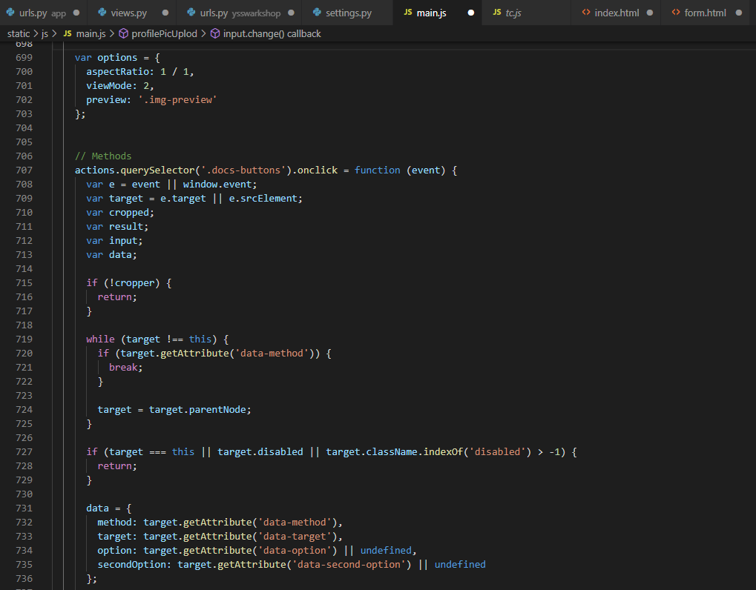

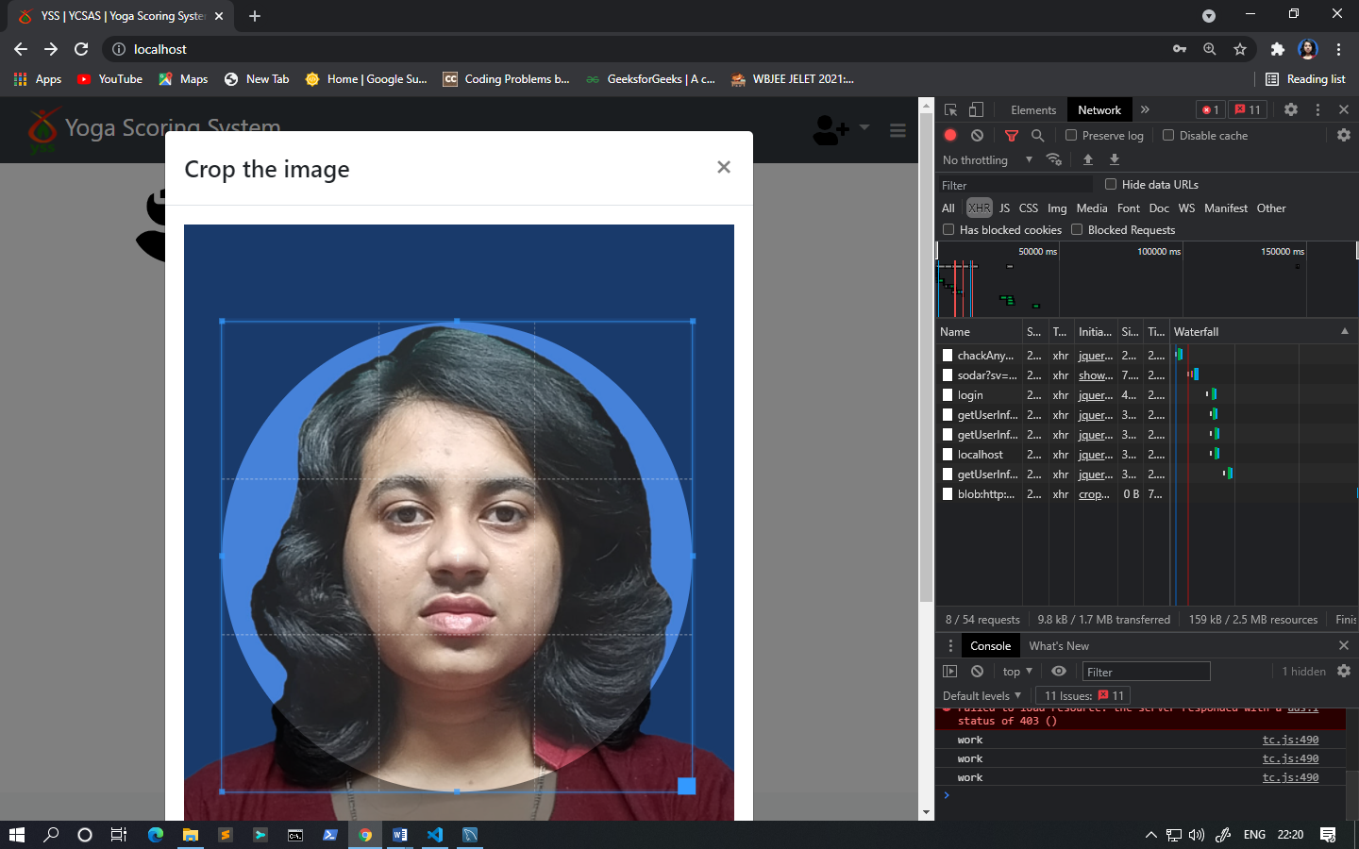

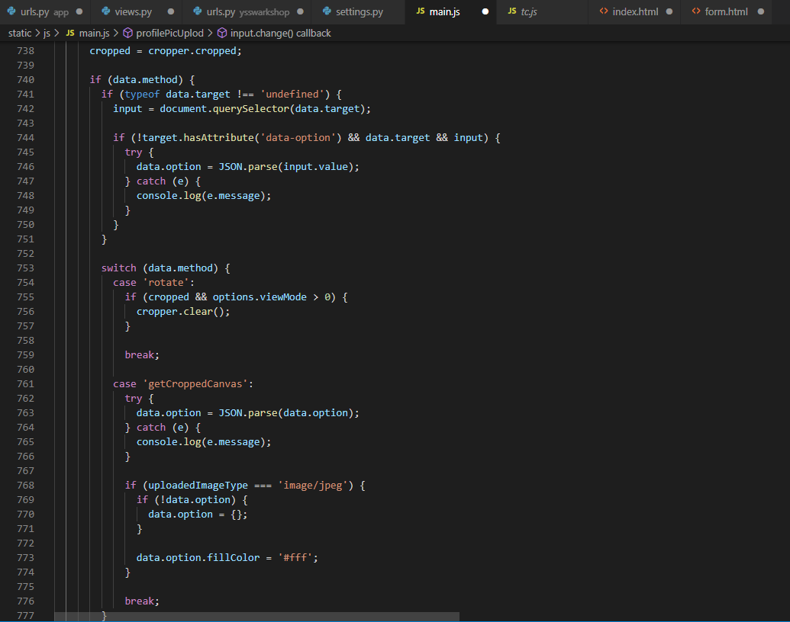

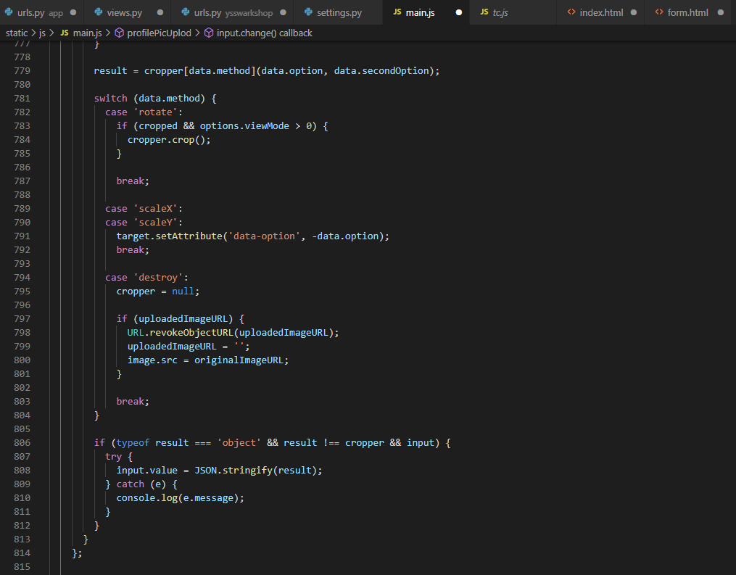

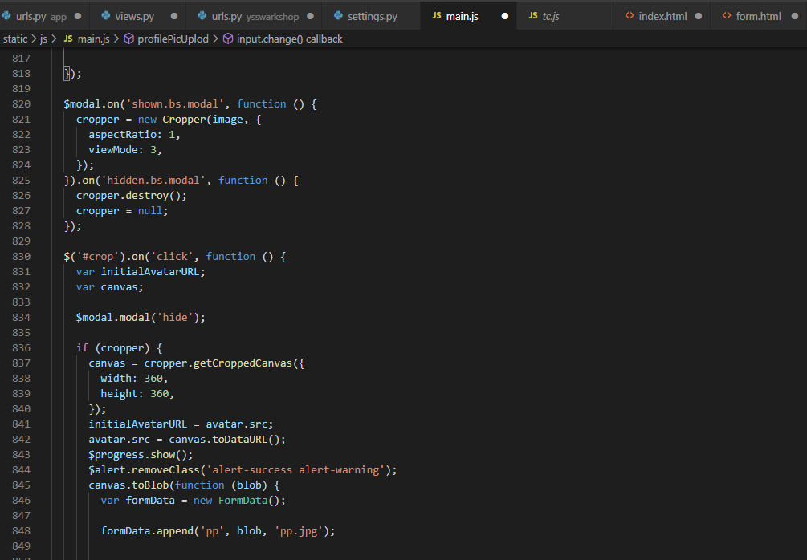

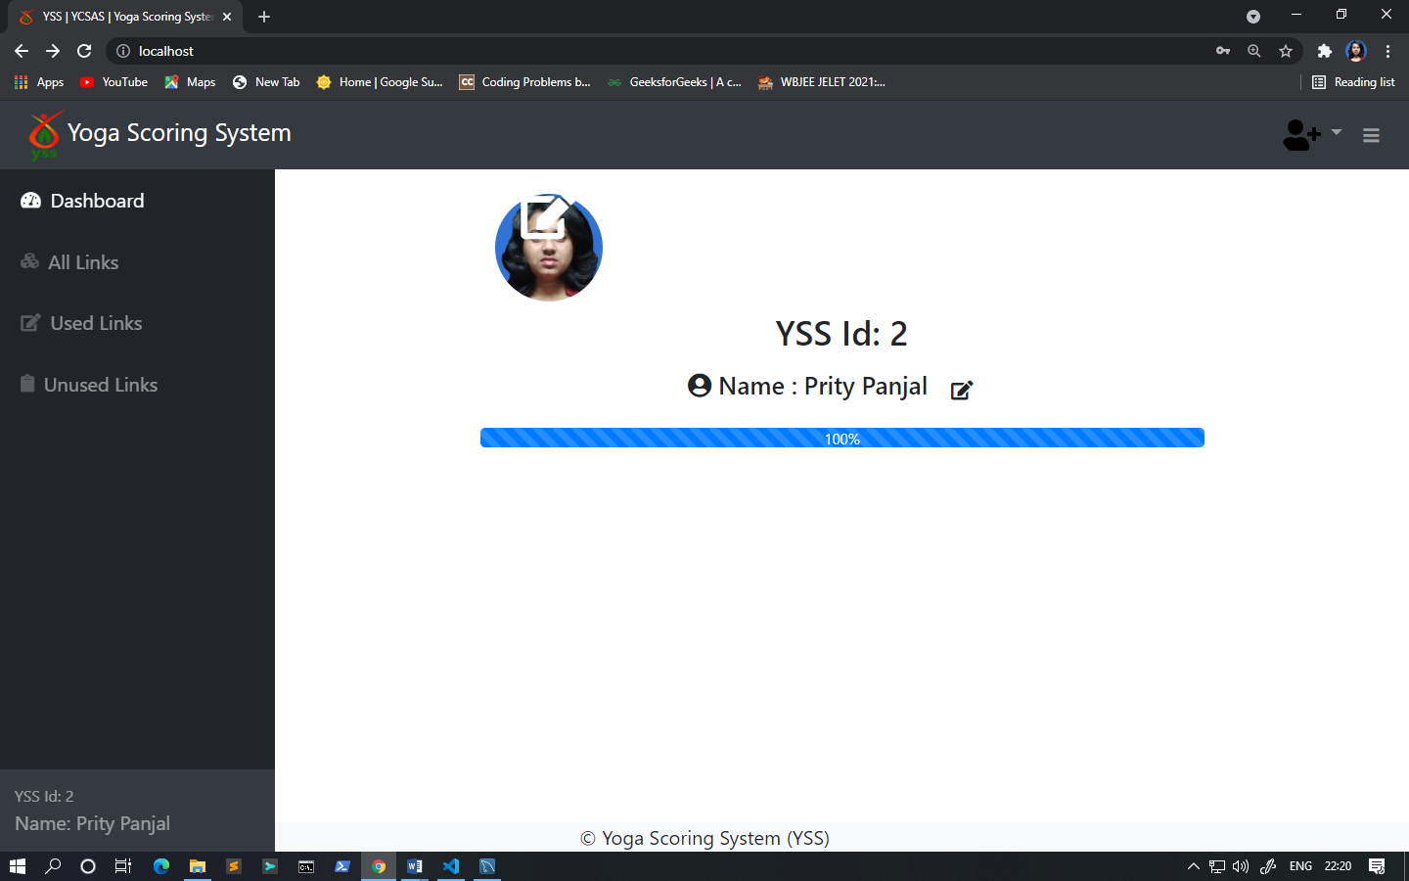

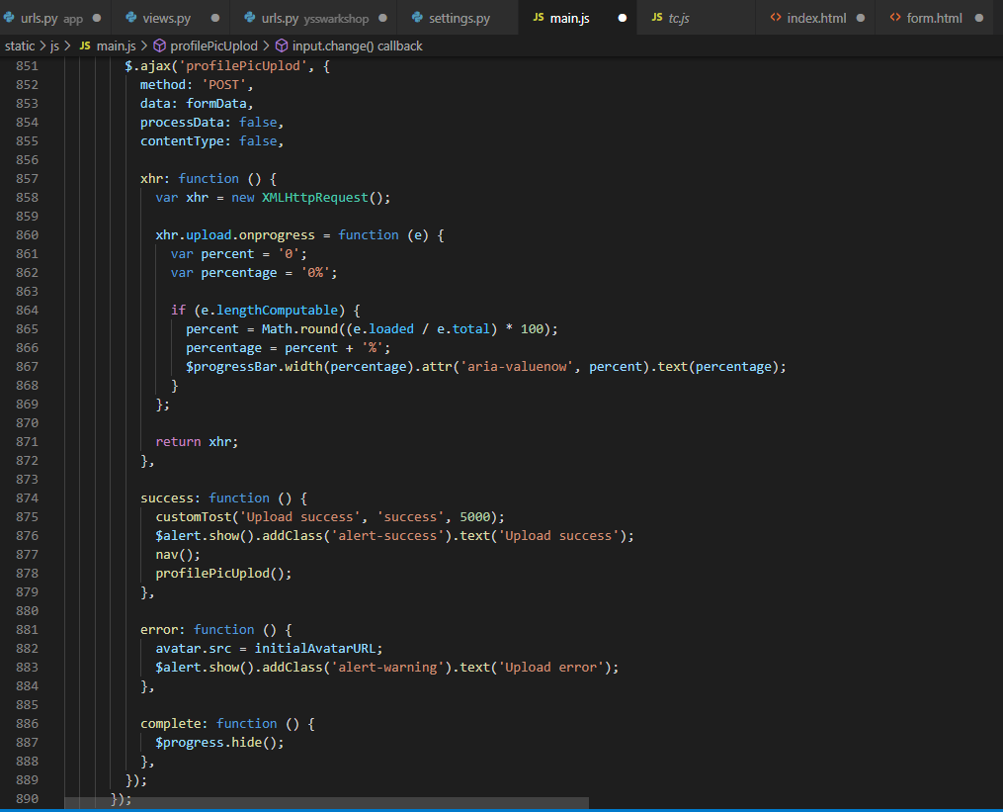

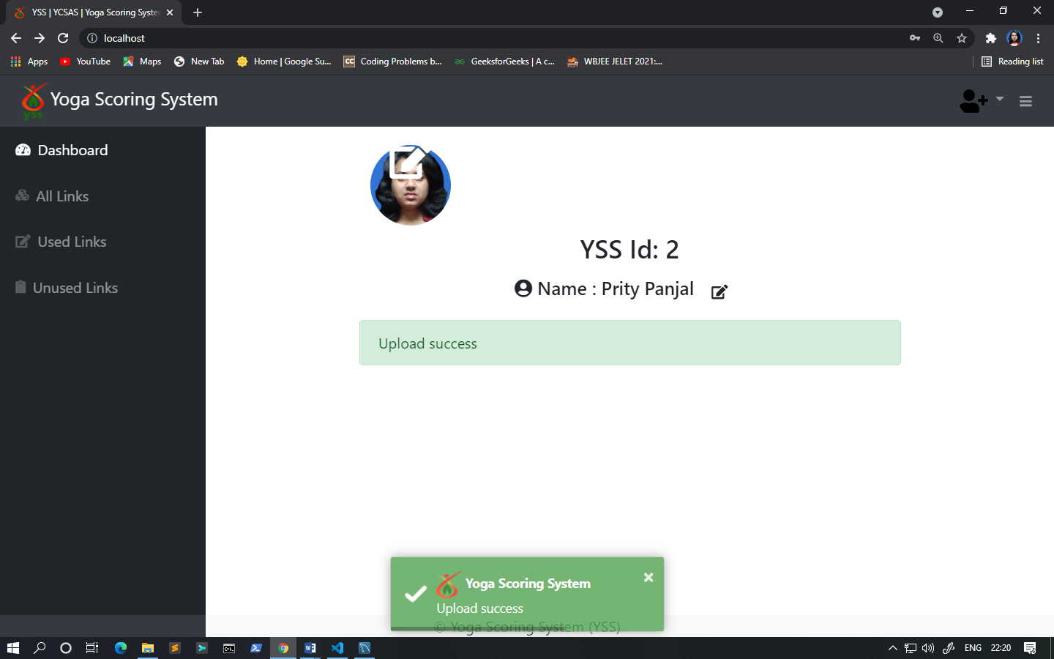

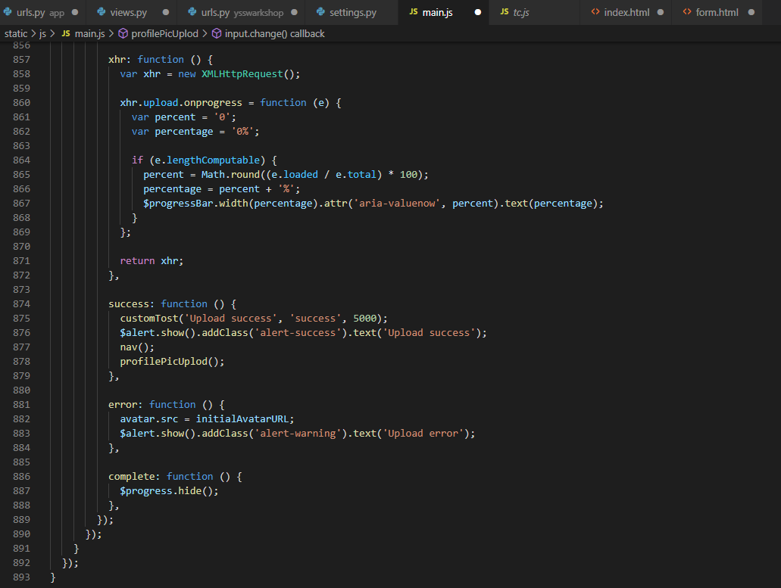

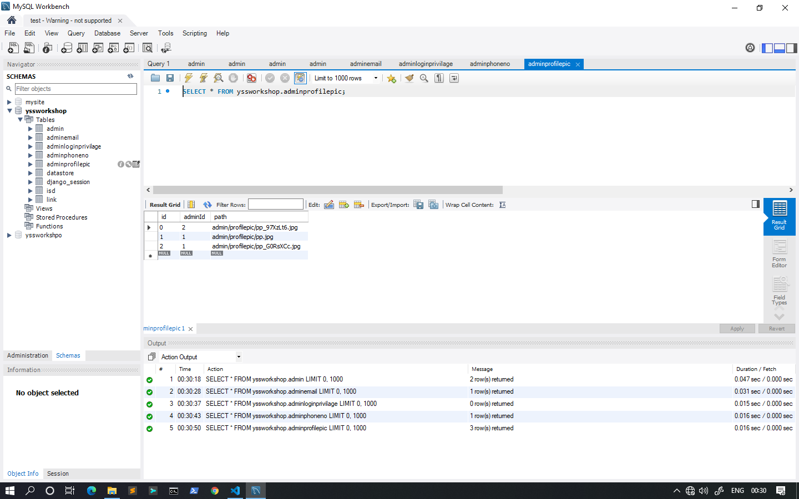

**Summarization**-. It is an active project, and has amazing future prospects. We will be working on new features such as Certificate and download links will be available, Forms similar to google forms will be available to the Admin where they can customized fields in the forms , Admin will get data in an excel file and much much more .